IN THE HIGH COURT OF SOUTH AFRICA
(WESTERN CAPE DIVISION, CAPE TOWN)

REPORTABLE
Review Case No.:54/2024
Magistrate’s Court Case No: B700/2023

In the matter between:

THE STATE
and
BERNARD LEWIS Accused

AUTOMATIC REVIEW JUDGMENT: 26 FEBRUARY 2024

SALIE, J:

1] This matter came before this Court as an automatic review in terms of the Criminal Procedure Act 51/1977, as amended, against the conviction and sentence by the
Magistrates’ Court for the district of Caledon on 23 and 27 November 2023 respectively.
2] The accused had been charged with two counts of contravention of the Domestic Violence Act, Act 116 of 1998. It is alleged that the accused had wrongfully and unlawfully contravened the terms of a protection order on 5 June 2023 and 6 June 2023 which had been obtained against him by the complainant, his sister. The relevant condition of the protection order, alleged to have been breached by him, reads as follows:

“3.1 The Court orders that:
3.1.2 An interim Protection Order is granted; and the Respondent is ordered-
3.1.2.1 not to commit the following act(s) of domestic violence [-] threaten with violence and/or swear at the applicant and/or related persons”

3] The aforesaid interim protection order was made final on the return day and is still in force. The accused pleaded not guilty, elected to waiver legal representation and conducted his own defence. At the end of the trial, he was convicted in respect of count 1, acquitted in respect of count 2 and sentenced to 12 months’ imprisonment wholly suspended for a period of five years on certain conditions, which included that he not be convicted of a contravention of Section 17 of the Domestic Violence Act within the period of suspension

4] The facts briefly are that the accused together with his sister, Mrs. Diana Lewis, (first complainant) and her children reside at their family home, owned by their mother. It is not disputed that there is tension between the accused and his sister. She testified that her children were studying for the school exams on the evening of 5 June 2023, when the accused came into the main house and prepared food for himself. He proceeded to play music loudly to which the children requested him to turn down the volume. After the accused refused to oblige, second complainant, the 17 (seventeen) year old daughter of Mrs. Lewis, proceeded to turn the volume down. She testified further that the accused made a reproachful protest and threatened her daughter with assault should she repeat the lowering of the volume. Mrs. Lewis testified that the accused cautioned that if her daughter touched the music again, he would assault them. The threat, “gaan ek julle in jou ma se p… in slaan”, was made in their home language of Afrikaans. The latter phrase is a vulgar manner of speaking, loosely translated as him threatening to beat them into her mother’s vagina. The accused thereafter increased the volume, and expressed profanities in a similar vein, and is alleged to have stated: “vat weer aan my p… se musiek, julle is in julle p…”, meaning that if she again interferes with the music then they would be in trouble. When he did not reduce the volume, the first complainant called upon the police followed by his arrest and detention overnight.

5] The charge in count 2 stems from an allegation that after the accused’s release from detention the following morning, he returned to the common home, and again threatened to assault the first complainant with the use of the p-word. It is also alleged that the accused threatened to burn the house down with them inside it. The first complainant was a single witness in relation to this charge. The accused denied the averments in respect of both counts and argued that the complainant was motivated to seek his eviction through the use of the interdict and consequently abuse the process. On the basis that her evidence was not satisfactory in all material ways, had a number of contradictions and that it was apparent that the allegation was motivated by her frustration towards the accused, the court acquitted the accused in respect of this count. Insofar as this review only relates to the conviction and sentence in respect of count 1, this judgment is limited thereto.

6] The accused testified that whilst an argument ensued between himself and the two complainants stemming from him playing loud music on the night in question, the second complainant entered the house and exclaimed that she is going to put off the damn music. He switched the music on again where after the second complainant switched it off again. Tempers were soaring, when he angrily stated: “los my ma se poes se ding.” In essence the latter statement is a crude manner of speaking instructing the second complainant to leave the music alone with words cursing the music player.

7] The trial court reasoned in its judgment that there are various versions as to exactly what words were uttered by the accused to the second complainant, however, the court accepted that the p-word was in fact used by the accused. I find it problematic however that simply using a swear word in his communication to the second complainant had amounted to a breach of the interdict and in particular contravention of the condition that he is not to swear at the first complainant or her relatives. In analysing the p-word the magistrate found that as it is a swear word, used in the exchange between him and his niece, it amounted to swearing directed at the complainant and accordingly that the State had proven its case beyond reasonable doubt. The accused’s version that he was not directing the p-word at the complainant but instead with reference to the music was rejected as being highly improbable and unlikely.

8] It is the aforesaid findings that warrant critique, more specifically in that the magistrate found that as the accused used the p-word to the complainant, he thus verbally abused her. The version of the accused that the p-word was used in relation to the music as opposed to the complainant was rejected. Effectively, it boiled down to whether the use of the offensive p-word, amounted to having committed a contravention of the interdict.

9] The p-word as it was found to have been used by the accused must be considered in the grammatical context. Whilst the word is indeed used as an offensive one in the Afrikaans language, it has also evolved over a number of years come to be colloquially used across our society and within various community circles. The culture of using it as a verb, noun or adjective has become prevalent and the term is used interchangeably depending on the context and phrasing of the sentence. It of course remains a term not used in polite company, however, the question is whether the State had proven beyond reasonable doubt that the accused had in fact sworn at the second complainant and in doing so had verbally abused her.

10] The use of the p-word herein [namely: leave this p-thing alone] was constructed as an adjective. The latter gives description to a noun. In this case, the noun was reference to the music. An adjective can be used to describe or give more information about a noun which forms the subject of the sentence. There are multiple categories and subcategories of adjectives based on their functions when used in a sentence. This type of adjective is referred to as an expletive attributive adjective and discussed in The Cambridge Grammar of the English Language by author Huddleston and others (2002). An expletive attributive is an adjective that does not contribute to the meaning of a sentence but is used to intensify its emotional force. The word is derived from the Latin verb explere, meaning to “to fill”, originally introduced into English in the 17th century for various kinds of padding.

11] Whilst the p-word remains offensive it has however, as in the case of various other offensive words, undergone a process referred to by linguists as delaxicalization. This represents a process where a word loses its original lexical value and often acquire other meanings and functions within a larger unit. The original taboo meaning and use of the p-word has been diluted over time depending on the context and grammatical use. It is not uncommon in contemporary culture to hear reference to the p-word to describe cold temperature for example. In the latter case, it too would be utilised by the communicator as an adjective to describe something. Whist it would not suffice in respectful or sophisticated company it would not necessarily be regarded as being verbally abusive.

12] Further to the aforesaid, this Court is alive to the commonplace feature and use of this term in our societ. Harvard University, Graduate School of Arts and Science features the doctoral dissertation by Warrick Moses, 2019 (In the Mix: Expressions of Coloured Identity in Cape Town-based Hiphop) investigates the expressions of coloured identity in the form of socio-political and cultural identity. Whilst coloured is a fiction of separatist ideology, a product of apartheid, he acknowledges that colouredness signifies socio-cultural practices, resulting in various styles of the Afrikaans language, being standard or vernacular varieties of the language. He describes the latter as being synonymous with the working-class “coloured” demographic of Cape Town. It is in this context that the p-word must also be considered. It had evolved as an expression and (with relevance to this matter) it bears significance that it is employed in language and communication constructs of the coloured community.

13] Cartoonist, Zapiro, had famously captured the deflated spirit of a caricature depicting a deserted Grand Parade, Cape Town, in The Argus newspaper publication in 1997 after the announcement that South Africa’s bid to host the 2004 Olympics had failed. Greece was the successful bidder. “ATHENS SE MA SE @*#&!!” was a satirical humorous sketch aptly reflecting the use of the term within the coloured community to express exclamation, disappointment or frustration. This cartoon still reflects decades later on the sale of t-shirts and other paraphernalia emphasising the continued acknowledgment by viewers than it appositely illustrates the indeed commonplace use of the p-word and phrase within the community.
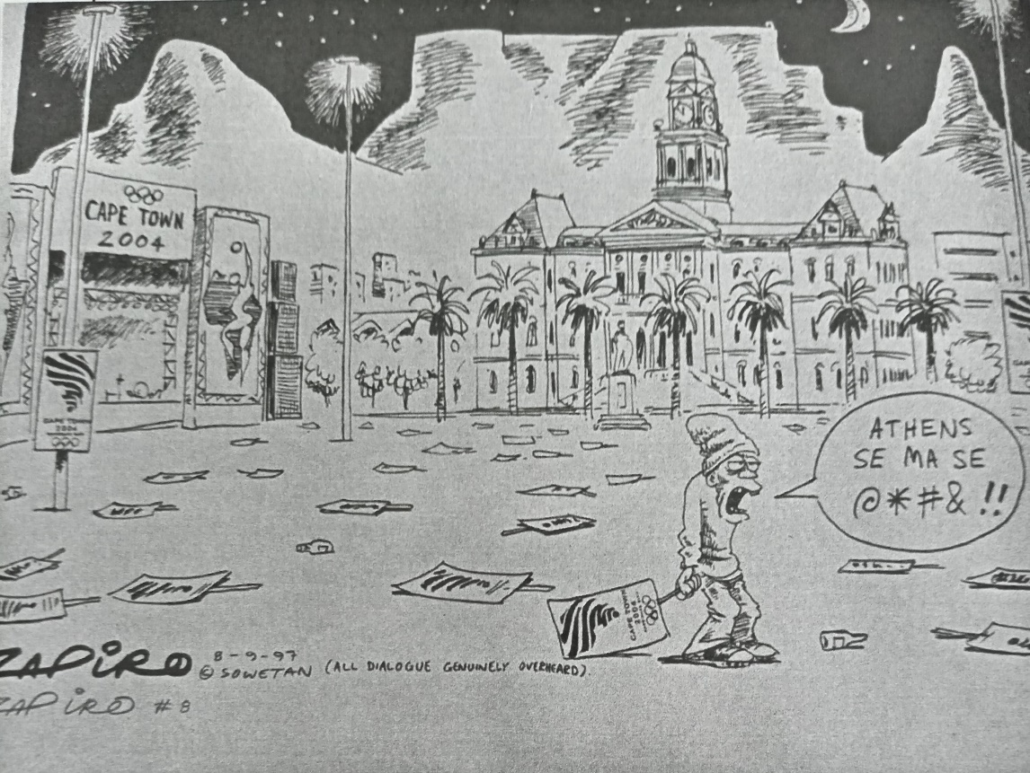

14] On these facts and given the circumstances herein, I am not persuaded that the use of the p-word by the accused to describe or give definition to the music (the thing) amounted to hurling abuse at the complainant and thus a contravention of the interdict. The word in question was not communicated in the context as a noun, in other words, the complainant was not referred to by the p-word. Same can be said for it not having been used as a verb. The complainant was not threatened to be assaulted or beaten with illustration of the p-word. Had it been the case that the p-word had been used as in the latter two examples, that being as a noun or a verb, the position would be different and would be considered as a violation of the interdict. It was not disputed that the second complainant referred to the music as “donnerse” loosely translated as bloody or damn. In that context the second complainant’s expletive word was also used as an attributive adjective to refer to the loud music. The communication between the accused and the second complainant had indeed become infused with irritation and annoyance. This supports the notion that the accused retorted with an expletive attributive adjective of his own, claiming ownership to the music and illustrate an emotional force to it. The offensive word was not a reference to the complainant. That was precisely his version, that being, when he said “los my ma se poes se ding” (leave my mother’s p… thing) he did not swear at the complainant but referenced to the music and what we can accept as expressing an emotional force to it. I cannot find the version of the accused, and in particular the meaning attributed to his outburst to the second complainant, not to be reasonably possibly true. I am satisfied that his version is reasonably possibly true and in the circumstances, the trial court was misdirected in its finding.

14] For the reasons aforesaid, I am of the view that the trial court was flawed in its reasoning, was misdirected in its findings and incorrectly found that the charge had been proven beyond reasonable doubt. Wherefore, the conviction and sentence ought to be set aside. Accordingly, the following order is made:

“(a) The conviction and sentence of the accused is set aside.
(b) The order of the trial court is substituted with the following order:
“The accused is acquitted in respect of count 1.”
(c) The order set out above is antedated to 23 November 2023.
(d) It is further directed that a copy of this judgment shall be filed with the
Chief Magistrate of the Caledon Magistrate’s Court as well as the Clerk of the Domestic Violence Court for filing in the court file in respect of the interdict issued as number 99/2020 between Diana Lewis and Bernard Lewis.”

_______________________
SALIE, J
JUDGE OF THE HIGH COURT
WESTERN CAPE

I CONCUR:

_________________________
ERASMUS, J
JUDGE OF THE HIGH COURT
WESTERN CAPE

