IN THE HIGH COURT OF SOUTH AFRICA
(EAST LONDON LOCAL CIRCUIT DIVISION)
Reportable: No
Date Heard: 23 August 2022
Date Delivered: 6 September 2022

Case No: 799/2020

In the matter between:

MAWONGA MDAZANE First Plaintiff
MDAZANE INVESTMENTS (PTY) LTD Second Plaintiff

and

PHUMLANI NENE First Defendant
NUTIGEN (PTY) LTD Second Defendant

JUDGMENT
_______________________________________________________________________________
Ntlama-Makhanya AJ

1 This is an application by the Plaintiffs (Mawonga Mdazane and Mdazane Investments (PTY) LTD for a default judgment against the first and second Defendants (Phumlani Nene and Nutigen (PTY) LTD) for the latter’s non-appearance in this Court on 23 August 2022 which was an agreed date that was arranged with their attorney for the determination of the merits of the claim in respect of the services that were offered by the Plaintiffs to the Defendants.

2 For purposes of this judgment, I will respectively refer to both parties to the dispute as the Plaintiffs and Defendants.

3 This judgment will not deal with the merits of the claim other than the reflection on the non-appearance of the Defendants in this Court.

4 This matter arose out of the partnership that was entered between the parties for the procuring of a tender for the provision of surgical masks for the Department of Health, Eastern Cape (Department).

5 The common intention was to improve the financial muscle of each and to share the joint profit and payment of the supplier upon receipt of payment by the Department.

6 It is not the intention to exhaust the facts of this claim as the Defendants on their notice to oppose it:

6.1 they did not dispute the existence of their agreement;

6.2 they tendered to pay an amount of R650 000.00; and

6.3 the said amount would be paid only on the resolution of the dispute raised by the Plaintiffs.

7 With this in mind, the Defendants or their representative did not appear in court to oppose or defend the application for default judgment which was prompted by the initial application by the Applicants for breach of contract.

8 This matter has a history in this court:

8.1 It was postponed on 02 June 2022 by agreement that it be deferred to 23 August 2022 before my Colleague: Honourable Swartbooi AJ.
8.2 The postponement was due to the Defendants instructing new attorneys on the matter.

8.3 The Defendants tendered the wasted costs of the postponement because of the instruction of the new attorneys on the matter by the Defendants.

8.4 On the above said day of appearance the Defendants did not appear in Court.

8.5 The Defendants did not provide or tender any explanation in any form of communication to the Court.

8.6 The said date was agreed by consent and the Defendants were aware of their needed appearance in this Court.

9 The crux of this application lies in compliance with the initial prescripts relating to the delivery of the summons by the Plaintiffs to the Defendants and in turn the latter submitting the notice to oppose the claim to the Court but on the day of the 23rd August 2022 to deal with the merits of the claim, the Defendants did not appear in Court without any justifiable reason of such non-appearance.

10 Thereof, the Plaintiffs thereof, applied for the default judgment against the Defendants and sought payment of the monies due to them.

11 The order sought by the Plaintiffs was for the Defendants:

11.1 to pay an amount of R1071500 .00 (One million and seventy-one thousand five hundred rands) as and for monies owed by the Defendants to the Plaintiffs which arose from the oral agreement between them
11.2 to pay the Plaintiffs the above-mentioned amount within 14 days from the date of the judgment.
11.3 to also pay interests at the prevailing prescribed legal rate from 21 July 2020 (date of demand) to date of payment.
11.4 to pay the Plaintiffs taxed or agreed costs on a punitive scale.
11.5 to pay the plaintiffs interests on the costs of the suit at the prescribed legal rate from 14 days after the allocator.
11.6 for the payment of capital, costs and interest into the Trust account of the Plaintiff’s attorneys of record with the details provided.

12 With no reason proffered for non-appearance, this Court find it difficult to equally establish any legitimate reason for such non-appearance.

13 It is reasonable to believe that the Defendants do not have a legitimate defence on the claimed amount.

14 It is for this Court to find the conduct of the Defendants despicable and constitute a deliberate disregard of the integrity of this Court and its processes.

15 Accordingly, it is ordered that the Defendants should pay the Plaintiffs:

15.1 an amount of R1071500 .00 (One million and seventy-one thousand five hundred rands) as and for monies owed by the Defendants to the Plaintiffs which arose from the oral agreement between them.
15.2 the above-mentioned amount within 14 days from the date of the judgment.
15.3 the interest at the prevailing prescribed legal rate from 21 July 2020 (date of demand) to date of payment.
15.4 the taxed or agreed costs on a punitive scale.
15.5 the interest on the costs of the suit at the prescribed legal rate from 14 days after the allocator.
15.6 the payment of capital, costs and interest into the Trust account of the Plaintiff’s attorneys of record with the details provided.

16 It is for this Order to be made available to the Defendants and for the claim to be paid within 14 days of such delivery.

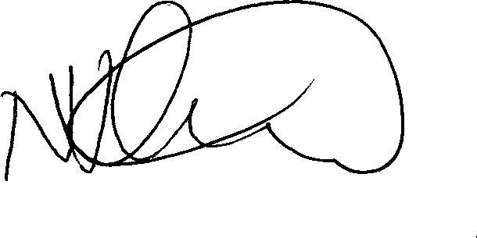
_____________________
N Ntlama-Makhanya
ACTING JUDGE OF THE HIGH COURT

For the first plaintiff: Mr S. Vapi, of Vapi Incorporated, Mthatha.

