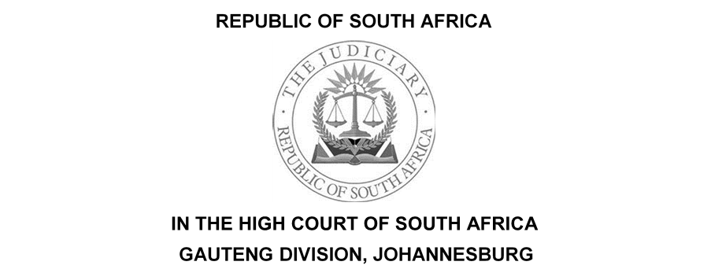

(1) REPORTABLE: NO
(2) OF INTEREST TO OTHER JUDGES: NO
(3) REVISED.

…………………….. ………………………...
DATE SIGNATURE

Case no.: 2022/13169
In the matter between:
TSI COMMUNICATIONS C.C | PLAINTIFF
And
OMEGA M PROJECTS | DEFENDANT

Coram: Dlamini J

Date of hearing: Date of hearing: 30 August 2022
Date of delivery of judgment: 27 September 2023

The Judgment is deemed to have been delivered electronically by circulation to the parties’ representatives via email and the same shall be uploaded onto the caselines system.

JUDGMENT

DLAMINI J

[1] This is an application for exception brought by the defendant against the plaintiff’s Particulars of Claim.

[2] The matter concerns a partnership between the plaintiff and the defendant. The plaintiff claims a sum of R 48 773.52 as part of profit sharing and R 35 305.47 being half of the tools and equipment that the defendant allegedly retained. The claim is being opposed by the defendant.

TEST FOR EXCEPTION

[3] In dealing with the exception it is trite that the pleadings must be looked at as a whole. An excipient must show that the pleading is excipiable on every possible interpretation that can reasonably be attached to it.

[4] The test on exception is whether on all reasonable readings of the facts pleaded, no cause of action may be made out.

[5] The well-established principle of our law is that the onus rests upon the excipient who alleges that a summons discloses no cause of action or is vague and embarrassing. The duty rests upon the excipient to persuade the court that the pleading is excipiable on every interpretation that can reasonably be attached to it.

[6] In H v Fetal Assessment Center, the court said "The test on an exception is whether, on all possible readings of the facts, no cause of action may be made out. It is for the excipient to satisfy the court that the conclusion of law from which the plaintiff contends cannot be supported on every interpretation that can be put upon the facts.”

[7] The trite principle of our law is that an excipient is obliged to confine his complaint to the stated grounds of his exception,

[8] in Luke M Tembani and Others v President of the Republic of South Africa and Another the Supreme Court of Appeal set out the general principle relating to and the approach to be adopted regarding the adjudication of exceptions as follows; “Whilst exceptions provide a useful mechanism to weed out cases without legal merit, it is nonetheless necessary that they be dealt with sensibly (Telematrix (Pty) Ltd v Advertising Standards Authority SA [ 2005] ZASCA 73; 2006 (1) SA 461 (SCA) para 3). It is where pleadings are so vague that it is impossible to determine the nature of the claim, or where pleadings are bad in law that their contents do not support a discernible and legally recognised cause of action, that exception is competent (Cilliers et al Hebstein and Van Winsen the Practice of the High Courts of South Africa 5ed Vol 1 at 631; Jowel v Bramwell-Jones and Others 1998 (1) SA 386 (W) at 899E-F). the burden rests on an excipient, who must establish that on every interpretation that can reasonably be attached to it, the pleading is excipiable (Ocean Echo Properties 327 CC and Another v Old Mutual Life Insurance Company (South Africa) Ltd [2018] ZASCA 9; 2018 (3) SA 405 (SCA) para 9). The test is whether on all possible readings of the fact no cause of action may be made out; it being for the excipient to satisfy the court that the conclusion of law for which the plaintiff contends cannot be supported on every interpretation that can be put upon the facts (Trustees for the Time Being of the Children’s Resources Centre Trust and Others v Pioneer Food (Pty) Ltd and Others [2012] ZASCA 182; 2013 (2) SA 213 (SCA); 2013 (3) BCLR 279 (SCA); [2013] 1 All SA 648 (SCA) para 36 ( Children’s Resource Centre Trust).”

[9] The tests applicable in deciding exceptions based on vagueness and embarrassment are now well established and have been consistently applied by our Courts. In Trope v South African Reserve Bank, it was held at (201-211) that an exception to a pleading of it being vague and embarrassing involves two primary considerations namely;

9.1 whether it is vague, and;
9.2 whether it causes embarrassment of such a nature that the excipient is prejudiced

[10] The Trope decision was approved in Jowell v Bramwell –Jones, at 899-903. In the Jowell – judgment it was also held that it was incumbent upon a plaintiff to plead a complete cause of action that identifies the issues upon which it seeks to rely and on which evidence will be led in an intelligible, lucid form that allows the defendant to plead to it.

BACKGROUND FACTS

[11] The facts underlying this dispute are largely common cause.

[12] The plaintiff (TSI Communication) is a company that provides telecommunication services for the mining industry. TSI in May 2020, entered into a partly verbal and a partly written joint venture agreement (‘the agreement”)with the defendant, Omega M Projects (Omega M) a company that is involved in the commissioning and installation of fibre networks.

[13] In terms of the agreement, TSI was expected to provide capital to finance the projects, including all expenses in relation to each individual project. The defendant was required to conduct the physical installations of the fibre networks. The parties further agreed that they shall be entitled to share in the profit of the individual projects and shall bear the losses on the individual projects.

[14] Subsequent, to the signing of the agreement the parties acquired two contracts. One is titled the Newcastle Project, which is Claim 1 wherein the plaintiff pleads that it is entitled to its share of profit, thus being a claim for profit sharing.

[15] Claim 2, relates to the Danville Project, wherein the parties were awarded the project, however during the course of the project, the main contractor which appointed the parties as sub-subcontractors was liquidated. On this claim, the plaintiff insists that it incurred expenses and as such a loss, and therefore the defendant is liable to reimburse the plaintiff in equal terms to such loss.

[16] After entering an appearance to defend, the defendant raised certain objections against the plaintiff's particulars of claim. The plaintiff amended its particulars of claim and its amendment was effected. Not satisfied with this amendment, the defendant delivered a notice in terms of Uniform Rule 23 (1) to the plaintiff's particulars of claim, on the basis that the particulars of claim do not disclose a cause of action and or are vague and embarrassing.

DEFENDANT EXCEPTION

[17] The issue to be decided is whether as the plaintiff has pleaded the existence of a partnership agreement and in terms of actio pro socio a claim for accounting, debatement, and reimbursement in a partnership is only available upon the dissolution of the partnership.

[18] In so far as Claim 1 is concerned the defendant submits that all profit made by the partners together with all loans to the partnership, whether by the parties themselves or from outsiders, also form part of the partnership assets. Therefore, insists the defendant that a partner cannot lay claim to partnership assets, absent dissolution of same as the partner's share is an undivided half share, which becomes divisible only upon dissolution.

[19] Same as in Claim 1, the defendant insists that just like the claim for payment, the accounting obligation comes to the fore only upon payment by a third party and there was no payment, therefore accounting becomes enforceable, ex lege upon dissolution of the partnership.

[20] In sum, Omega M’s submission is that the actio pro socio can only be instituted, upon the dissolution of the partnership. That absent the claim for dissolution as the plaintiff has failed to claim dissolution, there is no cause of action. Therefore, the plaintiff has no claim against the excipient for the amounts allegedly owed to it in relation to the partnership affairs until the accounts are settled and there remains a credit balance due to him from the excipient.

[21] TSI submits that it is not claiming for a division of partnership assets upon dissolution. That both its claims fall within the ambit of the actio pro socio and it is not necessary to dissolve the partnership for its claim to succeed. For this proposition, the plaintiff seeks reliance in Municipal Employees Pension Fund and Others v Chrisal Investment (PTY) Ltd and Others. See also Morar NO v Akoo and Another where the Court succinctly set out a detailed exposition of the general principles of the actio pro socio and its requirements the court said at [11] “Two points are noteworthy about this exposition of the general principles of the action pro socio. The first is that according to the authorities, the action is one that lies at the instance of one of the partners for relief against another, either during the subsistence of the partnership or after its dissolution. A detailed discussion is to be found in Voet 17.2.9 and 17.2.10 5 where it is said that the claim is one in terms of which one partner may claim against the other;

(a) an account and a debatement thereof, either during the subsistence of the partnership or after it has been terminated;

(b) delivery of a partnership assets to the partnership,

(c) the appointment of a liquidator to the partnership.

[22] Taking into account all the circumstances of this case I agree with the exposition of the actio pro socio as laid down in Morar NO above and this Court is in any event bound by the SCA decision. It must follow therefore that the defendant’s exception has no merit and stands to be dismissed. This is so because the trite principle of our law is that the actio pro socio is available during the existence of a partnership or during the dissolution.

[23] As a result, my view is that the plaintiff's particulars of claim are valid and contain the averments that are necessary to sustain a cause of action for the relief the plaintiff claim against the defendant.

[24] I make the following order.

ORDER

1. The defendant’s exception is dismissed with costs

_______________________
DLAMINI J

JUDGE OF THE HIGH COURT OF SOUTH AFRICA
GAUTENG DIVISION, JOHANNESBURG

Date of hearing: 30 August 2023
Delivered: 27 September 2023

For the Plaintiff; Adv. Christo van der Merwe
Dominus.cvdm@gmail.com

Instructed by: Annie van de Merwe Inc.

For the Defendant: Adv. Eugene Janse van Ransburg
eugene@law.co.za
Instructed by: baartman Du Plessis Attorneys
bean@bdpattorneys.co.za

[2014] ZACC 34 2015 (2) SA 193 (CC)
[2022] ZASCA 70 (20 May 2022)
1992 (3) SA 208 (T)
1988 (1) SA 836 (W)
2022 (1) SA 137 (SCA)
2011 (6) SA 311 (SCA)

