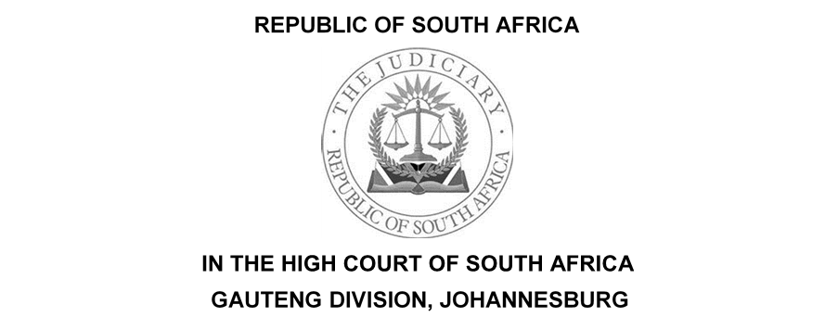

(1) REPORTABLE: NO
(2) OF INTEREST TO OTHER JUDGES: NO
(3) REVISED.

…………………….. ………………………...
DATE SIGNATURE

Case no.: 37332/18
In the matter between:

DEVELOPMENT BANK OF SA  And  FUSION GUARANTEE (PTY) LTD  REITY TRADING ENTERPRISE CC. | PLAINTIFF  1st DEFENDANT  2nd DEFENDANT

Coram: Dlamini J
Date of hearing:
Date of hearing: 16 August 2023

Date of delivery of judgment: 6 October 2023

The Judgment is deemed to have been delivered electronically by circulation to the parties’ representatives via email and the same shall be uploaded onto the caselines system.

JUDGMENT

DLAMINI J

[1] This a special plea application brought by the first defendant against the plaintiff's Particulars of Claim. The plaintiff, the Development Bank of SA (“DBSA”) issued summons against the defendants and claimed payment of the sum of R3 370 640.74. as against the first defendant (“Fusion”)based on the performance guarantee issued by the first defendant and a sum of R 12 237 633. 67 against the second defendant. The second defendant has not entered an appearance to defend.

BACKGROUND FACTS

[2] The facts underlying the dispute are largely common cause.

[3] On 18 July 2014, the plaintiff awarded a Contract to a joint venture between the second defendant and an entity called Phumi HD Construction CC (‘the Contractor’) for the demolition and additions of the new administration block, dining and nutrition center, computer room and related works to the New Waban Senior Secondary School, Libode, Eastern Cape.

[4] In terms of the aforesaid contract, the Contractor was required to procure and obtain a performance guarantee on behalf of the Contractor in favor of the plaintiff. The contract consisted of the following;
4.1 The Agreement and Contract Data and the Special Conditions of Contract.
4.2 The General Conditions of Contract, the JBCC Series 2000 Principal Building Agreement ( Edition 4.1 of March 2005) ( the JBCC).

[5] According to the plaintiff, the Contractor provided a fixed guarantee in terms of clause 14 of the Contract, issued by Fusion as security for the due fulfillment of the Contract.

[6] It is apparent that the Contractor struggled with the timely completion of the scope of the Works. As a result, the plaintiff extended the completion of the works to 6 August 2015. As a result of the Contractor's failure to meet the revised practical completion date of 6 August 20215, the plaintiff on 10 October 2015 canceled the Contract.

[7] After the cancellation of the Contract, DBSA issued a new tender and appointed a new service provider who completed the project.

[8] According to the plaintiff on the date of cancellation of the Contract, DBSA avers that it had already paid the Contractor an amount of R 15 079 071.00 in the form of interim payments. The balance of the value of the contract was R18 827 336.47. DBSA had withheld an amount of R 762 852 90, as retention in terms of the Contract. The contract value of the replacement contract to complete the Works was R 31 627 823.04. The plaintiff says it thus suffered damages of R 12 237 633.67 being the difference between the replacement contract value of R 31 627 823 .04 and the total available amount of R19 390 189.37
[9] Having filed a notice to defend and a plea, Fusion also filed a special plea of prescription, alleging that the plaintiff's claim has been prescribed in terms of section 11 (d) of the Prescription Act ("The Act").

[10] This is so insists Fusion, because the plaintiffs purported in terms of clause 36 of the written construction contract to cancel the contract on or about 5 September 2015. The first defendant submitted that the plaintiff's summons were served on the first defendant on or about 11 October 2018 which is more than three years after the date on which the plaintiff alleges its claim arose against the first defendant. claim arose. Therefore the plaintiff's claim has prescribed.

ISSUE FOR DETERMINATION

[11] The issue for determination at this stage is a very narrow one, the question is when did the DBSA claim arose against Fusion. The issue is not whether DBSA has a valid claim or not against Fusion. That is, whether the plaintiff's particulars of claim disclose any cause of action or not against the first defendant. The determination of this aspect, I submit must be left and be adjudicated upon during trial. The numb of the issue between the parties at this stage concerns the date on which DBSA alleges its claim arose against Fusion. It is contended by Fusion that the only debt for which it could be liable arose at the least after the extended date of the practical completion on or before 7 August 2015, whilst the plaintiff insists that the claim arose on or after the date of cancellation that is 10 October 2015.

[12] It is important to point out that at this stage that we are only concerned with the interpretation of the terms of clause 11(d) of the Act.

[13] The case made by Fusion is that any potential relevant claim to be made against it must have arisen before the Contract was canceled. This is so submit Fusion because the effect of the cancellation of a contract is in general to terminate all the obligations between the parties. Second, is that Fusion bound itself only to make good the Contractor's contractual obligations vis-à-vis the employer. That cancellation completely extinguishes an obligation and has no existence after the termination of the contract.

THE GUARANTEE RELATIONSHIP

[14] It is argued on behalf of Fusion that in this case the Guarantee is conditional, that it is a suretyship that incorporates the principle of accessories and does not have the principle of independence as a feature. Thus only in case of a principal debt owing by the Contractor to the Employer being in existence that the Employer can rely on the Guarantee vis-à-vis the Guarantor.

CONDITIONAL NATURE OF LIABILITY

[15] According to Fusion, the Guarantee was only given for a very specific and very limited type of obligation by the Contractor owing to the Employer, namely a right of recovery against the contractor in terms of clause 33 of the JBCC. Thus insists Fusion that the Employer's claim against the Contractor is for damages flowing from the cancellation of the Contract and not from the Contractor's breach. Therefore the debt against it could thus not arise upon cancellation. Furthermore, Fusion could be liable for any debt by reference to clause 33 and that such debt has prescribed.

[16] Accordingly, Fusion submits that the plaintiff's claim has prescribed in terms of section 11 of the Act, since the summons was served on 11 October 2018, which, the defendant insists is more than three years after the date on which the DBSA’s claim against Fusion arose.

[17] In sum, DBSA contends that the first defendant has not challenged its allegation that its debt against Fusion and the second defendant arose on or after 10 October 2015, when DBSA canceled the contract. The plaintiff avers that Fusion challenges the merits of the DBSA's claim, not when the debt arose. DBSA submits that this issue is not a matter that this Court can adjudicate upon at the prescription stage. That at the prescription stage, it must be accepted as it should, that the DBSA's claim as pleaded is valid, the issue being when the debts arose and not if the debt is valid as against the defendants. I agree with the plaintiff’s submission in this regard.

[18] It is apposite at the stage to look at section 11 (d) of the Act. It stipulates as follows:
The periods of prescription of debts shall be the following:
(d) save where an Act of Parliament provides otherwise, thee years in respect of any other debt.

[19] The principle of interpretation of statutes is now well established and has been repeated in numerous judgments of our courts. A sensible meaning is to be preferred to one that leads to insensible or unbusinesslike results or undermines the apparent purpose of the document. This process, it should be emphasised entails a simultaneous consideration of having regard to the context, the document as a whole, and the circumstances attendant upon its coming into existence. See Natal Joint Municipal Pension Fund v Endumeni Municipality.

[20] A sensible and business interpretation of the Act means that any plaintiff who avers that it has a claim against any defendant must issue and serve summons within three years against that defendant. The Act is not concerned about the validity or otherwise of the plaintiff's claim. The plaintiff insists that its claim against Fusion arose on 10 October 2015 and that it issued served summons upon the first defendant on 11 October 2018.

[21] In my view, once Fusion has conceded as it has done in this case that DBSA cancelled the contract on 10 October 2015 and Fusion concedes that the summons was issued and served on them on 11 October 2018. The logical conclusion is that the summons were validly issued and served on Fusion within three years as prescribed by the Act. This therefore means that DBSA’s claim is valid and was issued and served within the statutory limits as required by the Act.

[22] In light of the foregoing, this must be the end of this inquiry. In any event, Fusion is entitled to pursue the rest of its complaints against the plaintiff's particulars of claim either through an exception or during trial. The Act is clear and unambiguous, it only requires the plaintiff to issue its claim within three years from the date within which the claim arose. The Act is not concerned about the validity or otherwise of the plaintiff's claim.

[23] In all the circumstances that I have mentioned above I am not satisfied that Fusion has discharged the onus that rested on its shoulders to prove that the plaintiff’s claim has prescribed.

ORDER

1. The defendant’s special plea application of prescription is dismissed with costs.

_______________________
DLAMINI J
JUDGE OF THE HIGH COURT OF SOUTH AFRICA
GAUTENG DIVISION, JOHANNESBURG

Date of hearing: 16 August 2023
Delivered: 6 October 2023

For the Plaintiffs: Adv L Segeels-Ncube
segeels@advocatesa.co.za
Instructed by: CLIFF DEKKER HOFMEYR INC
Krevania.Pillay@cdhlegal.com

For the first Defendant: Adv. P. Louw S.C
pflouw@law.co.za
gjkotze@counsel.co.za
Instructed by: COWAN-HARPER-MADIKIZELA ATTORNEYS
hkorsten@chmlegal.co.za

The Prescription Act, Act 68 of 1969.
[ 2012] ZASCA 13 ; 2012 (4) SA 593 (SCA).

