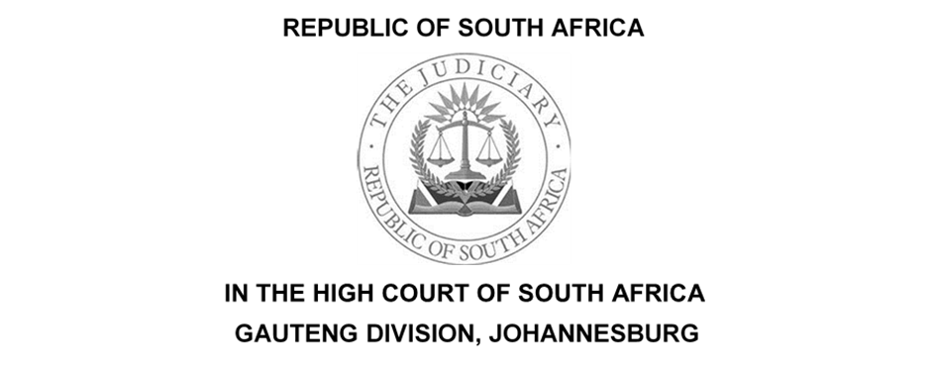

(1) REPORTABLE: NO
(2) OF INTEREST TO OTHER JUDGES: NO
(3) REVISED.

…………………….. ………………………...
DATE SIGNATURE

CASE NO:22/20741
In the matter between:

AVIATION CO-ORDINATION SERVICES (PTY) LIMITED  AIRLINES ASSOCIATION OF SOUTHERN AFRICA  BOARD OF AIRLINE REPRESENTATIVES OF SOUTH AFRICA | Applicant  2nd Applicant  3rd Applicant
And
AIRPORTS COMPANY SOUTH AFRICA SOC LIMITED  MINISTER OF TRANSPORT  MINISTER OF FINANCE  SOUTH AFRICAN CIVIL AVIATION AUTHORITY  AIR BOTSWANA (PTY) LTD  AIR FRANCE –KLM  AIR PEACE  AIR SEYCHELLESLTD  AIR ZIMBABWE (PRIVATE) LIMITED  BRITISH AIRWAYS PLC  CEMAIR LIMITED  CONGO AIRWAYS S.A  COMAIR LIMITED T/A BRITISH AIRWAYS AND KULULA  CONDOR FLUGDIENST  EDELWEISS AIR AG  EGYPT AIR  EMIRATES  ETHIOPIAN AIRLINES GROUP T/A  ETHIOPIAN AIRLINES  ETIHAD AIRWAYS  FLYSAFAIR  GLOBAL AVIATION OPERATIONS (PTY) LTD T/A  GLOBAL AIRWAYS AND LIFT  KENYA AIRWAYS PLT  LINHAS AREAS DE MOCABIQUE SAR T/A  LQM  LUFTHANSA AIRPLUS SERVICEKARTEN GMBH T/A LUFTHANSA  PRECISION AIR SERVICES LIMITED T/A PROFLIGHT ZAMBIA  QANTAS  QATAR AIRWAYS GROUP T/A QATAR AIRWAYS  SWISS INTERNATIONAL AIR LINES AG T/A SWISS  TAAG ANGOLA AIR LINES E.P T/A TAAG  TURKISH AIRLINES  UNITED AIRLINES INC | 1st Respondent  2nd Respondent  3rd Respondent  4th Respondent  5th Respondent  6th Respondent  7th Respondent  8th Respondent  9th Respondent  10th Respondent  11th Respondent  12th Respondent  13th Respondent  14th Respondent  15th Respondent  16th Respondent  17th Respondent  18th Respondent  19th Respondent  20th Respondent  21st Respondent  22nd Respondent  23rd Respondent  24th Respondent  25th Respondent  26th Respondent  27th Respondent  28th Respondent  29th Respondent  30th Respondent  31st Respondent

Coram: Dlamini J

Date of Request for Reasons: 22 May 2023

Date of delivery for Reasons: 10 July 2023

JUDGMENT

DLAMINI J

[1] On 23 May 2023, I made a draft order marked “X” an order of this Court. Below are my reasons for that order.

[2] This is an application in terms of Rule 30A of the Uniform Rules of Court.

[3] The common cause facts are as follows, on 14 June 2022 the applicants launched a review application in terms of Rule 53 of the Uniform Rules of Court seeking the following relief;-

3.1 Declaring that the decision of the first respondent, communicated by the first respondent to the first applicant by a letter on or about 17 December 2022, refusing to agree to the first applicant's planned replacement of aging Hold Baggage Screening ("HBS") equipment (“the refusal decision”) is unlawful, reviewed and set aside.

3.2 If applicable, declaring that the decision of the first respondent to procure HBS equipment itself and conduct a competitive process for the appointment of a third party to conduct HBS services at the first respondent's airports ("the termination decision") is unlawful, reviewed, and set aside.

[4] On 21 July 2022, the first respondent filed the record. Not satisfied with the filed record, the applicants launched this application in terms of Rule 30A compelling the first respondent to file a complete record.

[5] The main bone of contentions relates to the contents, status, and interpretation of the first respondent’s letter dated 17 December 2021, written by the first respondent’s attorneys to the first applicant’s attorneys.

[6] It is contended by the first applicant that the 17 December 2021 letter constitutes the refusal decision. The first applicant avers that the termination insourcing decision and the termination decision are for all intent purposes similar. In that with the insourcing decision, the first respondent has determined to insource the provision of HBS and with the termination decision it has determined that ACSA is responsible for the provision of HBS services and a result cannot allow ACS to continue providing HBS services, unless the first respondent has appointed ACS through a procurement process that is conducted in terms of section 217 of the Constitution to provide HBS services on ACSA’s airports.

[7] In the results, the first applicant insist that they are entitled to all the documents that relate to both the refusal and termination decisions.

[8] In its reply, the first respondent denies that the 17 December 2021 letter constituted a refusal decision by ACSA. The first respondent contends that it has not taken any decision cable of judicial review concerning the management and operation of HBS at its airport. The first respondent insists that the applicants are aware that no termination decision exists, in that no termination notice was given to the applicants from rendering the service of HBS. Further, that after the letter dated 17 December 2023 to date, the applicants continue to operate the HBS services at all ACSA airports.

[9] In my view, ACSA's submission that the letter of 17 December 2021 was simply a reply to the first applicant demand that ACSA should confirm or support the first applicant's application to SACAA for the replacement of the HBS system at ACSA's airport has merit.

[10] The submission by the first applicant that ACSA has taken what the first applicant refer to as the termination decision is concerned is meritless and must be dismissed. This is so because as at the launch, up to the hearing of this application, the first applicant continue to provide HBS services at all ACSA's airports. It was only during the hearing of this application that Counsel for the first respondent advised this Court that the ACSA’s Board had on 18 May 2023 taken a decision that related to the provision of HBS services at its airports. In part the resolution reads as follows; “1, The insourcing of Hold Bagge Screening Service be and is hereby approved subject to approval by the Minister in accordance with section 54(e) of the Public Finance Management Act, as amended”.

[11] On a businesslike and sensible interpretation, it is clear that it is only the above-mentioned ACSA’s Board decision of 18 May 2023, that has the effect of a ‘refusal’ and ‘terminating’ of the first applicant’s provision of the HBS services at ACSA’s airports and not the 17 December 2021 letter.

[12] It should therefore follow that this Court cannot grant an order compelling ACSA to produce records of a non-existent decision.

[13] In all the circumstances alluded to above, the first applicant have failed to discharge the onus that rested on their shoulders to justify the order that they seek.

ORDER

1. The draft order marked “X” that I signed on 22 May 2023 is made an Order of this Court.

_______________________
DLAMINI J

JUDGE OF THE HIGH COURT OF SOUTH AFRICA

GAUTENG DIVISION, JOHANNESBURG

Date of Request for Reasons: 22 May 2023
Date Delivered: 10 July 2023

For the Applicants: FA Snyckers SC (Mr)
Email: snyckers@group621.co.za
N Luthuli (Mr)
luthuli@group621.co.za

Instructed by: Webber Wentzel
Haydn Davies (Mr) et al
haydn.davies@webberwentzel.com

For the Respondents: Adv. IV Maleka SC

Email: ivmaleka@mweb.co.za

Adv. NB Kekana
nisisa@thulamelachambers.co.za

Instructed by: Mashiane Moodley & Monama Inc.
David Tumi Maphakela (Mr) et al
dmaphakela@m4attorneys.co.za

