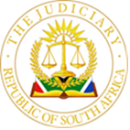

**IN THE HIGH COURT OF SOUTH AFRICA**

**GAUTENG DIVISION, PRETORIA**

**Case No:** 13204/2022

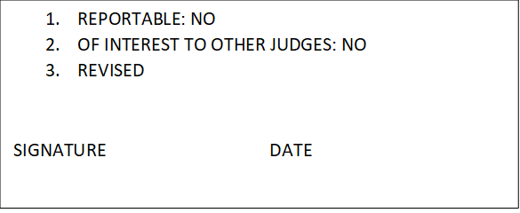

In the matter between:

**ADVOCATE SENZO WISEMAN MKHIZE** Applicant

and

**SOUTH AFRCAN LEGAL PRACTICE COUNCIL** Respondent

**___________________________________________________________________**

**JUDGMENT ON URGENCY**

**COWEN J**

**INTRODUCTION**

1. The applicant Mr Mkhize has approached this Court on an urgent basis for a range of relief, which appears fully from the notice of motion. The notice of motion is dated 10 November 2022 and the application is stamped 14 November 2022. The application was set down for 22 November 2022 and the respondent, the Legal Practice Council (LPC), afforded until 18 November 2022 to deliver answering affidavits. At its centre is a contention that the LPC has violated an order of this Court (per Thlapi and Neukircher JJ) dated 25 October 2022. In that order, this Court directed the LPC to deliver the Rule 53 Record in a decision under review within 10 days.

2. The review is a review of a decision of a Mr Jaco Fourie on or about 7 December 2020 to recommend the suspension or removal of the applicant from the roll of practitioners. Mr Fourie is the Senior Legal Officer of the LPC’s Disciplinary Department, Gauteng. There are other proceedings ensuing but for present purposes it is relevant that there is a pending application instituted by the LPC to suspend the applicant which is to be heard on 23 January 2022.

3. The matter came before me on the urgent roll on 22 November 2022. By that stage, the parties had filed affidavits. On that day, I heard Mr Mkhize and counsel for the LPC, Mr Hlalethoa on urgency. Mr Mkhize is facing proceedings that, whatever their outcome, have a profound impact in his life, reputation and livelihood and the importance of his rights are factors that I have kept in mind in assessing whether to hear the matter urgently. However, I am not persuaded that the application should be heard urgently. My main reasons, briefly, are as follows.

4. First, as Mr Mkhize emphasised during the hearing, the primary relief that he is seeking at this stage is a rule nisi through which he seeks to hold the LPC in contempt of this Court for failing to comply with the order of 25 July 2022. In this regard, Mr Mkhize emphasised that, in respect of relief sought for contempt of court, he only seeks a rule nisi at this stage so that the contempt proceedings can unfold in the ordinary course. But this submission itself defeats the argument on urgency in that regard.

5. Secondly, Mr Mkhize relies for relief he seeks on an imminent hearing date for the review application set down for 8 December 2022 on the unopposed roll. However, it is clear from the order of 25 October 2022 that this application cannot proceed on the unopposed roll and is to proceed together with the LPCs application on 23 January 2022. This is stated in terms in paragraph 3 of the order.

6. Third, it is common cause that the LPC did supply a Rule 53 record on 8 November 2022. This was received by the applicant. It was sent by e-mail pursuant to an agreement between the parties – as Mr Mkhize explained in argument. Mr Mkhize, however, seeks a transcription of proceedings before Mr Jaco Fourie, whereas the LPC maintains that there is none, and that the record as supplied is the complete Rule 53 record. There is nothing before me to gainsay this. But in the circumstances of this case, to the extent that the applicant wishes to prosecute the review on the basis that the LPC has failed to supply a complete Rule 53 record, he has various procedural and substantive remedies available to afford him substantial redress. These flow both from the rules and procedures of court – which enable a party, *inter alia,* to apply for the production of a complete record, to obtain extensions of time, and, if need be a postponement – and through the laws of evidence, specifically the manner in which Courts can draw appropriate inferences from conduct of the alleged sort.

7. In the result the application is struck from the urgent roll.

**___________________________________**

**S COWEN**

**JUDGE OF THE HIGH COURT PRETORIA**

*Delivered: This judgment was prepared and authored by the Judge whose name is reflected and is handed down electronically by circulation to the Parties/their legal representatives by email and by uploading it to the electronic file of this matter on CaseLines. The date for hand-down is deemed to be 23 November 2022.*

**HEARD ON 22 NOVEMBER 2022**

**JUDGMENT DELIVERED ON 23 NOVEMBER 2022.**

**APPEARANCES**

**The Applicant appeared personally**

**On behalf of the Respondents: Mr Hlalethoa**

**Instructed by: Mphokane Attorneys**