Editorial note: Certain information has been redacted from this judgment in compliance with the law.

REPUBLIC OF SOUTH AFRICA

IN THE HIGH COURT OF SOUTH AFRICA
GAUTENG DIVISION, PRETORIA
CASE NO: A297/2022 DPP REF. NO: SA 55/2022
(1) REPORTABLE: NO
(2) OF INTEREST TO OTHER JUDGES: NO
(3) REVISED: YES
SIGNATURE: PD. PHAHLANE
DATE: 28-09-2023

In the matter between:
NDUMISO SIBUSISO MBONANI APPELLANT

And
THE STATE RESPONDENT

JUDGMENT

PHAHLANE, J
[1] The appellant who was legally represented, was convicted for rape in terms of section 3 of the Criminal Law (Sexual Offences and Related Matters) Amendment Act 32 of 2007, read with the provisions of section 51(1) of the Criminal Law Amendment Act 105 of 1997 (“the Act”), and sentenced to life imprisonment by the regional court, Benoni, on 24 January 2022.

[2] Section 51 (1) of the Act provides that a person, who has been convicted of an offence referred to in Part I of Schedule 2, shall be sentenced to imprisonment for life, unless there exist substantial and compelling circumstances justifying a lesser sentence. Part I of Schedule 2 contains inter alia rape as contemplated in s 3 of Act 32 of 2007, where the victim is a person under the age of 16 years.

[3] The trial court ordered that the appellant’s particulars be included in the National Register of Sexual Offenders.

[4] It is worth mentioning that the appellant who was 21 years old at the time of the incident, was referred to Weskoppies hospital for observation in terms of section 77; 78 and 79 of the Criminal Procedure Act 51 of 1977, to ascertain whether he was fit to stand trial. He was diagnosed with mild intellectual disability, and the findings of the psychiatric doctor who conducted an evaluation was that at the time of the offence, the appellant did not suffer from any mental disorder or defect which could have affected his ability to act in accordance with the appreciation of his action. The doctor further noted in the psychiatric report that the appellant would be able to contribute meaningfully to his defence.

[5] The grounds of appeal as noted in the notice of appeal in respect of conviction are that the court erred in concluding that the State proved its case against the appellant beyond a reasonable doubt, thereby rejecting his version of a bare denial as being reasonably possibly true, and not properly applying the cautionary rule to the evidence of a single
child witness in a rape matter. The ground of appeal in respect of sentence is that the term of life imprisonment is shockingly inappropriate and disproportionate to the offence for which it was imposed.

[6] As a court of appeal, this court will firstly evaluate the evidence of the State as far as the credibility thereof is concerned, with specific reference to the evidence and legal requirements of a complainant in sexual matters. The evidence of the Appellant is then considered, taking specific cognisance of the fact that he is not burdened with any onus. The factual findings and legal principles will then be considered to ascertain whether the Appellant was correctly convicted.

[7] It is trite law that a court of appeal will not interfere with the trial court’s decision, unless it finds that the trial court misdirected itself as regards to its factual findings or the law. To succeed on appeal, the appellant needs to convince this court on adequate grounds that the trial court misdirected itself. There are well-established principles governing the hearing of appeals against findings of fact. In the absence of demonstrable and material misdirection by the trial court, its findings of fact are presumed to be correct and will only be disregarded if the recorded evidence shows them to be clearly wrong¹.

[8] The conviction of the appellant arose from the events which occurred around the period of October to November 2018 at or near 135 Godumo Street in Emakhupeni in the Regional Division of Gauteng, in that the appellant did unlawfully and intentionally commit an act of sexual penetration with Z S, an 8-year-old female person by inserting his penis inside her vagina and anus without her consent.

¹ S v Hadebe and Others 1997 (2) SACR 641 (SCA) at 645e-f. See also: S v Monyane and Others 2008 (1) SACR 543 (SCA) at para 15; S v Francis 1991 (1) SACR 198 (A) at 204e.

8.1 It is common cause that the appellant and the complainant are relatives. On the day of the incident, the complainant was in the company of the appellant and his sister Minenhle, eating in the appellant’s room. The appellant’s sister indicated that she was leaving, and the complainant accompanied her up to the gate of the premises. Upon reaching the gate, the appellant whistled and signaled the victim to approach him and she did.
8.2 The appellant called her to the garage which is in the premises where he instructed and forced her to undress. She complied and the appellant ordered her to bend over forward, then unzipped his trouser and penetrated her private part from behind, thereby raping her.
8.3 When he was done, he unlocked the door, and the complainant left the garage and went to where Minenhle was sitting with her friends, but did not make any report at the time. She later reported the incident to her friends, who were referred to by the court as “C and D”, who then spread the news, and the appellant was eventually arrested.
8.3 The complainant testified that she did not scream for help at the time of the incident because she was afraid that the appellant might hit her.
8.4 Two other witnesses testified that the complainant confirmed the report of the incident to them after they approached her after seeing her crying while she was in the company of her friends.
8.5 The complainant was taken to Daveyton clinic where she was examined on 23 November 2018 by a professional nurse, Ms. Mbatha who testified and confirmed that the complainant had previously been penetrated beyond the labia majora. The gynecological examination on the complainant revealed that the fossa navicularis had scars; the hymen was irregular and the hymenal rim was thinning; and there was another scar surrounding the skin around the anal orifice.
[9] While it was conceded that identity of the perpetrator is not in dispute, it was however argued on behalf of the appellant that the trial court should have accepted his bare denial as being reasonably possibly true. The respondent on the other hand submitted,
and correctly so, that the appeal against conviction is void of merits and that the trial court did not misdirect itself because it had properly evaluated the evidence before it to come to a just decision.

[10] In convicting the appellant, the trial court found that the description of the appellant could not have been mistaken because the complainant and the appellant are related, and that there was no incident that could have led the complainant to falsely implicate the appellant.

[11] With regards to the evidence of a single witness, the trial court applied the cautionary rule and held that the evidence of the complainant was satisfactory in every material respect and found no contradictions and improbabilities in the complainant’s evidence. It also considered the totality of the evidence while being mindful of the fact that firstly, the State was vested with the burden of proving the guilt of the appellant beyond a reasonable doubt, while simultaneously bearing in mind that if the version of the appellant is reasonably possibly true, he is entitled to an acquittal.

[12] The question whether the trial court was correct in finding that the State proved its case against the appellant requires the evidence of the State to be measured against the evidence of the appellant. It was therefore imperative that in determining whether the appellant’s version was reasonably possibly true, and whether his guilt was proven beyond a reasonable doubt, that the court should consider the totality of the evidence before it, in order to come to a just decision.

[13] On the conspectus of the evidence as it appears on record, I am of the view that the trial court properly evaluated the facts before it and correctly followed the above principles as it had correctly pointed out that it had to consider the totality of the evidence before it, and not to follow a piecemeal approach in order to come to a correct and just decision.

[14] Having read the transcript and having given proper and due consideration to all the circumstances of this case, I am unable to find any fault with the assessment of the evidence of the witnesses by the trial court, which had the advantage of seeing them testify and observing their reactions to questions during cross-examination. This gave the trial court an advantage which this court as a court of appeal did not have. In the absence of any misdirection by the trial court, I have no reason to interfere with the finding of the trial court. Accordingly, I agree with the finding of the trial court, and I am of the view that the trial court did not misdirect itself in convicting the appellant.

[15] With regards to the alleged misdirection by the trial court in respect of sentence, this court must also determine whether the sentence imposed on the appellant was justified. Having said that, it should be noted that the appeal court does not enjoy carte blanche to interfere with the sentence which has been properly imposed by a sentencing court. This salutary principle implies that the appeal court will only interfere with the sentence if the reasoning of the trial court was vitiated by misdirection, or the sentence imposed induces a sense of shock, or can be said to be startling inappropriate.
[16] It is on record that the appellant was warned of the provisions of section 51(1) of the Act. In this regard, he has been sentenced for an offence which attracts the imposition of life imprisonment. To avoid this sentence, the appellant had to satisfy the trial court that substantial and compelling circumstances existed which justified a deviation from the imposition of the prescribed minimum sentence.

[17] The trial court did not find such circumstances because no evidence was placed before it justifying the imposition of a lesser sentence in respect of the rape of the minor complainant who was 8 years old at the time of the commission of the offence. The trial court considered all the personal circumstances of the appellant when it imposed sentence.

[18] Having done that, the trial court was mindful of the triad’ factors pertaining to sentences as enunciated in S v Zinn and the warning given in S v Malgas that the court should not deviate from imposing the prescribed sentences for flimsy reasons. With that in mind, it is important to heed to the purpose for which legislature was enacted when it prescribed sentences for specific offences which falls under section 51(1) for which the appellant has been convicted and sentenced for.

[19] In light of the circumstances of this case, and in applying the above principles, the submissions made on behalf of the appellant that the sentence imposed by the trial court is shockingly inappropriate and disproportionate to the offence for which it was imposed, cannot be accepted.

[20] Having given proper and due consideration to all the circumstances, this court cannot fault the decision of the sentencing court, nor can it be said that the sentence imposed was shocking or unjust. I cannot find any misdirection in the trial court’s finding that there are no substantial and compelling circumstances justifying a deviation from the prescribed minimum sentence. Consequently, I am of the view that the trial court did not misdirect itself in imposing the prescribed sentence of life imprisonment, bearing in mind that the legislature has ordained life imprisonment as the sentence that should ordinarily and in the absence of weighty justification, be imposed for the offence committed by the appellant.

[21] In the circumstances, the following order is made:
1. The appeal against conviction and sentence is dismissed.

_________________________
PD. PHAHLANE JUDGE OF THE HIGH COURT

I agree,

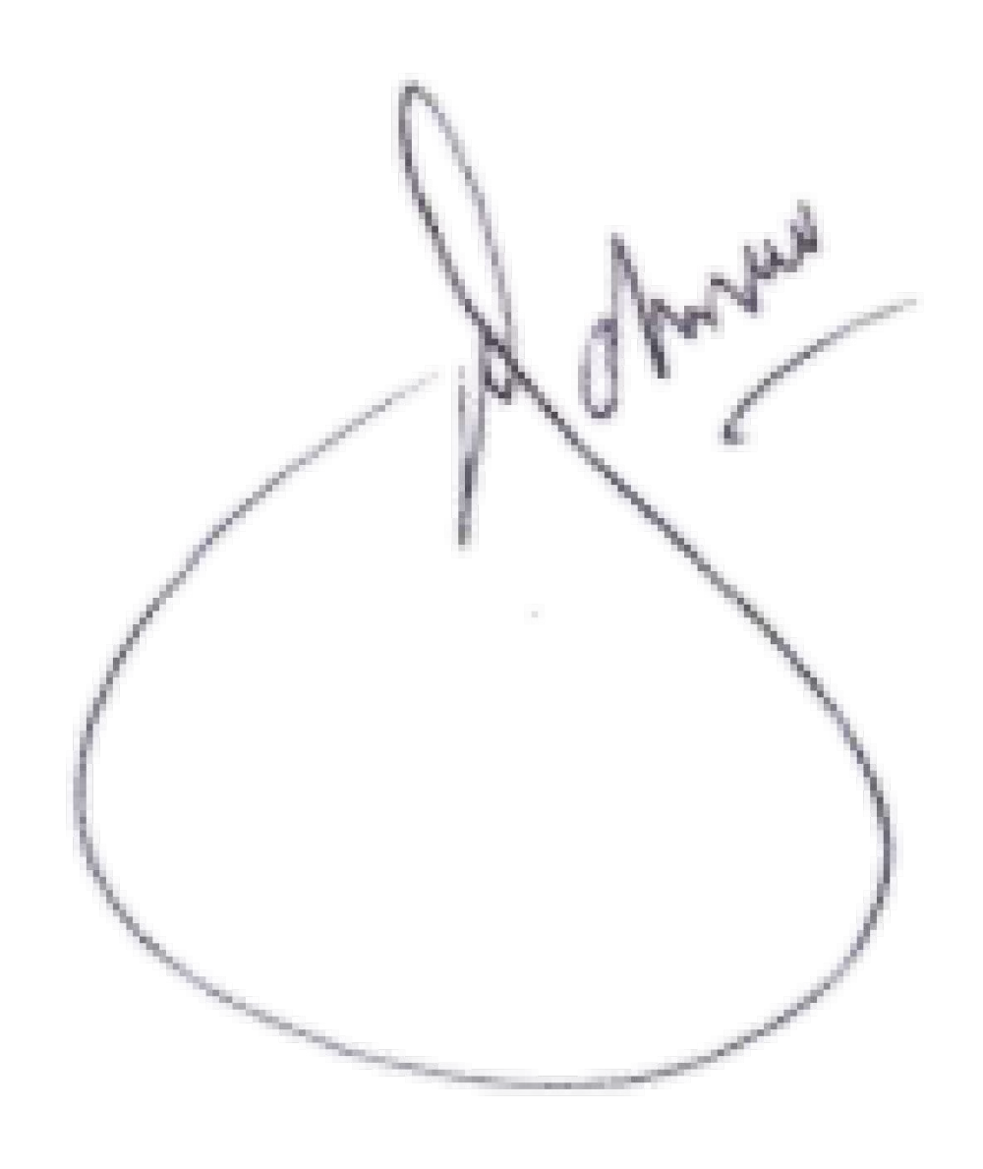
P.J. JOHNSON
____________________________

ACTING JUDGE OF THE HIGH COURT

APPEARANCES
Counsel for the Appellant : Adv B Kgagara
Instructed by : Legal Aid South Africa
Counsel for the Respondent : Adv. Germishuis
Instructed by : Director of Public Prosecutions, Pretoria
Heard on : 22 August 2023
Date of Judgment : 28 September 2023

Section 208 of the Criminal Procedure Act 51of 1977 states clearly that “an accused person may be convicted of any offence on the single evidence of any competent witness”.
See: S v Trainor 2003 (1) SACR 35 (SCA) at 9; S v Chabalala 2003 (1) SACR 134 (SCA); S v Van der Meyden 1999 (1) SACR 447 (W); also: S v Van Aswegen 2001 (2) SACR 97 (CSA) at para 8; S v Shilakwe [2011] ZASCA 104;2012 (1) SACR 16 (SCA) para 11
S v Engelbrecht 2011 (2) SACR 540 (SCA) at para 18.
Mokela v The State 2012 (1) SACR 431 (SCA) at para 9.
1969 (2) SA 537 (A)
2001 (1) SACR 469 (SCA).

