Editorial note: Certain information has been redacted from this judgment in compliance with the law.

REPUBLIC OF SOUTH AFRICA

IN THE HIGH COURT OF SOUTH AFRICA

GAUTENG DIVISION, PRETORIA

CASE NO: 56048/15

- REPORTABLE: NO
- OF INTEREST TO OTHER JUDGES: NO
- REVISED.

18 April 2023 ………………………...
DATE SIGNATURE

In the matter between:
VAN DER MERWE, ADV J as Curator ad Litem for and on behalf of:

Zizipho Ntame PLAINTIFF

and

ROAD ACCIDENT FUND DEFENDANT

JUDGMENT

PIENAAR AJ

INTRODUCTION:

[1] The Plaintiff is the duly appointed Curator ad Litem for Zizipho Ntame
(“the patient”). She claims delictual damages and or behalf of the patient
from the defendant in terms of the provisions of the Road Accident Fund Act
number 56 of 1996, as amended (“the Act”). The damages arise as a result
of personal injuries sustained by the patient in a motor vehicle collision which
occurred on the 1 March 2012 on the R58 near Necobo, Elliot an accident
occurred.

[2] On 10 August 2022 Mrs Tammy-Jean van Jaarsveld was appointed as
Curatrix Bonis for and on behalf of Zizipho Ntame.

[3] The patient, whose date of birth is the […] September […] was 19 years
old at the time of the accident, she sustained a severe traumatic brain
injury with diffuse and focal damage and very marked percent
neuropsychological and cognitive impairments and fallouts and personality
changes; a distal radius and ulna fracture left, facial injuries, neck injury,
depression and anxiety, multiple permanent scars; bruising and contusion.
She is currently 30 years old.

[4] On 19 March 2018 an order was made in favour of the Plaintiff in respect of
100% liability for merits.

[5] On 23 November 2021 an order was made in favour of the Plaintiff in respect
of 100% liability for merits, R1 500 000,00 in respect of General Damages
and future medical expenses with an unlimited undertaking in terms of the
provisions of Section 17(4)(a) of the Road Accident Fund Act, Act 56 of
1996. This means the only issue which remains unresolved which I am
required to adjudicate are that of the quantum of the Plaintiff’s past and
future loss of earnings/loss of income earning capacity/loss of employability.

[6] The defendant entered an appearance to defend and filed a plea, but at
some stage the attorneys of record for the defendant withdrew and no
attorneys were appointed. On 10 February 2022 the defendant’s defence
was struck out. It is on that basis that the plaintiff proceed with an
application for default judgment.

[7] The Plaintiff did not present any viva voce evidence, but relied on numerous
affidavits, accompanied by reports, compiled by expert witnesses.

[8] The Plaintiff amended the Particulars of Claim for past and future loss of
earnings and/or earning capacity as follows:

8.1 Past loss of earnings/earning capacity R1 000 000,00
8.2 Future loss of earnings/earning capacity R8 000 000,00

[9] For sake of completeness the following documents is uploaded onto
Caselines as exhibits for the trial, namely:

9.1 Plaintiff’s quantum bundles as Exhibit A pg 1 -115 Caselines 012(a)
9.2 Plaintiff’s hospital record bundles Exhibit B pg 1-149 Caselines 012 (b)
9.3 Plaintiff’s expert reports bundles Exhibit C pg 1 -655 Caselines 014
9.4 Plaintiff’s experts’ affidavits Exhibit D pg 1 - Caselines 015 (a)
9.5 Plaintiff’s Affidavit for trial Exhibit E pg 1 - Caselines 015 (b)
9.6 Plaintiff’s amended actuary report for trial Exhibit F

[10] At the commence of the trial, the Plaintiff Counsel made submissions that
past medical expenses must be postponed sine die.

THE FACTS:

[11] After the accident on the 01 May 2012 she was taken to All Saints Hospital
from where she was transferred the following day to Queenstown hospital
after a back slab was put on the left arm. On arrival her GCS was 10/15
(03/05/12) this was two days later. She was in ICU for another 2 weeks.
Ntame had difficulty to walk. She was very confused and she laughed at
everything. She was transferred to Life Rehab Centre in East London on
16 May 2012 with the final diagnose of diffuse axonal head injury and left
forearm fracture.

[12] She is emotionally unstable due to her injury/her mood is often changing
and shifting and she appears to have episodes of confusion and
disorientation.

[13] She complains of daily headaches, some of the headaches are vascular
headaches (migraine). The pain is in her eyes. She does not
want to open her eyes at all. She has severe chronic pain including
headache, neck, arm and back pain. The neck and back pain suggestive
of a whiplash injury. Dr M Mazabow (neuropsychologist) concludes in his
report that Ms Ntame sustained a severe traumatic brain injury, comprising
diffuse and right frontal focal components.

[14] Dr JA Smuts (neurologist) is of the opinion that she sustained a severe
diffuse concussive head injury that influences both her memory and
personality.

[15] Ms Ntame was a Grade 12 learner at the time of the accident.
Reportedly she always obtained good academic results.

[16] According to the Natasha van der Heyde (Occupational Therapist), post-
accident the plaintiff is unemployable in the open labour market, because of
her functional difficulties, as well as her physical and psychological
presentation. Also her cognitive, emotional and behavioural profile would
preclude her from securing/maintaining gainful employment.

LOSS OF INCOME:

[17] Ms Möller (Educational Psychologist) opines that taking the background
and her intellectual ability into account, Ms Ntame was a girl with promising
learning potential. She had the intellectual potential to complete at least
Grade 12 (NQF4) followed by a three year diploma (if finances were made
available) enter the open labour market in her professional field of study.

[18] Dr Pretorius (Industrial Psychologist) accepts that, and the accident not
occurred, Ntame would have searched for financial support to further her
studies for one year. And postulates she would have entered the open
labour market in January 2017 with earnings in line with Paterson Level B3
(R179 049,00 p/a) reaching her earnings pinnacle around the age of 45
with earnings comparable to Paterson Level C4 (R619 749,00 pa/)
followed by inflation related growth until retirement at age 45.

[19] After the accident she did not return to school but managed to complete
Grade 12 the following year in 2013. She attempted to improve her marks
and obtain further education and remained unemployed since leaving
school until 2020 when she obtained contract work as a teacher’s assistant
and in January 2021 started self-employment as seller of handbags and
flasks, but was unsuccessful and stopped in September 2022. At present
she is 29 years old and unemployed and the experts concur that she is
rendered unemployable in the open labour market.

[20] She sustained a severe traumatic brain injury and is unable to perform
accordingly to her potential. The experts are in agreement that she
sustained and note in their reports a severe traumatic brain injury resulting
in profound cognitive and psychological impairments keeping her from
functional autonomy in the prime of her life.

[21] According to Dr Nel (psychiatrist) she met the criteria for severe traumatic
brain injury with chronic severe depressive illness and behavioral disorder
secondary to the accident with significant mood disorder, behaviour
disorder and cognitive deterioration.

[22] Due to the injuries sustained in the collision, the Plaintiff cannot even
manage and take care of her personal affairs as a situation resulting to the
appointment of a Curator ad Litem.

[23] The Plaintiff relied on the report, as confirmed via affidavit, of an Industrial
psychologist, Dr Pretorius and an actuarial report compiled by
Willem Boshoff from Munro Forensic Actuaries in support of the claim for
past and future loss of earnings.

[24] Therefore, on the basis of the calculations as per the report by Munro
Actuaries dated 23rd March 2023 including the RAF cap and after applying
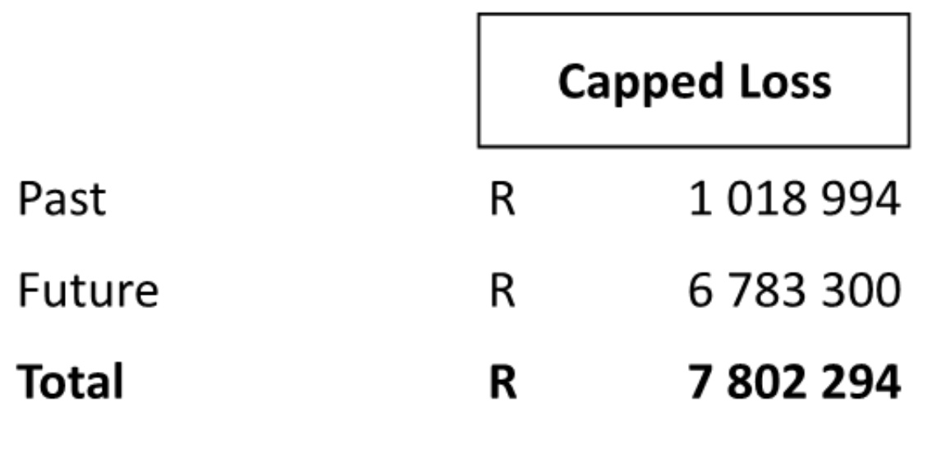
contingencies are as follows:

[22] This was submitted notwithstanding that the amended particulars of claim
refer to an amount of R1 000 000,00 for past loss of earnings/earning
capacity and no further amendments has been delivered or applied for to
amend the amount to an amount being proposed by Plaintiff’s Counsel.

CONTINGENCIES

[23] According to Munro actuary report, the Claimant is HIV positive. Koch
defines life expectancy as “the sum of the separate chances of survival
into each and every possible year and notes that it is assumed that
a person has a normal expectation of life unless there is evidence to the
contrary.

[24] Koch refers to the following as some of the guidelines a regards
contingencies:

* “Normal contingencies” as deductions of 5% for past and 15% for
future loss.

* Sliding scale: 1/2 % per year retirement age, i.e. 25% for a child, 20%
for a youth and 10% in the middle age and relies on Goodall v
President Insurance 1978 (1) SA 389.

[25] In his book The Quantum Yearbook, Koch states that when assessing
damages for loss of earnings or support it is usual for a deduction to be
made for general contingencies for which no explicit allowance has been
made in the actuarial calculation. The deduction is in the prerogative of the
Court. General contingencies cover a wide range of considerations which
may vary from case to case and may include: taxation, early death, loss
of employment, promotion prospect, divorce etc.

[26] See Van der Plaats v South African Mutual Fire and General
Insurance Co Ltd 1980 (3)SA 105 (A) at 114-5. The rate of the
discount cannot of course be assessed on any logical basis: the assessment
must be largely arbitrary and must depend upon the trial Judge’s
impression of the case.

[27] It is trite that the determination of a suitable contingency deduction falls
within the discretion of the Court. In Southern Insurance Association
Ltd v Bailey NO 1984 (1) SA 98 (AD) the advantage of applying
actuarial calculations to assist in this task was emphasized. It was stated
that:
“Any enquiry into damages for loss of earning capacity is of its nature
speculative, because it involves a prediction as to the future without the
benefit of crystal balls, soothsayers, augers or oracles. All that the court
can do is to make an estimate, which is often a very rough estimate, of the
present value of a loss. It has open to it, two possible approaches. One is
for the Judge to make a round estimate on an amount which seems to him
to be fair and reasonable. That is entirely a matter of guesswork, a blind
plunge into the unknown. The other is to try and make an assessment, by
way of mathematical calculations on the basis of assumptions resting on the
evidence. The validity of this approach depends of course upon the
soundness of the assumptions and these may vary from the strongly probable
to the speculative. It is manifest that either approach involves guesswork to
a greater or lesser extent. But the court cannot for this reason adopt a
non-possums attitude and make no award”.

[28] Ms Ntame is currently 29 years of age. Having regard to all the
uncertainties in the future, I am of the view that a 25% pre-morbid
contingency deduction will be fair and reasonable.

As a result the following order is made:

[29] The Defendant shall make payment in the sum of R7 783 300,00 (seven million seven hundred eighty three thousand three hundred rand and zero cents) as full and final settlement of loss of earnings/ earning capacity within 180 days from the date of this Court Order which is computed as follows:
29.1 Past loss of income R1 000 000,00
29.2 Future loss of income R6 783 300,00

At the hearing of the matter, I was presented with a draft order, which the Plaintiff’s attorney is directed to account to the curatrix bones Mrs Tammy van Jaarsveld who has already been appointed and it is ordered that the net award payable from the proceeds of this order to her is to be administered mutatis mutants in compliance with the orders previously made.

I therefore make the Draft Order attached herewith an Order of Court, which I have marked “X” signed and dated.

____________________
M PIENAAR
Acting Judge of the High Court
Gauteng Division, Pretoria

Date of hearing : 23 March 2023
Date of judgment : 18 April 2023
Counsel for the Applicants : Adv Ludvich Visser
court@slerouxprok.co.za
: Adv J van der Merwe
jana@gkchambers.co.za
Instructed by : Salomè Le Roux Attorneys
sleroux@law.co.za
Appearance for the Respondents: No appearance

[1] Court Order dated 16 May 2019 - Curatrix ad Litem appointed
[2] Court Order dated 10 August 2022
[3] Court Order dated 19 May 2018 - Merits
[4] Court Order dated 23 November 2021 - Merits ; Section 17(4)(a) and
General Damages
[5] Court Order dated 10 February 2022 - Defendant’s defence be struck out
[6] Caselines : 00 (c ) Trial of 23 March 2023 : Trial documents
Notice of Set down - 14 February 2023
[7] Goodall v President Insurance 1978 (1) SA 389
[8] Van der Plaats v South African Mutual Fire and General
Insurance Co Ltd 1980 (3)SA 105 (A) at 114-5
[9] Southern Insurance Association Ltd v Bailey NO 1984 (1) SA 98 (AD)

