Editorial note: Certain information has been redacted from this judgment in compliance with the law.

**REPUBLIC OF SOUTH AFRICA**



**THE HIGH COURT OF SOUTH AFRICA**

**GAUTENG DIVISION, PRETORIA**

|  |
| --- |
| **DELETE WHICHEVER IS NOT APPLICABLE:**   1. REPORTABLE: ~~YES~~/NO 2. OF INTEREST TO OTHER JUDGES ~~YES~~/NO 3. REVISED:   14 28 JUNE 2023  DATE SIGNATURE |

**CASE NR: 35055/2019**

In the matter between:

**ITUMELENG MODISE** Plaintiff

and

**ROAD ACCIDENT FUND** Defendant

JUDGMENT

BOKAKO, AJ:

**Introduction**

[1] The plaintiff seeks compensation for loss of earning due to bodily injuries sustained in a motor vehicle collision. On 16 June 2017, at R573 Moloto road (between Moloto RDP and Zakhene Bridge), a collision occurred between an unidentified motor vehicle driven by an unidentified driver and the insured vehicle (a Toyota Corolla motor vehicle, bearing registration letters and number W[…] […] GP) in which the plaintiff, then aged 41 years, was a passenger. The Toyota Corolla was driven at the time by Mr Simon Mnguni.

[2] The collision was caused by the sole negligence of the first insured driver. The plaintiff is a self-employed carpenter. At the time of the accident, he was doing carpentry in RDP houses under construction on a subcontract basis. He has been self-employed since 2002, before this, he worked for Grinaker doing rural maintenance and construction. After the incident, the plaintiff was off work for approximately a year.

[3] The plaintiff launched a claim against the Road Accident Fund in terms of section 17 of the Road Accident Fund Act 56 of 1996, (the Act), as a result of the injuries which are fully set out in the summons.

[4] The matter proceeds only in respect of quantum. The merits of the case were previously settled entirely in favour of the plaintiff.  The matter was enrolled for trial, and it came before me on 24 April 2023. Counsel appeared for the plaintiff and there was no appearance for RAF. Proof of service of the notice of set down directly on RAF has been filed. RAF appears to be represented by the State Attorney after parting ways with its earlier appointed attorneys. The matter was heard on a default judgment basis, due to the non-appearance of RAF at the trial. This judgment was reserved after the Court had listened to brief oral submissions by counsel for the plaintiff, who has also filed their written submissions.

[5] The plaintiff does not qualify as having suffered serious injuries and therefore does not claim general damages.

[6] The plaintiff demonstrated in his founding affidavit that the reasons for using an affidavit for evidence are that: firstly, the defendant has not demonstrated intention to cross examine experts in respect of loss of earnings. Secondly, the defendant is not participating in the proceedings. Lastly, the application of contingencies on the actuarial report is within the discretion of the court and it is cost effective to use the expert affidavit than giving evidence in person.

[7] I have no doubt that given the current status of the defendant, it would most likely be convenient and justifiable for the plaintiff to lead evidence by way of affidavit. I find that the plaintiff complied with the Rules of Court in so far as giving the defendant a reasonable notice of such an application under Rule 38. It is evident that the defendant did not participate in the legal process.

**Evidence and submissions on behalf of the plaintiff**

[8] Counsel for the plaintiff submitted that the issues for determination were about the plaintiff’s loss of earnings or earning capacity.

***Loss of earnings or earning capacity***

[9] The plaintiff filed reports of the following experts in support of his claim for loss of earnings: Dr Birrell (Orthopaedic Surgeon), Dr Ferreira -Teixeira (Clinical Neuropsychologist), A Greeff (Occupational Therapist), Dr KF Truter (Clinical Psychologist), E Noble (Industrial Psychologist) and G Whittaker (Actuary). The experts had, prior to the trial, deposed to affidavits in terms of which they confirmed their qualifications and the opinions or contents of their medico-legal reports which were filed on behalf of the Plaintiff. All expert reports were served and filed timeously.

*A Greeff (Occupational Therapist)*

[10] According to the occupational therapist, the plaintiff retained significant impairment in the functional use of his arms and neck. He will have to approach and execute tasks in an adjusted manner for the rest of his life and this will always have an impact on his ability as well as willingness to partake and enjoy chosen life amenities. From the collateral information obtained by the industrial psychologist it appeared that the plaintiff had a long-standing work relationship with all the employers that contracted him.

*Dr Ferreira -Teixeira (Clinical Neuropsychologist)*

[11] The neuropsychologist reported that the plaintiff’s emotive dysfunction has worsened over time. It is associated with severe depression and moderate anxiety caused by severe PTSD symptoms.

*E Noble (Industrial Psychologist)*

[12] The industrial psychologist did a full assessment of the plaintiff’s invoices and bank statements from which it appeared that the plaintiff earned grossly R12 618 per month. Further, the industrial psychologist, considering the orthopaedic surgeon’s opinion, recommended that the plaintiff’s earnings would probably have been less once the ankylosing spondylitis presented, and she recommended that two thirds of the above earnings may be used as a basis.

*Dr Birrell (Orthopaedic Surgeon*

[13] Following the orthopedic surgeon’s estimates the plaintiff’s loss of work capacity is between 5% and 6%. The Plaintiff will always be slower to perform tasks and will probably have to continue to rely on assistance to perform the strenuous demands of his employment.

*Dr KF Truter (Clinical Psychologist)*

[14] According to the clinical psychologist the plaintiff has attentional and memory problems attributed to the emotional distress after the accident and the effects of ongoing pain and discomfort. The plaintiff is considered more vulnerable as a result of his involvement in the accident. His depression and anxiety symptoms may result in him being less motivated and driven overall. This in turn may hamper his employment opportunities and render him vulnerable in any employment situation.

[15] The occupational therapist agrees with the clinical psychologist that the plaintiff’s neurocognitive deficits may render them more prone to making errors or negligent mistakes with related decrease in effectiveness in an occupational environment.

*G Whittaker (Actuary)*

[16] The actuary’s report set-out assumptions that the plaintiff sustained a complete loss of income for a justified period of six weeks and a partial loss of income for another 3 ½ weeks. Accepting that he would have been able to earn two thirds of his normal income during the latter period. Pre-morbidly his earnings on 1 May 2023 are taken as R105 994 with inflation-related increases until retirement at age 60 in scenario one and 65 in scenario two. Post-morbidly the plaintiff’s earnings on 1 May 2023 are taken as R70 663 with inflationary increases until the same retirement age as above. G Whittaker provided the following calculations:

* 1. Retirement age 60 both pre- and post-accident with a **5%** differential contingency: (15% pre-morbid contingency): R296 587
  2. Retirement age 60 both pre-and post-accident with a **10%** differential contingency: (15% pre-morbid contingency): R328 079
  3. Retirement age 60 both pre- and post-accident with a **5%** differential contingency: (20% pre-morbid contingency): R281 662
  4. Retirement age 60 both pre- and post-accident with a **10%** differential contingency: (20% pre-morbid contingency): R313 155
  5. Retirement age 65 both pre- and post-accident with a **5%** differential contingency: (15% pre-morbid contingency): R373 877
  6. Retirement age 65 both pre- and post-accident with a **10%** differential contingency: (15% pre-morbid contingency): R413 868
  7. Retirement age 65 both pre- and post-accident with a **5%** differential contingency: (20% pre-morbid contingency): R354 906
  8. Retirement age 65 both pre- and post-accident with a **10%** differential contingency: (20% pre-morbid contingency): R394 897

***Submissions on behalf of the Plaintiff***

[17] Counsel argued on behalf of the plaintiff that a fair and reasonable award would be arrived at when the average of the above eight scenarios are calculated, that being an amount of R384 387.00 (Three hundred and eighty-four thousand, three hundred and eighty-seven Rands).

[18] Regarding the application of contingency deductions, counsel made submissions with reference to *Southern Insurance Association v Bailey NO* 1984 (1) SA 98 (A) at 116 - 117, wherein Nicholas JA stated that:

“Where the method of actuarial calculations is adopted, it does not mean that the trial Judge is tied down by “inexorable actuarial calculations”. He has a “large discretion to award what he considers right’’.

Furthermore, counsel submitted that according to the learned author Koch “g*eneral contingencies cover a wide range of considerations which may vary from case to case and may include: taxation, early death, saved travel costs, loss of employment, promotion prospects, divorce, etc. There are no fixed rules as regards general contingencies*”*.*

**Conclusion**

[19] I note that the views expressed by the expert witness, especially the views expressed by Dr Birrell, the plaintiff did not lose more than 5% to 6% of his work capacity as a result of the accident under review. The plaintiff will not have to retire early as a result of the accident but will always be slower to perform tasks. Further, the plaintiff will probably have to continue to rely on assistance to perform the strenuous demands of his employment.

[20] It is further indicated and corroborated by the experts that the plaintiff is considered more vulnerable as a result of his involvement in the accident. His depression and anxiety symptoms may result in him being less motivated and driven overall. This, in turn, may hamper his employment opportunities and render him vulnerable in any employment situation. In *De Jongh v Du Pisani NO [2004) 2 all SA 565 (SCA)*, it was stated that a court should exercise discretion on the appropriateness of quantum to be awarded, and to do so with due regard to the previously decided cases of similar facts and law. As well as to fairness to the parties.

[21] In light of the above, I am of the view that the amount for loss of earnings and incapacity that is fair is R384 387 (Three hundred and eighty-four thousand, three hundred and eighty-seven Rands).

[22] Therefore, I will award to the plaintiff the total amount of R384 387 (Three hundred and eighty-four thousand, three hundred and eighty-seven Rands) in respect of loss of earnings or earning capacity. Costs will follow this outcome as fully set out below.

**Order**

[23] In the premises, I make the order that:

1. The defendant is ordered to pay 100% of the plaintiff’s proven or agreed damages.

2. The defendant shall pay to the plaintiff the sum of R384 387 (Three hundred and eighty-four thousand, three hundred and eighty-seven Rands) in respect of the plaintiff’s loss of earnings or earning capacity.

3. The aforesaid total sum of R384 387 (Three hundred and eighty-four thousand, three hundred and eighty-seven Rands) shall be payable by direct transfer into the trust account of Adams & Adams attorneys, the details of which are as follows:

**Account holder: Adams & Adams Trust Account**

**Bank: Nedbank**

**Account number: […]**

**Branch code: 198765**

**Branch: Pretoria**

**Reference : DBS/MQD/P4108**

4. The defendant will be afforded a period of 180 calendar days from the date of the court order to effect payment of the capital amount herein. During which period the plaintiff will not be entitled to execute a writ against the defendant. The plaintiff shall be entitled to recover interest at the rate of 10.75% per annum on the aforesaid amount calculated from 180 calendar days after the date of the order to the date of final payment.

5. The defendant shall furnish the Plaintiff with an undertaking in terms of section 17(4)(a) of the Road Accident Fund Act 56 of 1996, to compensate the plaintiff for 100% of the costs of the future accommodation of the plaintiff in a hospital or nursing home. The defendant shall compensate the plaintiff for 100% of the costs for treatment of or rendering of any services or supplying of any goods to the plaintiff which resulted from the injuries sustained by him as a result of the accident that occurred on 16 June 2017.

6. The defendant shall, over and above any previous cost orders granted in favor of the plaintiff, also make payment of the plaintiff’s taxed or agreed party and party costs for the action on the High Court scale, which costs shall include, but not be limited to the following, subject to the discretion of the Taxing Master.

7. The fees of Senior and Junior Counsel on the High Court scale, inclusive of, but not limited to Counsel’s full day fee for 24 April 2023, her preparation fees and the costs of preparing heads of argument.

8. The reasonable, taxable costs of obtaining all expert, medico legal, RAF4 Serious Injury Assessment, actuarial and addendum reports from the plaintiff’s experts which were either furnished to the defendant and/or included in the trial bundles and/or uploaded onto Case Lines.

9. The reasonable taxable costs associated with preparing the Application in terms of Rule 38 and obtaining of the affidavits of the relevant experts used in support thereof attached thereto, as well as the experts’ charges pertaining to their time and attendances spent in, *inter alia,* the commissioning thereof.

10. The reasonable taxable preparation, qualification, reservation and travelling fees, if any, for 24 April 2023 of all the experts of whose reports notice have been given and/or that have been included in the trial bundles and/or uploaded onto Case Lines.

11. The costs of all consultations between the Plaintiff’s attorneys, and/or counsel and/or the witnesses, and/or the experts and/or the Plaintiff, in preparation of the hearing.

12. The reasonable taxable accommodation and transportation costs (including Toll and E-Toll charges) incurred by or on behalf of the plaintiff in attending all medico-legal consultations with the parties' experts. All consultations with his legal representatives and the court proceedings, either at court or at his attorneys of record’s offices, as well as the costs (fees and disbursements) of shuttle services and/or assessors where utilized. Finally, the quantum of which is subject to the discretion of the Taxing Master.

13. The account of ATC (fees and disbursements) for obtaining the hospital records, statutory medical report form (RAF1), affidavits from the plaintiff and/or witnesses, accident report form, and transportation of the plaintiff etc.

14. The above costs shall also be paid into the trust account.

15. The plaintiff’s attorneys do not act herein in terms of a contingency fee agreement.

16. The following provisions shall apply with regards to the determination of the taxed or agreed costs: -

16.1. The plaintiff shall serve the notice of taxation on the defendant either by hand and/or electronically by email on the claim’s handler.

16.2. The plaintiff shall allow the defendant 180 calendar days to make payment of the taxed or agreed costs from the date of settlement or taxation thereof, whichever date is the earlier. During which period the plaintiff will not be entitled to execute a writ against the defendant.

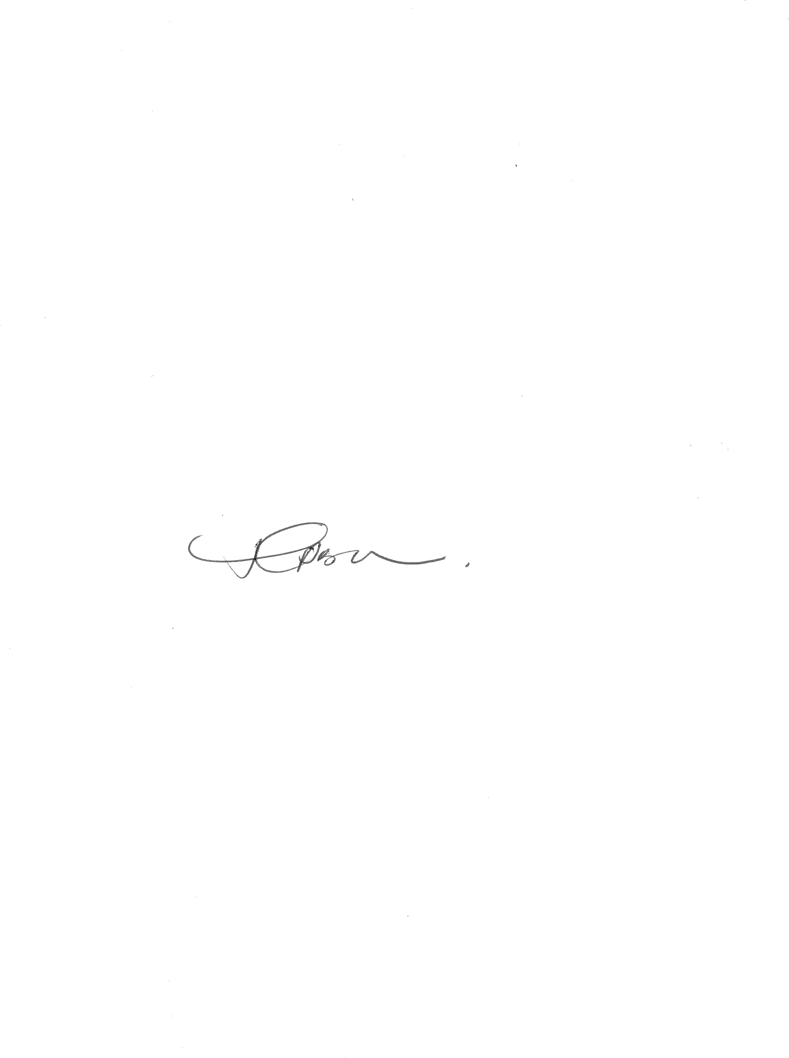16.3. The plaintiff shall be entitled to recover interest at the rate of 10.75% per annum on the taxed or agreed costs from the date of allocator or settlement, whichever date is the earlier, to the date of final payment.

__________________________

T. BOKAKO

ACTING JUDGE OF THE HIGH COURT

**APPEARANCE:**

**COUNSEL FOR PLAINTIFF: ADV R FERGUSON**

**COUNSEL FOR DEFENDANT: N/A**

DATE OF HEARING 24 APRIL 2023.

JUDGMENT DELIVERED: 28 JUNE 2023