

**THE HIGH COURT OF SOUTH AFRICA**

**GAUTENG DIVISION, PRETORIA**

|  |
| --- |
| **DELETE WHICHEVER IS NOT APPLICABLE:**  (1) REPORTABLE: ~~YES~~/NO  (2) OF INTEREST TO OTHER JUDGES ~~YES~~/NO  (3) REVISED:    14 31 August 2023 ……………………………….  DAT E SIGNATURE |

CASE NUMBER: 42362/2021

In the matter between:

**ADÉ MEYER PLAINTIFF**

**And**

**HEINER MEYER FIRST DEFENDANT / EXCIPIENT**

**HEINER MEYER N.O. SECOND DEFENDANT / EXCIPIENT**

(In his capacity as trustee of the

Akkedis Trust: IT8998/07)

|  |  |
| --- | --- |
| **ADÉ MEYER N.O.**  (In her capacity as trustee of the  Akkedis Trust: IT8998/07) | **THIRD DEFENDANT** |
| **THE STANDARD BANK OF SOUTH AFRICA** | **FOURTH DEFENDANT** |
| **THE MASTER OF THE HIGH COURT** | **FIFTH DEFENDANT** |
|  |  |

**Delivered:** This judgment was prepared and authored by the Judge whose name is reflected and is handed down electronically by circulation to Parties / their legal representatives by email and by uploading it to the electronic file of this matter on Case Lines. The date of the judgment is deemed to be 31 August 2023.

**JUDGMENT**

BOKAKO AJ;

**Introduction:**

1. In this case, the excipient brought this application in terms of rule 23 of the Uniform Rules of Court, wherein it excepts to the plaintiff's particulars of the claim because they do not disclose a cause of action and are vague and embarrassing. The causes of the complaint raised by the first and second defendants relate to the applicant`s third and fourth claims.

2. The facts foundational to this case are that the plaintiff and the first defendant were previously married, and their marriage was dissolved on 4 February 2016. The plaintiff, first and third defendant and the late Mr. Jan Andreas Rautenbach who passed away on 5 April 2018 are authorized trustees of the Akkedis Trust (Trust Number: IT8998/07)  The Trust was established on or about 12 July 2007 to hold the future assets of the plaintiff and the first defendant. The Trust is the registered owner of two immovable properties: the immovable property known as 1 Riboville Street, stand 135, Mooikloof, Gauteng, referred to as "the Mooikloof property, and the immovable property described as Scheme Sawubona Number 258, Unit 88, with title deed number ST5891/2012, also known as 18 Sawubona, Zimbali Estate, referred to as "the Zimbali property. The plaintiff and the first defendant and their children are the beneficiaries of the Trust. The Standard Bank is the registered bondholder over the Zimbali property.

3. It is trite that an exception that a pleading does not disclose a cause of action strikes at the formulation of the cause of action and its legal validity. Furthermore, it is trite that exceptions should be dealt with sensibly since they provide a valuable mechanism to weed out cases without legal merit. However, an overly technical approach should be avoided because it destroys the usefulness of the exception procedure. (See Telematrix (Pty) Limited v Advertising Standards Authority S.A. 2006 1 ALL SA 6 (SCA); 2006 1 SA 461 (SCA)).

4. In M Ramanna and Associates cc v The Ekurhuleni Development Company (Pty) Ltd, Case No: 25832/2013 (4 April 2014) ZAGPJHC, this court stated the following:

"It is a fundamental principle that particulars of claim should be so phrased that a defendant may reasonably and fairly be required to plead to it. This must be seen against the background of the abolition of the requests for further particulars of pleading and the additional requirement that the object of pleadings is to enable each side to come to trial prepared to meet the case of the other and not be taken by surprise. Pleadings must be lucid, logical, and intelligible, and the cause of action or defense must appear clearly from the factual allegations. The whole purpose of pleadings is to bring clearly to the notice of the court and the parties to action the issues upon which reliance is to be placed, and this fundamental principle can only be achieved when each party states his case with precision"

5. In the recent past, the Supreme Court of Appeal per Ponnan JA in Luke M Tembani and Others vs President of the Republic of South Africa and Another (Case no 167/2021) [2022] ZASCA 70 (20 May 2022) referring to the authorities quoted above stated the following:"

“Paragraph 14: While exceptions provide a useful mechanism to weed out cases without legal merit, it is nonetheless necessary that they be dealt with sensibly. It is where pleadings are so vague that it is impossible to determine the nature of the claim or where pleadings are bad in law because their contents need to support a discernible and legally recognized cause of action; that exception is competent. The burden rests on an excipient, who must establish that on every interpretation that can reasonably be attached to it, the pleading is excipiable. The test is whether, on all possible readings of the facts, no cause of action may be made out, it being for the excipient to satisfy the court that the conclusion of law for which the plaintiff contends cannot be supported on every interpretation that can be put upon the facts."

6. The causes of the complaint raised by the defendants only relate to the plaintiff's third and fourth claim. No alleged causes of the complaint are levelled at the first two claims of the plaintiff. The first and second defendants except to the plaintiff’s particulars of

claim on six grounds, before proceeding with the discussion, it is helpful to restate the causes of the complaint of the excipient, which are the subject of this exception and which are as follows:

6.1 First complaint relates to paragraph 7.2 of the plaintiff's particulars of claim, whereby the plaintiff pleads that on 18 December 2015 at Pretoria, the plaintiff and the first defendant, both acting personally and in their capacities as trustees of the Trust, entered into a written settlement agreement in full and final settlement of amongst others all patrimonial and further monetary claims against each other. In paragraph 7.3 of the plaintiff's particulars of claim, the plaintiff annexes a copy of a written settlement agreement marked Annexure "Bl", this is a written agreement of settlement between the Plaintiff and First Defendant. It is not an agreement between Plaintiff; First and Second Defendants, first and second defendants contends that the Trust is not a party to the agreement. Therefore, the plaintiff failed to disclose a cause of action against the Trust.

6.1. The second complaint pertains to clause 14.4.1 of the plaintiff's particulars of claim, the plaintiff pleads that a verbal agreement was concluded between the Trust, represented by its trustees, that the plaintiff and first defendant agreed that the plaintiff and first defendant would be responsible for various payments in respect of the Trust's property situated at Zimbali. In clause 14.410, the plaintiff pleads that the Trust is indebted to the plaintiff in the amount of R2 625 347,50. This notwithstanding that the plaintiff avers that it was verbally agreed that the plaintiff and first defendant would be responsible for such payments. The plaintiff fails to plead the terms of the alleged verbal agreement in concluding that the plaintiff is entitled to the total amount of the likely payments from the Trust or that the alleged terms continue to apply.

6.2 Third complaint is that the plaintiff pleads in paragraph 3.4 of the Particulars of Claim that the late Mr. Jan Andreas Rautenbach is an authorized trustee of the Trust. In paragraph 3.6 of the Plaintiff's Particulars of Claim, the plaintiff relies on letters of authority issued on 14 August 2007 by the fifth defendant, reflecting Jan Andreas Rautenbach ("Rautenbach") as a trustee. However, the plaintiff should have cited Rautenbach as a party to these proceedings, so the Trust is not properly before the court. Moreover, the plaintiff pleads in paragraph 3.5 of the particulars of the claim that Rautenbach passed away on 5 April 2018.

6.3 The fourth complaint relates to paragraph 9.1 of the Plaintiff's Particulars of Claim, the plaintiff pleads that she complied with all her obligations regarding the settlement agreement. In clause 5.6 of the settlement agreement, the plaintiff expressly agreed that she would be liable and responsible for paying the expenses regarding the immovable properties at Mooikloof and Zimbali. She would further be liable for the transfer costs, transfer duty and VAT where applicable, municipal costs, imposts, charges, and any capital gains tax or dividend tax insofar as the same applies. Moreover, a suspensive condition concerning the transfer of the Mooikloof and Zimbali property into the plaintiff's name had to be effected within three months from the signature of the written settlement agreement (18 December 2015). The plaintiff has pleaded no facts which establish compliance with her obligations above and fulfilment of the aforementioned suspensive condition. As such, the agreement relied on by the plaintiff does not show a cause of action and is, in fact, void ab initio for non-fulfilment of the suspensive condition.

6.4 The fifth complaint is that the plaintiff claims against the Trust regarding a suretyship agreement annexed marked "l" to Plaintiff's Particulars of Claim is a written suretyship agreement in which the first defendant and plaintiff bound themselves as surety for the payment of debts of the Trust in favor of the Standard Bank of South Africa, i.e., the fourth defendant. The plaintiff pleads no facts from which it can be concluded that the fourth defendant demanded her to satisfy any obligation(s) as surety. As such, she has no right of action against the Trust for payment of any amounts alleged to be made by her to the Trust in terms of her obligation as the surety.

6.5 The sixth complaint relates to clause 6.2 of "Bl" to the plaintiff's particulars of claim, an annexure "KLM" forms part of the written agreement relied on by the plaintiff; however, the same is not attached.

7 I do not intend to deal with all the grounds of the exception but will mainly focus on the crux of this relief sought against the assets owned by the Trust in this application. In order to seek this relief, the applicant requires, as a first step, to join the Trust in this proceedings. The defendants contend that the applicant has not made out a sufficient case regarding the Trust. In fact the applicant has not joined the Trust in these proceedings.

8 The essence of the respondents contention is that the plaintiff`s assertions regarding clause 5 of the settlement agreement expressly deals with the fact that the Trust is the owner of the Mooikloof property and the Zimbali property, and with the obligation accepted by the plaintiff and the first defendant that they would jointly take a trust decision that the Mooikloof property and the Zimbali property will be transferred to the name of the plaintiff.

9 The plaintiff seeks a first relief claimed in her claim against the second defendant specific performance of this obligation upon the Trust. In the introduction of paragraph 8 of the Particulars of Claim, the plaintiff relies on express, alternatively tacit, alternatively implied terms of the settlement agreement and has expressly averred in paragraph 7.2 of the Particulars of Claim that the deal was reached between the plaintiff and the first defendant, both acting personally and in their capacities as trustees of the Trust.

10 The principle which belies the issue of joinder is that no court may make a decision "adverse to any person’s interests, without that person first being a party to the proceedings before it." The court cannot grant relief, ordinarily, where any other person’s interests may be directly affected without formal judicial notice of the proceedings.

11 The plaintiff intends to seek relief against the Trust. The plaintiff alleges that if the claim succeeds against the Trust, it follows that benefits of the trustees and beneficiaries may be affected. Respondents contends that the plaintiff has an interest in the accounts of the Trust to pursue and enforce her rights to payment of her share from the trust of-trustees.

12 To join a party which the law would require to be included in the proceedings, the test is not premised on the nature of the subject matter of a particular suit, but rather the manner in which, and the extent to which, the relief sought may affect the interest of a party, in this case the Trust.

13 The relief claimed by the plaintiff does affect the Trust substantially and directly; any contractual relationship existing between the plaintiff and the Trust is legally relevant for the purposes of the plaintiff's claim. The non-joinder is material and legally fatal to the claim of the plaintiff .

14 From the above-mentioned facts it is legally sound that the Trust be joined to the action being a party with direct and substantial interest in the litigation pertaining to the true terms of the agreement and the monies due and owing.

15 In *Amalgamated Engineering Union v Minister of Labour* 1949 (3) SA 637 (A) at 659, it was said:

'Indeed it seems clear to me that the Court has consistently refrained from dealing with issues in which a third party may have a direct and substantial interest without either having that party joined in the suit or, if the circumstances of the case admit such a course, taking other adequate steps to ensure that its judgment will not prejudicially affect that party's interest'.

16 To put matters into perspective, the plaintiff`s third and fourth claim is centered around the trust which is not a party to these proceedings. Having sketched the above background, the plaintiff`s claim is excipiable.

**The order**

17 I accordingly grant the following order:

17.1 The first to the sixth ground of exception are upheld.

17.2 The plaintiff is ordered to pay costs on a party and party scale, including

the fees consequent upon the employment of Counsel.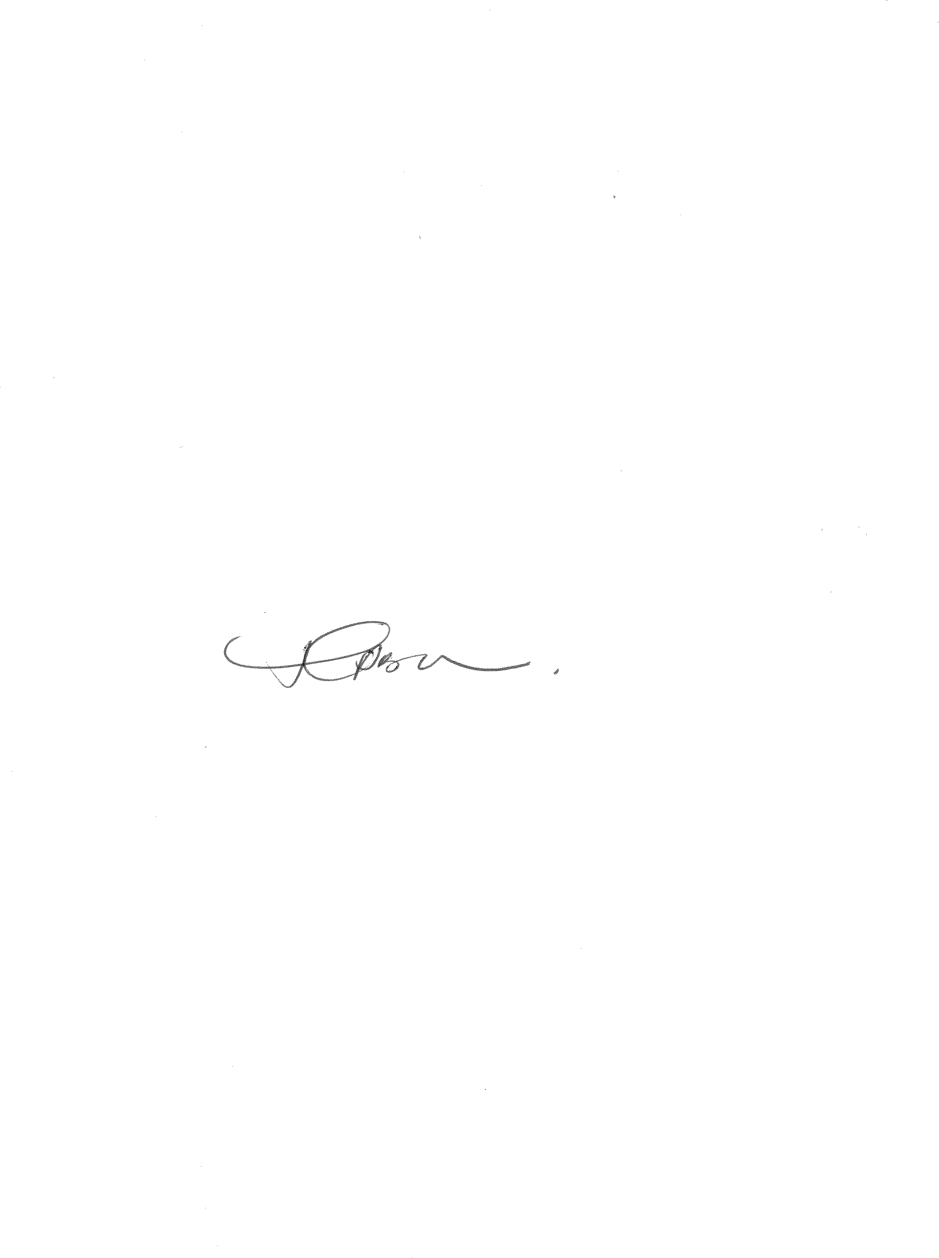

**T BOKAKO**

*Acting Judge of the High Court*

*Gauteng Local Division, Pretoria*

**HEARD ON: 16 May 2023**

**JUDGMENT DATE: 31 August 2023**

**FOR THE PLAINTIFF: Adv. A. Scott**

**FOR THE**

**DEFENDANT: Adv. J.A. Klopper**