

**THE HIGH COURT OF SOUTH AFRICA**

**GAUTENG DIVISION, PRETORIA**

|  |
| --- |
| **DELETE WHICHEVER IS NOT APPLICABLE:**  (1) REPORTABLE: ~~YES~~/NO  (2) OF INTEREST TO OTHER JUDGES ~~YES~~/NO  (3) REVISED:    14 31 August 2023 ……………………….  DATE SIGNATURE |

**CASE NO. 003603/2023**

|  |  |
| --- | --- |
| In the matter between |  |
| **LIBERTY GROUP LIMITED** | First Applicant |
| **2 DEGREES PROPERTIES (PTY) LTD** | Second Applicant |
| **PARETO LIMITED**    and | Third Applicant |
| **S SURTEE ESQUIRE (PTY) LTD T/A GRAYS** | First Respondent |
| **SOYAB SULIMAN SURTEE** | Second Respondent |
| **SHAHED SURTEE** | Third Respondent |

**Delivered:** This judgment was prepared and authored by the Judge whose name is reflected and is handed down electronically by circulation to Parties / their legal representatives by email and by uploading it to the electronic file of this matter Son Case Lines. The date of the judgment is deemed to be 31 August 2023.

**JUDGMENT**

BOKAKO AJ;

**Introduction:**

1. In this application, the applicant sought an order that judgment be summarily entered against the respondents in the following terms:

1.1. Payment in the sum of **R1 749 747.64**;

1.2. Interest on the sum described above at the rate of **10.75%** per annum from

23 January 2023, until the date of final payment.

1.3. Applicants' damages claim be postponed *sine die*;

1.4. Costs of suit.

2. The genesis of the case is that the applicant and the first respondent concluded a commercial lease agreement for the commercial premises situated at Shop U43, Upper Level, Sandton City Shopping Centre. The premises were leased to operate a men's clothing store and accessories under the "Grays” label from 1 May 2019 to 29 February 2024. The first respondent breached the terms of the lease agreement by failing to make full and punctual payment of the monthly rental amount(s) and ancillary charges. Consequently, the business went into business rescue thus action was instituted under the above case number.

3. The applicants are landlords and rent out a commercial premises to the first defendant. The case against the second and third respondents have been brought based on the suretyship agreement that the second and third respondents are alleged to have concluded as security for the indebtedness of the first respondent in favour of the applicants arising out of the lease agreement.

4. It is trite that for a respondent to succeed in resisting an application for summary judgment, it must show that it has a *bona fide* defense to the applicant's claim. Although the respondent does not have to establish such a defense as it would commonly in a plea, it must place specific facts before the court, demonstrating that such a defense may succeed in the trial that may ensue.

5. In Joob Joob Investments (Pty) Ltd v Stocks Mavundla Zek Joint Venture 2009 (5) SA 1 (SCA), the court stated the following:

*"The rationale for summary judgment proceedings is impeccable. The procedure is not intended to deprive a defendant of a triable issue or a sustainable defense of her/his day in court. After almost a century of successful application in our courts, summary judgment proceedings can hardly continue to be described as extraordinary. Our courts, both at first instance and at the appellate level, have during that time rightly been trusted to ensure that a defendant with a triable issue is not shut out. In the Maharaj case at 425 G-426E, Corbett JA was keen to ensure first an examination of whether there has been sufficient disclosure by the defendant of the nature and grounds of his defense and the facts upon which it is founded. The second consideration is that the disclosed defense must be both bona fide and good in law. A court satisfied that this threshold has been crossed is bound to refuse summary judgment. Corbett JA also warned against requiring the defendant the precision apposite to pleadings. However, the learned Judge was equally astute to ensure that recalcitrant debtors pay what is due to a creditor."*

6. Counsel for the applicant contended that on 19 July 2019, the respondents bound themselves as sureties for and co-principal debtors with the first respondent for the payment of all debts of the first respondent due to the applicant. The applicant and the first respondent signed a written lease agreement on 12 June 2021. The applicant further contended that the first respondent did not comply with its obligations in terms of the lease agreement, specifically by failing to effect the monthly rental and other amounts due.

7. The applicant further refuted the respondents’ contentions in that the first respondent has been placed under business rescue, referencing Section 133 of the Companies Act, 71 of 2008 which provides that there is a moratorium on the continuation of legal process against companies under business rescue and therefore denies the liability of the first respondent of the indebtedness amount due.

8. Applicant also submitted that the fact that the first respondent is under business rescue and therefore the legal processes are suspended against it, does not preclude the applicant to proceed with its action against the sureties. Indicating further that the respondents do not deny that the first respondent breached its payment obligations in terms of the lease agreement

9. Respondents contend that the summons served on them did not include copies of the suretyship agreement on which the applicants’ case is based, nor does it include a copy of the computation of the amount claimed and respondents deny the correctness of the amount claimed by the applicant.

10. Furthermore, it was contended that applicant's supporting affidavit does not comply with the peremptory requirements of Rule 32(2)(b) in that the terms of the recently amended Rule 32(2)(b) and 32(3) provides that a plaintiff is required to (1) verify the cause of action and amount claimed, (2) identify any point of law relied upon, (3) identify the facts upon which the plaintiff's claim is based, and (4) explain briefly why the defence as pleaded does not raise any issue for trial.

11. The respondents’ counsel submitted that the respondents have raised a triable issue in their plea arising out of the respondent's denial of the validity of the suretyship and that the summons served by the applicant did not include copies of either the suretyships or a document of the computation of the amount claimed from the respondents. The respondent contends that it is not enough for the applicant to merely allege that the points taken by the respondent are bad in law and that they are based on a misunderstanding of the law as such.

12. *In Maharaj v Barclays Ltd,* 1976 (1) SA 418 (A), it was held that in determining whether the defendant has established a bona fide defense, the court has to enquire whether the defendant has, with sufficient particularity, disclosed the nature and grounds of his defense and the material facts upon which his defense is based. All he has to do is to swear to the defense, which is competent in law in a manner that is not inherently or seriously unconvincing. (See also *Standard Bank South Africa Ltd v Friedman* 1999 (2) SA 456 (C) at 462 G).

13. It is clear from the particulars of the claim that the applicant's cause of action is based on a suretyship agreement in which, the respondents bound themselves as surety and co-principal debtors with the first respondent. The applicant contends that the respondents in signing the acknowledgement of debt, amongst other things declared that all admissions and acknowledgements of indebtedness by the principal debtor would be binding on them.

14. The general principle: It is trite that a contract of suretyship is accessary to the contractual relationship between the principal debtor and the creditor. In this regard the Supreme Court of Appeal (the SCA) held *Van Zyl v Auto Commodities (Pty) Ltd* (279/2020) [2021] ZASCA 67 that

14.1 "It follows from the accessory nature of the surety's undertaking that the liability of the surety is dependent on the obligations of the principal debtor. A consequence of this is that if the principal debtor's debt is discharged, whether, by payment or release, the surety's obligation is likewise discharged. If the principal debtor's obligation is reduced by compromise, the surety's obligation is likewise reduced. If the principal debtor is afforded time to pay, that ensures the benefit of the surety. If the claim against the principal debtor prescribes, so does the claim against the surety. This will be subject to any terms of the deed of suretyship that preserve the surety's liability notwithstanding the release or discharge of, or any other benefit or remission afforded to, the principal debtor."

15. Having regard to the issues raised by the respondents in that the applicants bear the onus of proving the validity of the suretyship agreement and Annexure B to the particulars of claim was not attached and served on the respondents. I find that indeed material issue have been raised by the respondent regarding the said agreement.

16. According to Rule 32(2) as stated above, if the supporting affidavit does not contain all four of these points, then it is defective, and the applicants are not entitled to summary judgment, notwithstanding the merits of the defence as pleaded.

17. I am of the view that, the applicant did not succeed to show compliance with the peremptory provisions of Rule 32(2) and (3). The applicants also rely on the ex-facie content of Annexure B to the particulars of claim to prove compliance., there was no Annexure B served on the respondents. Therefore respondent ought to be granted an opportunity to set out facts that will constitute an answer to the applicant's claim.

18. On this particular aspect the applicant failed to convince the court that they had made out a case for summary judgment, since summary judgment is an extraordinary, stringent, and drastic remedy, it calls for strict compliance with the prerequisites as provided for in Rule 32 (2) (b). See *Gull Steel (Pty) Ltd v Rack Hire BOP (Pty) Ltd* 1998 (1) SA 679 (O) at 683 H.

19. It is clear that the applicants have not verified the amount claimed, despite this amount being disputed by the respondents in the plea, and despite being required to do so by Rule 32(2). Instead, the applicants only state that the respondents are indebted to the applicants in the amount of R1 749 747.49 arising out of arrear rental and other charges, there is no explanation provided as to what those charges are, which amount is supported by reference to Annexure C to the particulars of claim, which was not attached to particulars of claim as served on the respondents. This is not sufficient for the purposes of Rule 32(2).

20. The learned authors in *Erasmus[1]* submit that a court will have to be satisfied that each of these requirements has been fulfilled before it can hold that there has been proper compliance with sub-rule (2)(b).[2] What must be verified are the facts as alleged in the summons. Further, the deponent to the affidavit in support of the application for summary judgment must verify what has been referred to as a complete or perfected cause of action. As pointed out in *Mphahlele,**[3]*.

21. I do find that the respondents have established a *bona fide* defense. It is important that the respondents ought to be content that the applicant's claim has been clearly verified and that their pleadings are technically in order.

22. The applicant has failed to show that there is compliance and thus proving the validity of the suretyships. Therefore applicants failure to expressly verify these details, and instead rely on the reference to Annexure B to the particulars of claim, which in any event was not attached to the document as served on the respondents, is insufficient.

23. I do find that the defence raised by the respondents in respect of the suretyships arises out of the onus placed on the applicants to prove that those suretyships complied with section 6 of the General Law Amendment Act proving validity of a suretyship falls into the same category as that of proving the existence of a term or the conclusion of a contract.

24. The applicants have not verified the amount claimed and this amount is being disputed by the respondents in the plea. The applicants only state that the respondents are indebted to the applicants in the amount of R1 749 747.49 arising out of arrear rental and other charges and did not explain what those charges are. The applicant made reference to Annexure C to the particulars of claim, which was not attached on the document as served on the respondents. This is not sufficient for the purposes of Rule 32(2). it is trite law that the applicants bear the onus of proving every fact underlying its claim, including the quantum owed.

25. The applicants have not annexed proof of these facts to the particulars of claim, nor verified these facts, therefore without evidence this court cannot enter a final judgment against the respondents. Summary judgment can only be granted if the applicant has made an unanswerable case against the respondent. *In casu* the respondents have raised a genuine, *bona fide* triable issue, and the applicants are therefore not entitled to summary judgment.

26. In order to grant summary judgment, the principle is that the court has to look at the matter and all the documents that are properly before it. The defences raised by the respondents, which are contested, cry out for evidence that needs to be thoroughly and adequately interrogated, as well as the submissions made by the applicant. The denied facts by the respondents call for the applicant to lead evidence, bearing in mind that the applicants bear the onus of proof, which constitutes a triable issue.

27. In my view, the defences raised by the respondents are not merely technical, as argued by the applicant but call for an answer. There is sufficient and full disclosure by the respondents of the nature and grounds of the defense sought to be relied upon, and the defense so disclosed is *bona fide* and reasonable in law.

28. I am of the considered view therefore that the respondent has succeeded in disclosing triable issues, and such matters constitute a *bona fide* defense.

**The order**

29. I accordingly grant the following order:

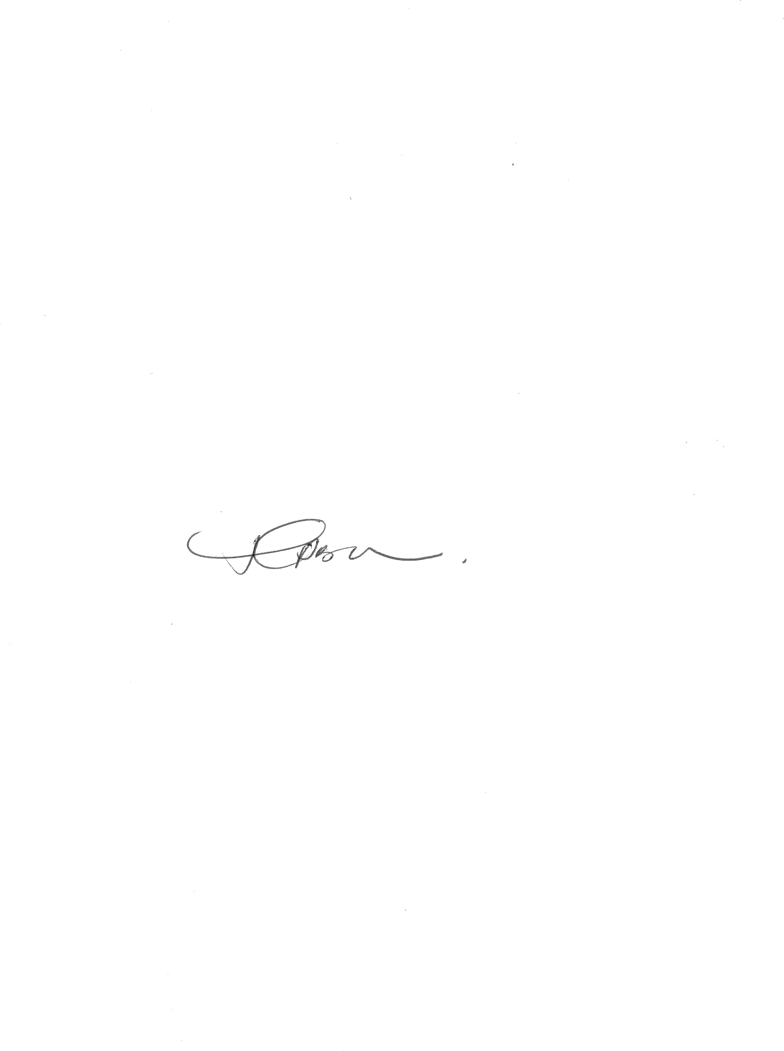29.1. The Application is dismissed with costs**.**

**T BOKAKO**

*Acting Judge of the High Court*

*Gauteng Local Division, Pretoria*

**HEARD ON: 24 MAY 2023**

**JUDGMENT DATE: 31 AUGUST 2023**

**Counsel for Applicants ADV LA PRETORIUS**

**Counsel for Respondents ADV SUHAIL MOHAMMED**

1. See: Erasmus, ‘Superior Court Practice’ (2nd edition) at D1-401
2. This view was endorsed in Mphahlele supra, at par 15 and is a view I share. It accords with the established case law under the former rule 32(2) wherein the requirements of such sub-rule were considered to be peremptory. See, for example, the reasoning employed in Shackleton Credit Management (Pty) Ltd v Microzone Trading 88 CC 2010 (5) SA 112 (KZP) at 122F-I
3. *Absa Bank Limited v Mphahlele N.O and Others* (45323/2019, 42121/2019) [2020] ZAGPPHC 257 (26 March 2020), par 14. (‘*Mphahlele*’)