Reportable: YES / NO
Circulate to Judges: YES / NO
Circulate to Magistrates: YES / NO
Circulate to Regional Magistrates: YES / NO

Editorial note: Certain information has been redacted from this judgment in compliance with the law.

IN THE HIGH COURT OF SOUTH AFRICA
NORTH WEST DIVISION, MAHIKENG

CASE NUMBER: CC21/2023

In the matter between:

THE STATE APPLICANT

AND

S[…] M[…] K[…] RESPONDENT

Coram: Petersen J

Dates heard: 21 – 24 May and 27 - 28 May 2024

Date of executive summary: 30 May 2024

Date of full reasons: 03 June 2024
ORDER

In terms of section 66(3) of the Criminal Procedure Act 51 of 1977 it is ordered
that:

1. The bail of the accused is cancelled.

2. The bail amount of R50 000 (fifty thousand rand) paid is forfeited to the State.

3. The accused is remanded in custody to 3 June 2024 at the Circuit Court of the Division sitting at Klerksdorp for further trial before Acting Judge Reddy.

4. The accused is to be detained as an awaiting trial detainee at a detention facility other than Orkney Police Station.

REASONS IN THE APPLICATION FOR THE CANCELLATION OF THE BAIL OF THE ACCUSED IN TERMS OF SECTION 66 OF THE CRIMINAL PROCEDURE ACT, ACT 51 OF 1977

PETERSEN J

Introduction

[1] The accused has been arraigned in the High Court sitting at the Circuit Court, Klerksdorp, on a myriad of charges of which the main charge is murder read with the provisions of s 51(1) of the Criminal Law Amendment Act, Act 105 of 1997 as amended (“the CLAA”), in which he is alleged to have killed his wife on 27 November 2022.

[2] The trial proceeded during the week of 13 May 2024 to 17 May 2024 before Acting Judge Reddy and is presently part-heard. I was informed that on 17 May 2024 the applicant (‘the State’) indicated its intention to bring an application for the cancellation of the bail of the respondent (‘the accused’). The application was said to be premised on alleged breach of certain bail conditions which were determined as part of the fixing of bail in terms of section 60 of the Criminal Procedure Act, Act 51 of 1977 (‘the CPA’). The application was subsequently brought before me on 21 May 2024 and concluded on 28 May 2024 with judgment being reserved to 30 May 2024.

[3] At the commencement of the application, the State as represented by Advocates Goloda, Chulu, Molefe and Tlatsana, indicated that the application was brought in terms of section 68 of the CPA. The rationale for this submission was clearly based on a misconstrued reading of the CPA. In S v Dlamini, S v Dladla and Others; S v Joubert; S v Schietekat (CCT21/98, CCT22/98 , CCT2/99 , CCT4/99) [1999] ZACC 8; 1999 (4) SA 623; 1999 (7) BCLR 771 (3 June 1999) at paragraph 7, the Constitutional Court made it plain that Chapter 9 of the CPA being the point of reference in matters of bail “...is where the effect, rules and consequences of bail are primarily to be found. Chapter 9 of the CPA is therefore not only an invaluable point of reference in any general enquiry into the law of bail, and a primary source to be consulted in looking for an answer to any specific bail question, but provides a comprehensive framework in which any answers can be judged…”

[4] The framework for the present application resorts snugly within the ambit of section 66 of the CPA and provides a very succinct answer to the approach to be adopted in the case of breach of bail conditions, as opposed to section 68 of the CPA which deals with a broader range of breaches and infractions. The application consequently proceeded on the prescripts of section 66 of the CPA which (in relevant part) provides that:

“66 Failure by accused to observe condition of bail

(1) If an accused is released on bail subject to any condition imposed under section 60 or 62, including any amendment or supplementation under section 63 of a condition of bail, and the prosecutor applies to the court before which the charge with regard to which the accused has been released on bail is pending, to lead evidence to prove that the accused has failed to comply with such condition, the court shall, if the accused is present and denies that he or she failed to comply with such condition or that his or her failure to comply with such condition was due to fault on his or her part, proceed to hear such evidence as the prosecutor and the accused may place before it.
…
(3) If the accused admits that he failed to comply with the condition in question or if the court finds that he failed to comply with such condition, the court may, if it finds that the failure by the accused was due to fault on his part, cancel the bail and declare the bail money forfeited to the State.”

Background

[5] On 4 April 2023 this Court, in a successful appeal against the refusal of bail by the Magistrate Orkney, fixed bail for the accused in the sum of R50 000,00 with six (6) bail conditions either of a mandatory or prohibitory nature. The accused is alleged to have breached conditions 3, 4 and 5 of the order of 4 April 2023 which conditions are instructive as follows:

“3. That the appellant does not communicate with his children who have been moved to protective care, whether directly or indirectly for the duration of this matter. The appellant is prohibited from contacting or communicating directly or indirectly with any of the witnesses or possible witnesses in this case until finalization of this matter. A list of the witnesses will be provided to him by the prosecutor/investigating officer on Tuesday 05 April 2023.
4. That the accused reports in person to the person in charge of the Charge Office (Community Service Centre) at Orkney Police Station twice a day, every day (Monday to Sunday) between the hours 07h00AM and 09h00AM and 16h00PM and 18h00PM with his identity document. The appellant shall first report in accordance with this order on Wednesday, 05 April 2023 or the very first day following his release on bail and every day thereafter;
5. The appellant is restricted to the Magisterial district of Orkney and may not leave the magisterial district without prior written approval of the investigating officer. If granted permission to leave the magisterial district, which permission may only be withheld on reasonable grounds, the appellant is to provide a valid itinerary of his movements and keep the investigating officer updated at all times as to his whereabouts. The appellant will be required to report to his nearest police station at his destination in accordance with condition 4 and upon his return to Orkney in accordance with paragraph 4 above.”

[6] The breach of condition 3 relates to an allegation that the accused communicated (had contact) with his children; and communicated (had contact) directly with witnesses for the State. The breach of condition 4 read with condition 5 relates to an allegation that the accused failed to report to the Orkney Police Station as mandated by the Court and left the Magisterial District of Orkney without written approval of the investigating officer.

The onus

[7] It is trite that, in terms of section 66 of the CPA, the State must prove that the accused has breached his bail conditions, on a balance of probabilities. In so doing, the State has to prove dolus or culpa on the part of the accused. See S v Packham (CC50/2018) [2018] ZAWCHC 183 (20 December 2018).

[8] The onus in this regard is less stringent that proof beyond a reasonable doubt. This Court is merely to consider the probability or improbability of the versions presented by the State and the accused. A qualitative assessment of the evidence of all the witnesses is called for to determine which of the versions is more probable. In the final analysis, what is required of the State is simply to prove that the version of the State, relevant to the alleged breach of the bail conditions, is more probable than the version of the accused; or for the accused to rebut such evidence as being improbable.

The effect of bail

[9] To fully appreciate the obligations which attach to the grant of bail to an accused, which right is not absolute but conditional, it is prudent to have regard to the effect of bail, and how the present application fits into the scheme of bail in terms of Chapter 9 of the CPA.

[10] The effect of bail in terms of section 58 of Chapter 9 of the CPA, relevant to the present application, is that “…bail granted in terms of the succeeding provisions is that an accused who is in custody shall be released from custody upon payment of… the sum of money determined for his bail, and … that the release shall, unless sooner terminated under the said provisions, endure until a verdict is given by a court in respect of the charge to which the offence in question relates, or, where sentence is not imposed forthwith after verdict and the court in question extends bail, until sentence is imposed.”
(my emphasis)

[11] The present application by the State is what section 58 of the CPA envisages under the rhetoric of the release of an accused being terminated sooner under provisions of section 66 of the CPA. The succeeding provisions to section 58 therefore form an intricate nexus to the granting and cancellation of bail. Whilst section 60 of the CPA calls upon a court to make a value judgment on the future, section 66 and 68 for that matter, calls on a court to make a value judgment on events which have occurred subsequent to the granting of bail in breach of not only bail conditions but the very fabric of section 60 of the CPA.

The evidence

[12] The State initially relied on the oral evidence of Sergeant Aaron Keobokile Mpudi, the investigating officer, with an accompanying affidavit deposed to by himself – Exhibit A; affidavits of Sgts Thabo Serabela and Theko Khetla of Orkney Police Station – Exhibits B and C; extracts of a document purported to be a record relevant to the accused reporting at Orkney Police Station in accordance with condition 4 – Exhibits D and D1; an affidavit of Lehlohonolo Paulus Rasmesi, a state witness in the main trial (Exhibit E); and video footage from a CCTV system at Orkney Police Station.

[13] The State subsequently sought to adduce the evidence of the sister of the deceased, hereinafter referred to as MM, with whom the minor children of the accused reside and who is a state witness in the main trial. The defence opposed the calling of MM, which opposition was dismissed by the Court in a brief ex tempore ruling. The accused testified under oath, to rebut the evidence presented by the State.

The alleged breach of condition 3 – the prohibitory condition that the accused should not communicate with his minor children

[14] In brief the evidence of Sgt Mpudi, in relevant part is that MM, during a journey from Moruleng in Rustenburg to Mafikeng, for purposes of consultation with the State Advocate seized with the trial of the matter, enquired if the accused was allowed to see his children. The enquiry was premised on her having heard that the accused was not allowed to see his children. According to Sgt Mpudi, MM was taken aback when he told her that the accused was not allowed to have contact or communicate with his minor children. MM then told Sgt Mpudi that the accused arrived unannounced at her home some time in December 2023 to visit the children, where he spent time with them in the house and spoke to them. MM indicated that she was afraid to ask the accused why he was there.

[15] Whilst Sgt Mpudi was crucified in cross examination on why he failed to obtain a statement from MM regrading her allegations, this did not advance the matter for the accused since the version of the accused in this regard, as put to Sgt Mpudi was a bare denial. The only contact, as put to Sgt Mpudi, according to the accused was that which he had with MM and not the children. This contact was either in August or October 2023 when he purchased clothing for the children and handed over birth certificates for his children and a clinic card. The narrative from the accused to Sgt Mpudi in respect of this evidence is that he bears a grudge against the accused.

[16] MM testified that she resides in Moruleng with the children of the deceased and the accused. Whilst she testified in chief that the children were living with her pursuant to a court order from the Orkney Childrens Court, she later readily conceded under cross examination that the children were in fact residing with her and her brother, in whose favour the court order was granted. Much was made of the court order being granted to the Department of Social Development, which is irrelevant to this application. The minor children as it would appear were placed in the protective care of MM’s brother and by implication herself.

[17] According to MM the accused made telephonic contact with the minor children in August 2023 and visited her homestead in Moruleng from 1 to 5 December 2023 where he sojourned with them for that period. During this visit the accused is said to have taken the children to a Mall and engaged with them in conversation. On 1 December 2023, the accused is said to have accompanied the family to the school of his daughter, where she was to receive academic awards. The existence of condition 3 according to MM was unknown to her.

[18] It is apposite to note that at the conclusion of the evidence in chief of MM, Mr Dlanjwa for the accused informed the Court that his instructions were to object to the evidence of MM being adduced. Furthermore, in the event of the objection being dismissed the instruction will be not to cross examine MM, since she had assumed the role of guardian to his minor children and was a link to communications from her regarding the wellbeing of his children. The accused was said not to want this link to his children to be disturbed. The matter was postponed to Monday 27 May 2024 for Mr Dlanjwa to secure further instructions from the accused, in light of the evidence tendered by MM.

[19] On Monday 27 May 2024, the cross examination of MM was concluded telephonically by agreement of all concerned, as information had been received that she had taken ill. The protracted cross examination sought, inter alia, to challenge MM on the order of the Childrens’ Court at Orkney, a pending a Maintenance Court application at Mogwase; and her status as a Lesotho national in South Africa. These issues were greatly irrelevant to the enquiry under section 66 of the CPA, in as far as they were introduced to cast doubt on the credibility of MM.

[20] MM readily conceded under cross examination that she had not mentioned in her evidence in chief that her brother also lived with the children and herself. The suitability of the residence for housing children was questioned, which again is greatly irrelevant for purposes of the enquiry at hand.

[21] MM disputed ever calling the accused to come to Moruleng but that he instead called her day in and day out, month to month, in a threatening manner. At some stage he told her that he has an army and the day he came to Moruleng he would leave no stone unturned and kill them all. This she did not report to the police because the accused was not afraid of the police as he called himself the “Government”. Even if she did report it she believed nothing would come of it.

[22] She, however, agreed that she did meet him to get the birth certificates of the children and a clinic card. It is not clear whether this was in August or October 2023. On that occasion she testified he arrived with two men who looked dodgy, left with the children and returned with them later. She also did not report this because she was not told that the accused was not allowed near her “yard”.
[23] The version of the accused put to MM is essentially that he denies any direct contact with his children when he met MM either in August or October 2023, to give her clothing and the birth certificates and clinic card. He would not have been aware that his daughter would be receiving awards at school, if MM did not again contact him. In fact, Mr K[…]’s version is that he would not have been aware if one of his children would get an award unless MM told him. On Mr K[…]’s version MM asked him to at least come to the school. MM disputed this and said that he called her regularly to speak to the children, and that she was surprised to see him at the school, which was questioned by the teachers and the principal. That even if it was true that he went to the school on 1 December 2023, he never had any contact with his daughter, which the witness disputed.

[24] The evidence of the accused in this regard is that MM called him to attend the awards ceremony of his daughter in Moruleng. Since there was a funeral in Ledig which is 20km from Moruleng, he travelled to Moruleng with his driver and his girlfriend. The arrangement at the school was that the children who would be receiving awards would be seated at the front and those observing at the back. He therefore had no direct contact with her, despite being invited by teachers to sit in the front, as they still believed he was a member of Parliament, even though he had stepped aside because of the policy of the African National Congress of which he was a member.

[25] He further denies that he slept over in Moruleng since such arrangement was impossible because of his girlfriend being with him. He therefore denies any breach of condition 3 in respect of his children.

The alleged breach of condition 3 – the prohibitory condition that the accused should not communicate with state witnesses

[26] Sgt Mpudi testified that he thinks that on Tuesday, which would have been 14 May 2024, he transported state witnesses in the main trial, from the holding cells at Orkney Police Station to the court at Klerksdorp and back. En route back to Orkney Police Station, one of the state witnesses, Lehlohonolo Rasmesi informed him that the accused visited him on the previous Sunday night, where he was in detention at the holding cell 6 at Orkney Police Station. This would appear to be before the trial was to start on Monday, 13 May 2024. According to Sgt Mpudi he had worked at Orkney Police cells and visiting is only allowed on a Wednesday at Orkney Police Station.

[28] Mr Rasmesi further told him that the accused was in the company of one Papi April who was also a state witness; and two other unknown male persons. When Mr K[…] and the three men visited Mr Rasmesi they were in the company of Sgt Kgetla. Mr K[…] and his companions according to Mr Rasmesi, brought food and other items for him, which included two (2) packs of cigarettes, soft drinks, Boxer brand tobacco and a small portion of dagga. Messrs K[…] and April further told him to change his statement which he had furnished in the main trial. Mr Rasmesi told him that whilst he did not have a watch, he noticed that it was dark outside. He further told Sgt Mpudi that there were cameras at Orkney Police Station which he could view to get the time.

[29] The following afternoon Sgt Mpudi went to view the cameras starting at a time stamp around 17h00 to 18h15. Upon viewing the video footage, he saw the accused, Papi April, a male known to him as the leader of a gang at Kanana known as “SVK” by the nickname (Mazzey), and a fourth unknown male person. The video footage was availed, and Sgt Mpudi described the persons seen in the video footage as follows: Sgt Kgetla and Sgt Serebele, Papi April who was wearing a pink T-shirt, the accused who was wearing a two-piece grey tracksuit; and a person clad in blue T-shirt and one in a floral top who were unknown to him. The four men were carrying plastic bags and proceeded to the holding cells where Sgt Khetla opened holding cell 6 where Mr Rasmesi was. Thereafter they proceeded to cell 5 where state witness Johannes Mohlomi was detained. When they left, they were no longer in possession of the plastic bags.

[30] It is prudent to quote the affidavits of Sgts Serabele, Khetla and Mr Rasmesi verbatim to appreciate the allegations inherent in the breach of condition 3. The affidavit of Sgt Serabele reads thus:

“2.
On Sunday 2024/05/12 at around 18h00 I was officially on duty, performing my duties as the CSC Commander at Orkney SAPS.

3.
On Sunday 2024/05/12 at around 18h20 I came from one of the Pakistani shops as I went to buy data for my phone. On my arrival at the Police Station I found three (3) African males standing next to the Station’s main gate. I greeted them as their face looked familiar to me.
4.
After that I saw Sgt Khetla approaching towards our direction where we were standing and later the man known to me as Mr S[…] K[…] also came from the CSC and he also joined us, then I heard that Mr K[…] and the guys that I found next to the main gate are together as they were talking.

5.
I did not know what was the arrangement as I realised that Sgt Khetla was in the possession of the cell key and one of the guys brother was on cell 6 and need to take food to him. Then I accompanied them to the cells and I was not that close to them to hear their conversation.

6.
I did not notice anything wrong while I was with them until they left. That is all I can say on my statement under oath in English.”

[31] The affidavit of Sgt Khetla reads thus:

“2.
On Sunday 2024/05/12 at around 18h00 I was officially on duty. While I was on duty I was approached by Mr K[…] carrying plastics containing food. Then Mr K[…] asked me whether can he give one of his relatives food and I was accompanied by Sgt Serabele and I went to cell 6 and give one of inmate those Movite and soft drinks and I do not know that inmate.”

[32] The affidavit of Mr Rasmesi reads thus:

2.

On Sunday 2024/05/12 at about 18h00 to 19h00 I was in Orkney Police Cells and particularly cell six (6) as an awaiting trialist.

3.

I was then visited in my cell by the person known to me as Papie April and S[…] K[…] and two (2) other persons unknown to me and they brought and provided (gave) me Bread, Movite Soft Porridge, soft drinks and 2x big bags of BB tobacco, 20 Bankies of Dagga and 2x 20s of cigarettes “Remington Gold”.

4.

Then Papie April and S[…] K[…] told me and requested me to change the contents of my statement given on S[…] wife murder case.

5.

I was told to add to my statement that Sergeant Mpudi made up the statement and I should do this in the name that S[…] is a gang member under Up Seven (7).

6.

And should I do all that as I’m being requested they will visit me everytime in the cells and provide me with all what I want or need.
7.

I was told to tell the Court that S[…] didn’t kill his wife in my statement. I was in my cell and I don’t (sic) what they said to Johannes Mohlomi because he is in a separate cell; but they told me that they are also go to talk to him as well.

8.

That is all.”

[33] The version of the accused put to Sgt Mpudi is that he denies taking anything to any person connected to the murder case against him; that a police officer told him that a certain Mlungise (later said to be the cousin of the accused) asked him to buy cigarettes for him. Since he had a pack of cigarettes in his pocket, the police officer accompanied him to the cells. It was said that he in no way went to the holding cells with the people in the video footage even though he was seen with them. This he maintains is borne out by the video footage which shows him entering alone with the police officer, at the main gate. He raised a concern with the police officer that he was not supposed to be there, but the police officer reassured him that it was fine as he knew him.

[34] The version of the accused version put to Sgt Mpudi was further that he denies ever having communicated with Lehlohonolo Rasmesi or Johannes Mohlomi. The police officer was looking for the person that the accused had to give the cigarettes to by going from holding cell to holding cell, which Sgt Mpudi disputed as the name of the person could simply be called out to respond. Lastly, that he could not have spoken to the said witnesses in the respective holding cells in a matter of 30 seconds.

[35] A vigilant examination of the video footage which traverses four cameras numbered as Cameras 4 (Holding cells), 7 (Entrance gate to the Community Service Centre), 8 (Community Service Centre) and 12 (Gate to holding cells) reveals the following:

Camera 12 (Gate to holding cells)
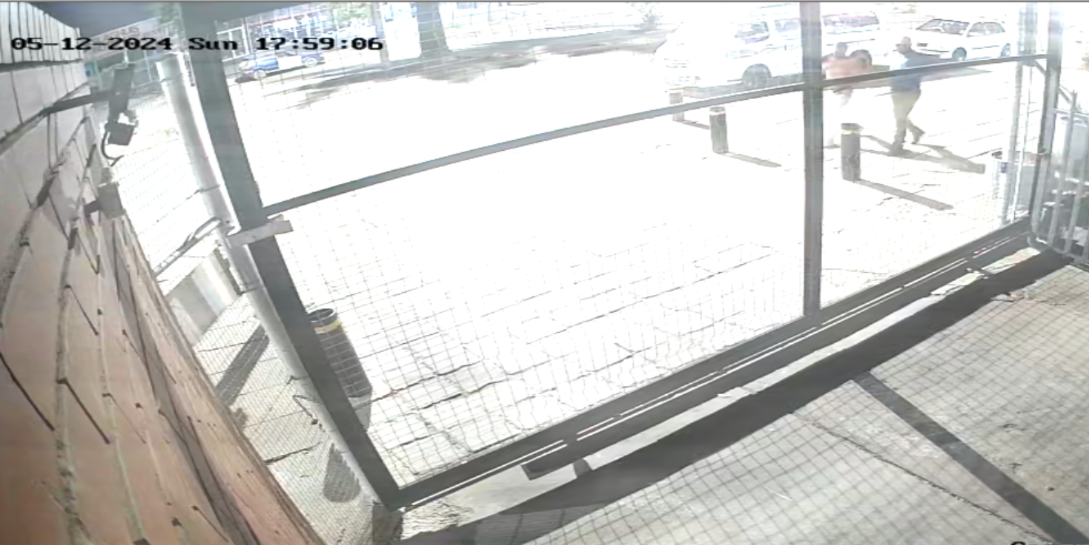

17h59: Two males wearing, respectively:
• A blue top, fawn trousers and a yellow hat (unknown to Sgt Mpudi);
• A pink t-shirt and white trousers (Papie April a state witness according to Sgt Mpudi). Papie April is carrying a green plastic bag over his shoulder.

Camera 7 (Entrance gate to Community Service Centre)
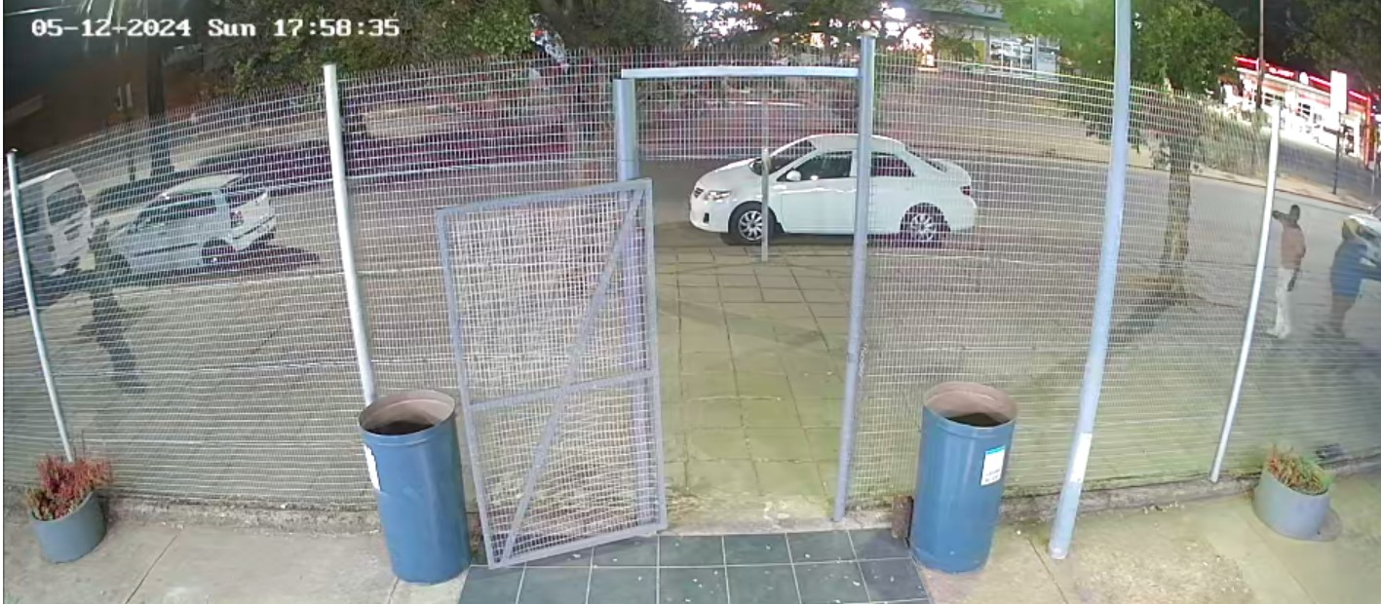
17h58:34/5: The two males as described above are seen on Camera 12 entering the frame at the small gate leading to the Community Service Centre. They eventually walk past the police station.
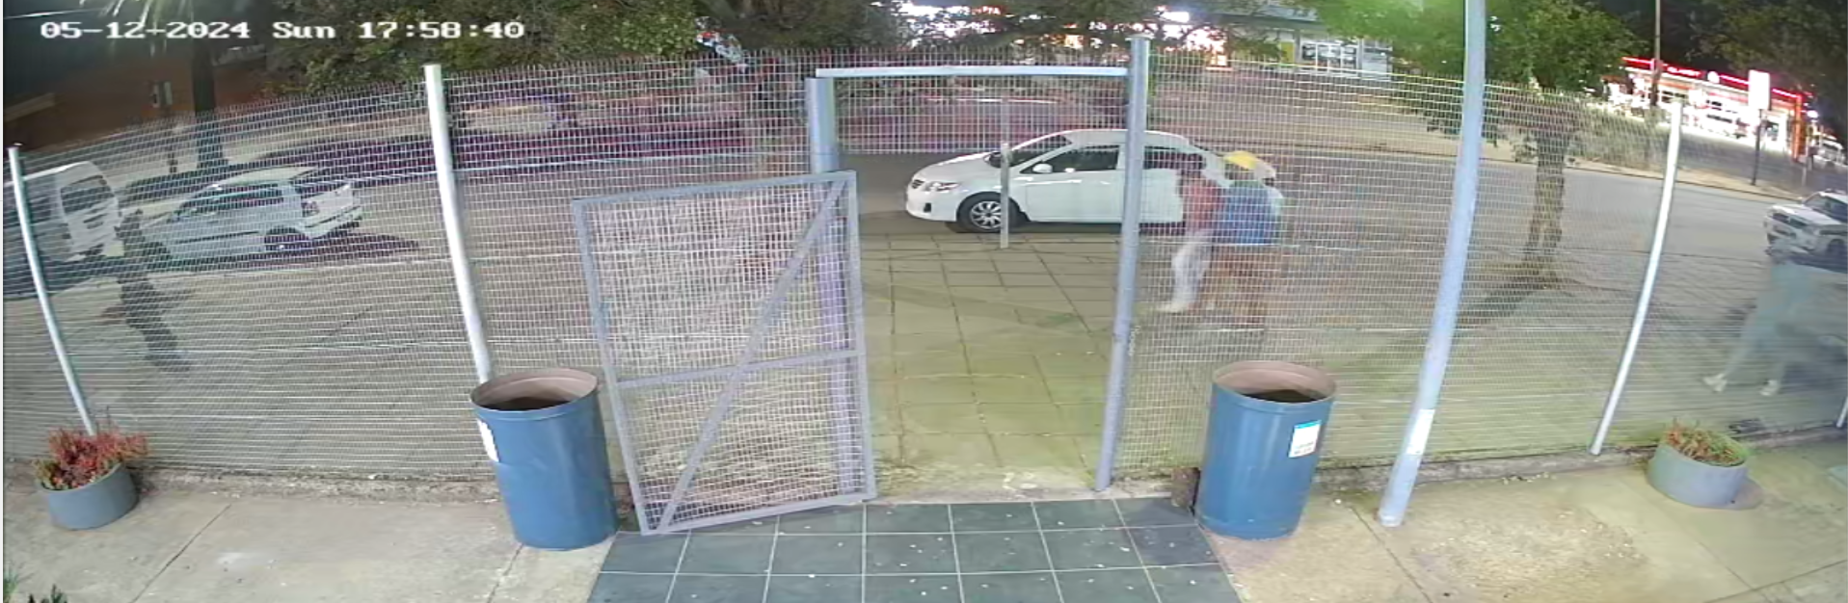
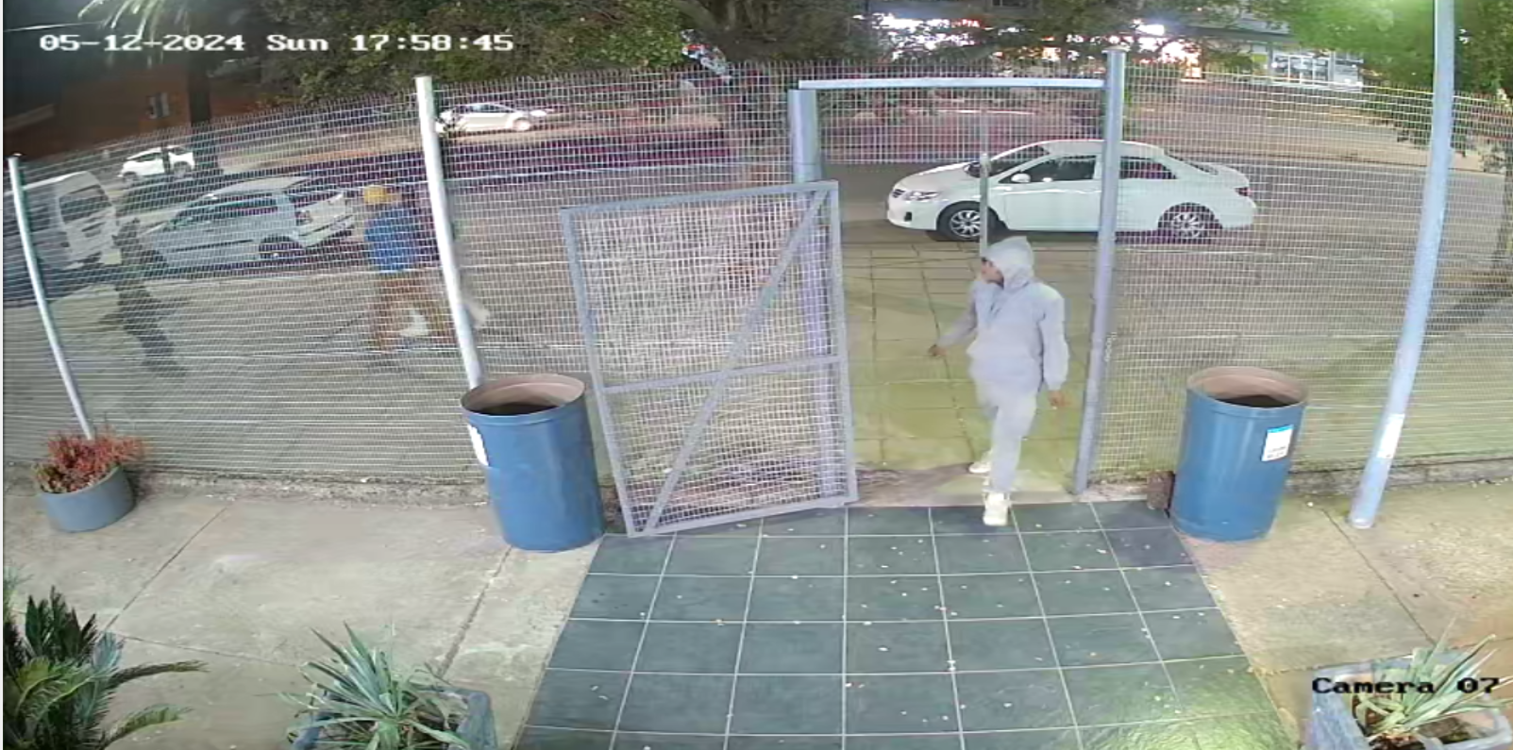
17h58:40: The accused enters the frame and walks through the small gate and is out of sight on Camera 7 at 17h58:50.

Camera 8 (The Community Service Centre)
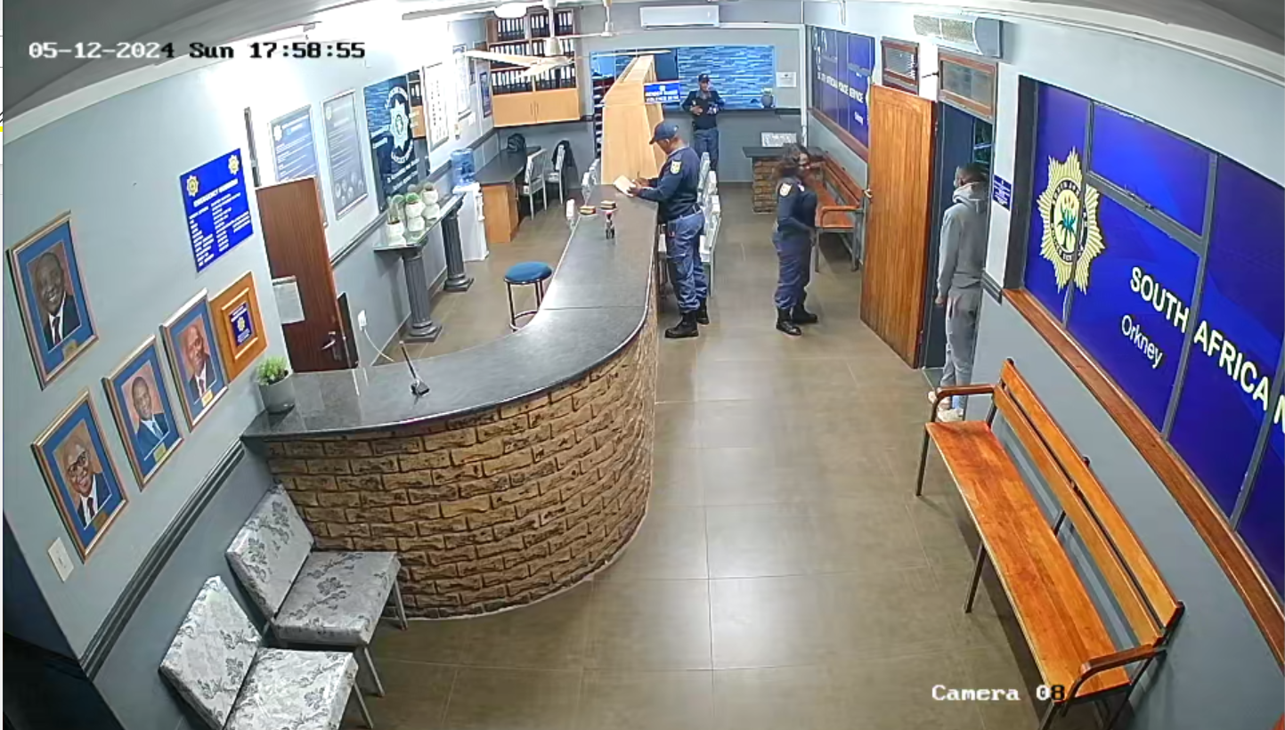
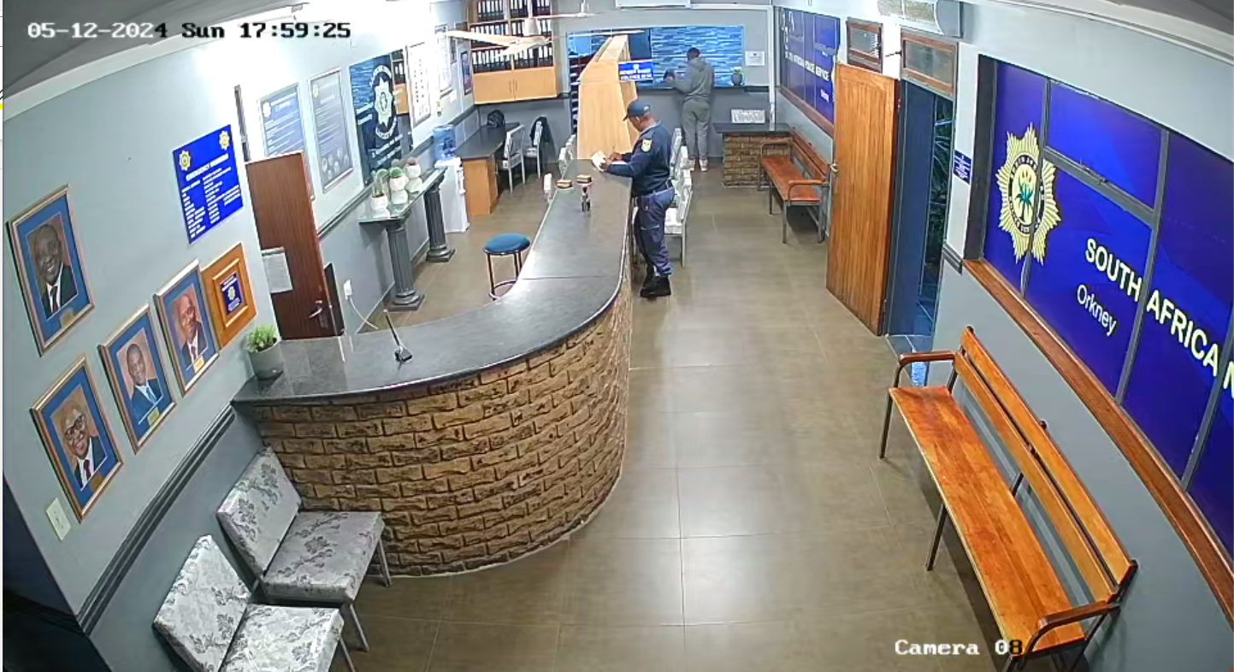
17h58:55: Thea accused enters the Community Service Centre where he talks to a female police officer until 17h59:06 before proceeding to where he must report.
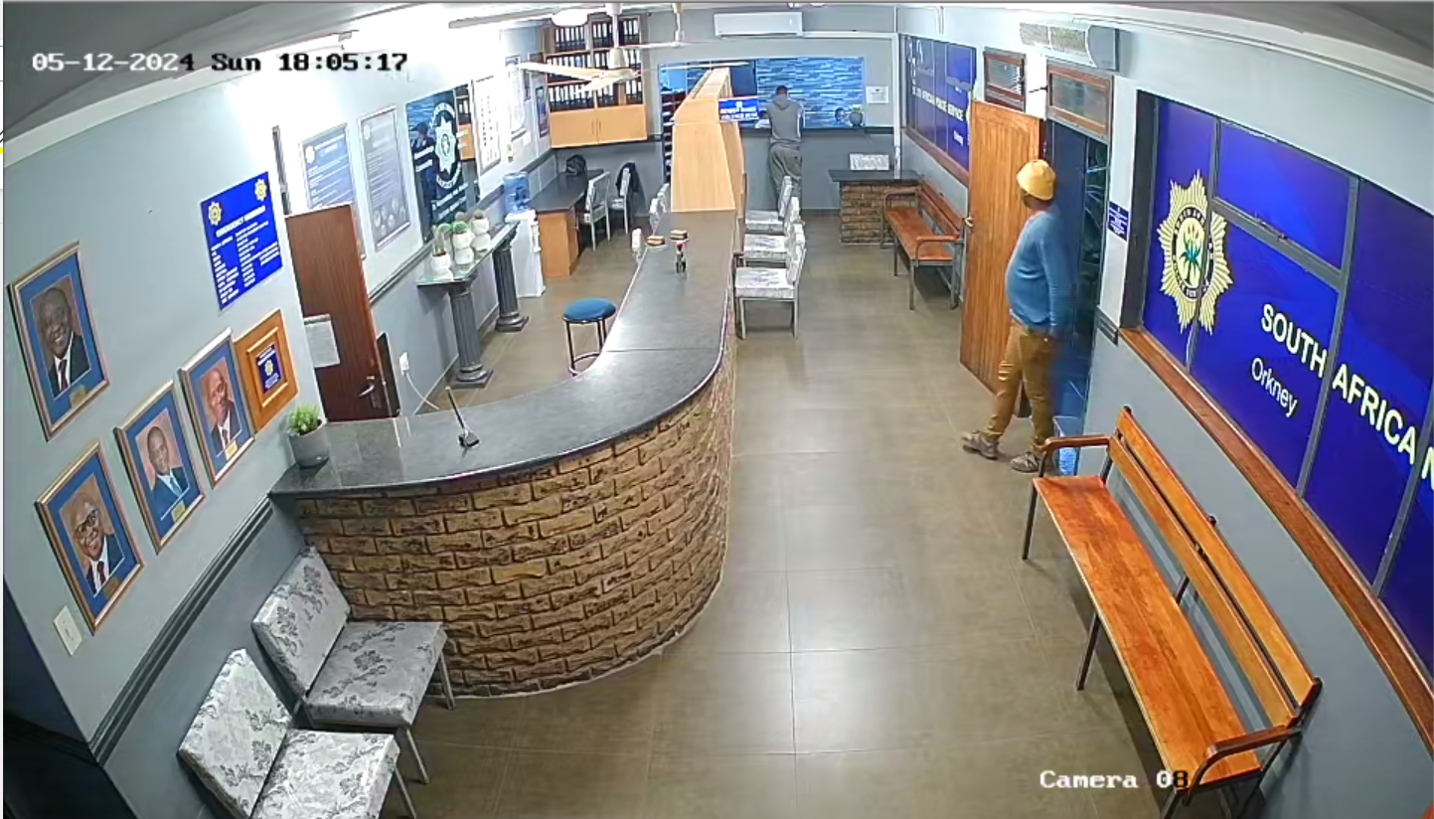

At 18h05:16: The unknown male with the blue top, fawn trousers and yellow hat enters at the door of the CSC. He stands in the entrance way of the door and appears to call out to the accused, who at 18h05:25 turns to look at him. They are in conversation with the accused still standing where he must report. The said unknown male keeps gesturing outside with his right hand.
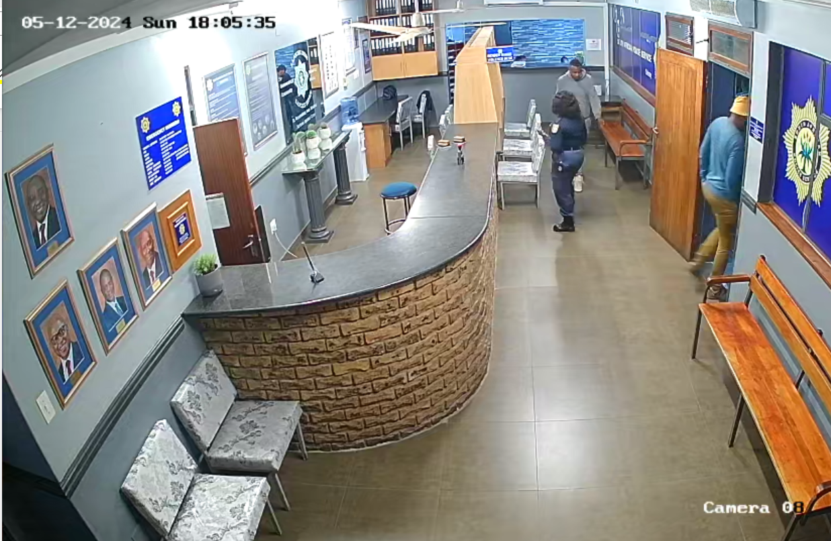
This male walks out of the CSC at 18h05:35 and the accused follows him. The accused does not return to the CSC. The accused and the said male are next seen at the gate to the holding cells (Camera 12)

Camera 12: Gate to holding cells
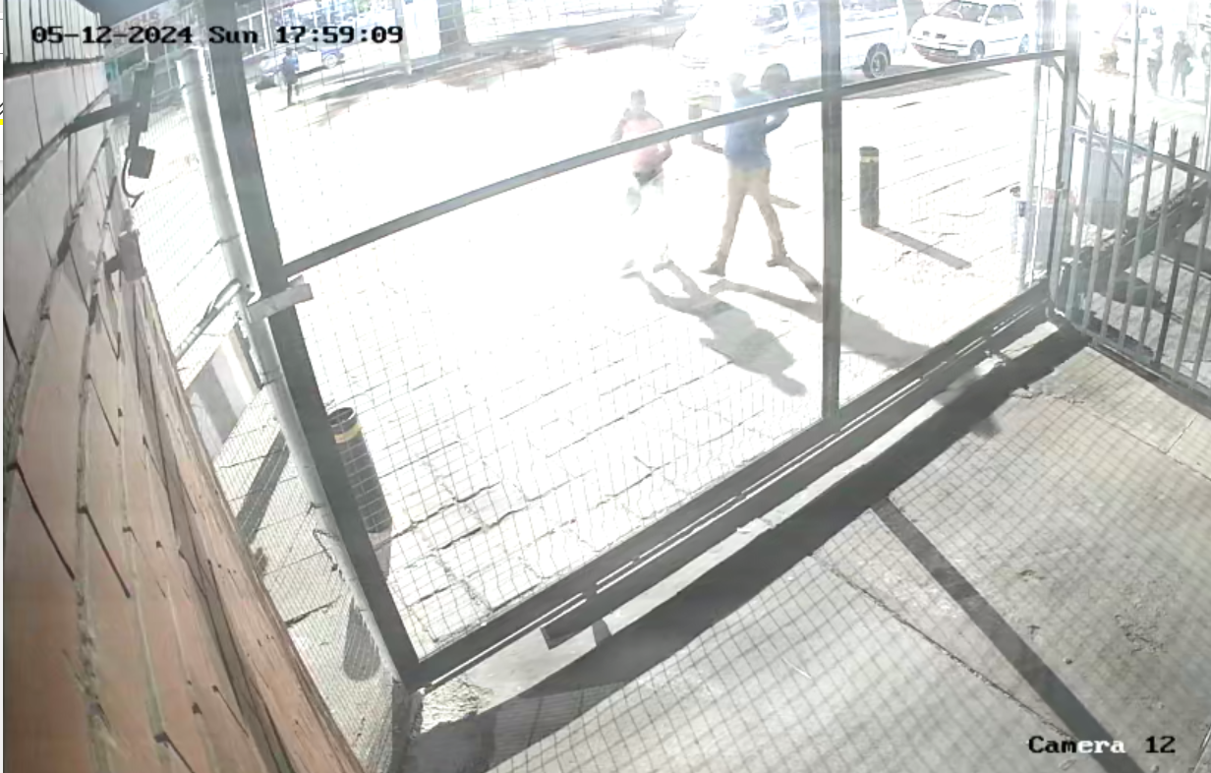
At 17h58:34: Papie April and the male he is seen with earlier as above enter the frame and are seen together passing the gate to the holding cells.
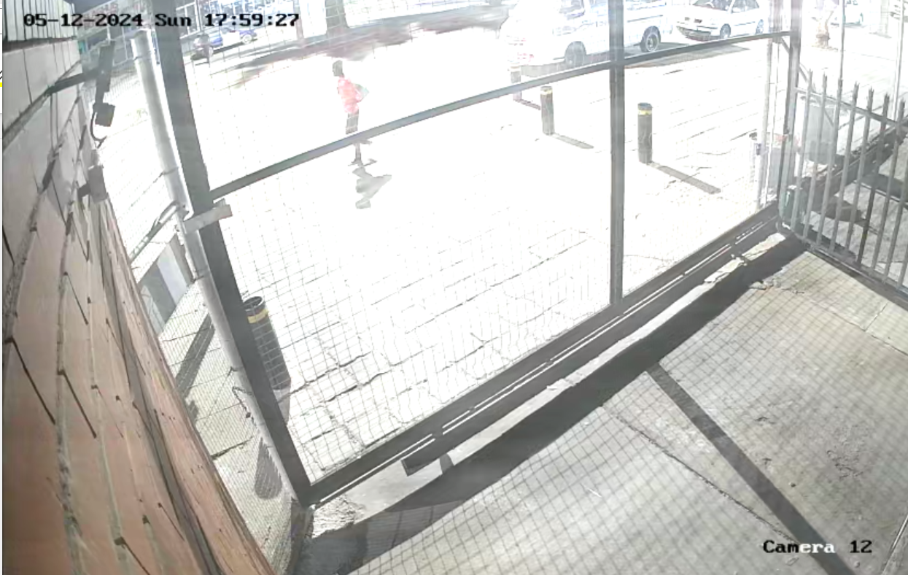

At 17h59:15: The second unknown male (according to Sgt Mputi) wearing a floral top, enters the frame carrying a similar green bag to Papi April. He too walks past the gate to the holding cells and is seen again entering from the left side of the frame at 18h05:48.

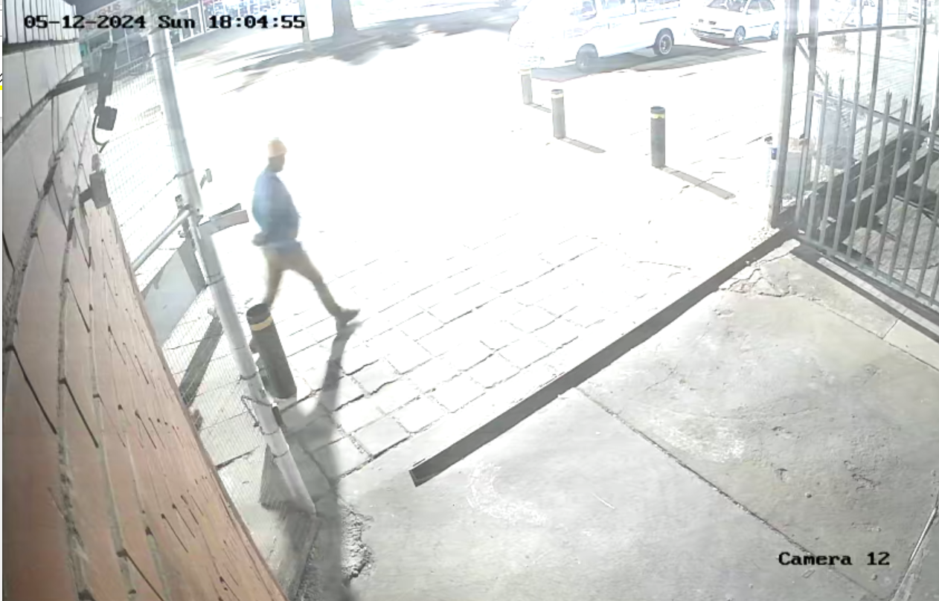

At 18h04:55 the male with the blue top, fawn trousers and yellow hat is seen entering the frame on camera 12. Sequentially this appears to tie in with him walking to the CSC where he is seen talking to the accused and the accused following him. The frame below shows him passing by the gate to the holding cells in the company of the accused who is talking on a cellphone at around 18h05:53. The male with the floral top enters the frame from the left side walking towards them and they pass him. He follows them.
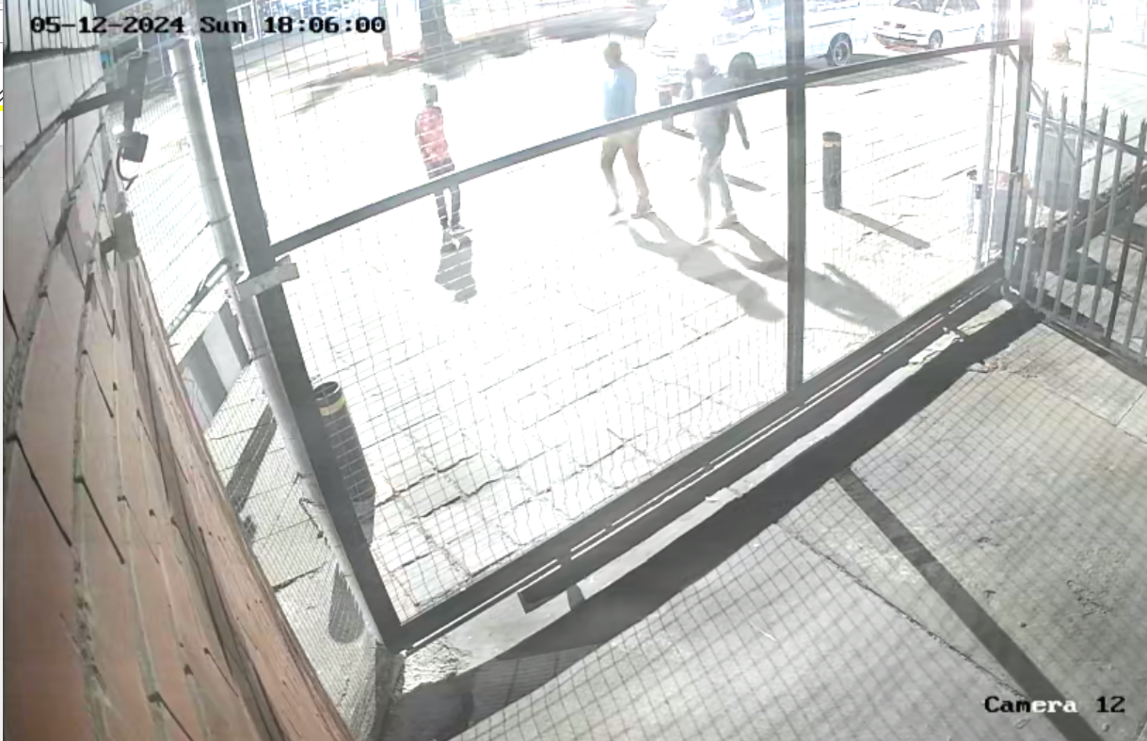

The video screenshots below show that at 18h09:26 two police officers, seemingly Khetla and Serabele enter the frame from the left. At 18h09:27 the big gate opens. Papie April enters first at the gate carrying a green plastic bag in his right hand; the unknown male with the yellow hat enters also now carrying a green plastic bag. At 18h09:31 the two police officers enter, followed by the male with the floral top; the accused follows the male with the floral top. At 18h09:33 the one police officer joins the accused and the rest of the males walk ahead with the other police officer. At 18h09:35 they are all out of view on camera 12.

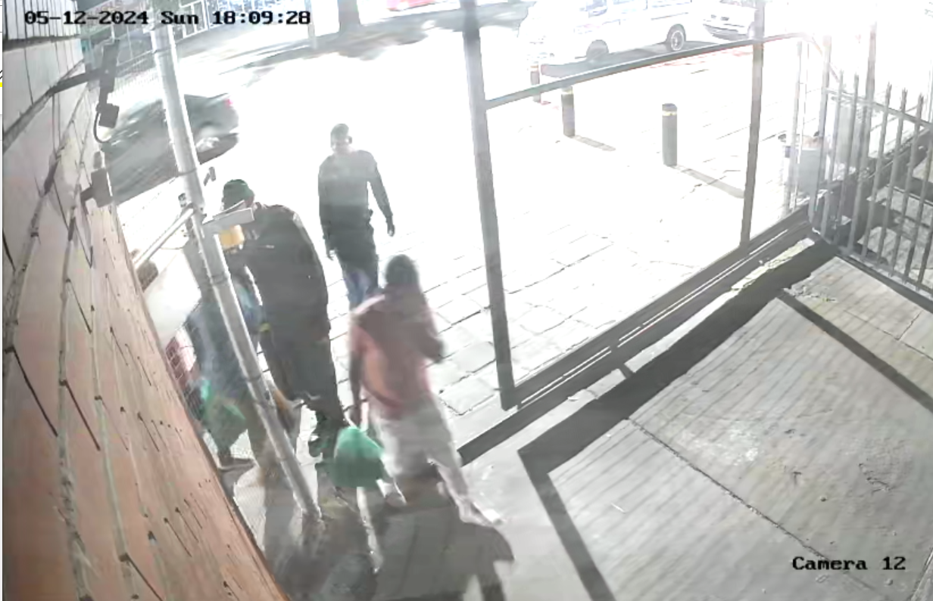

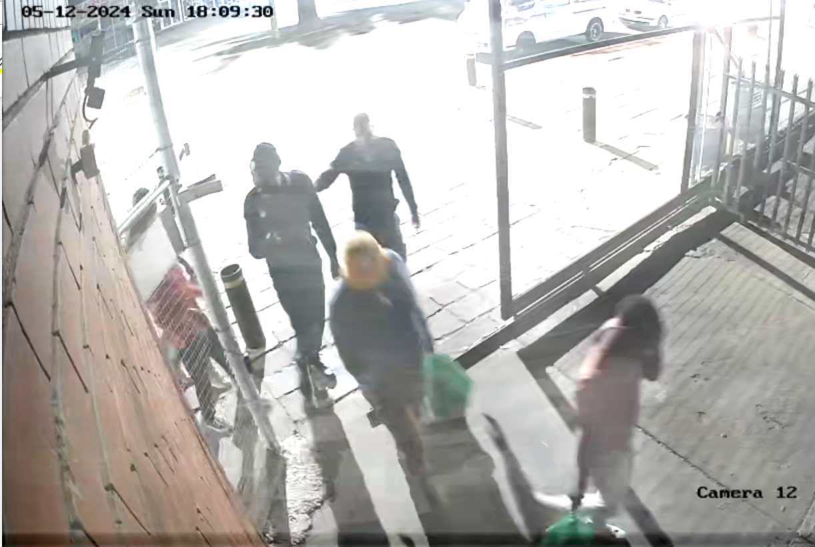
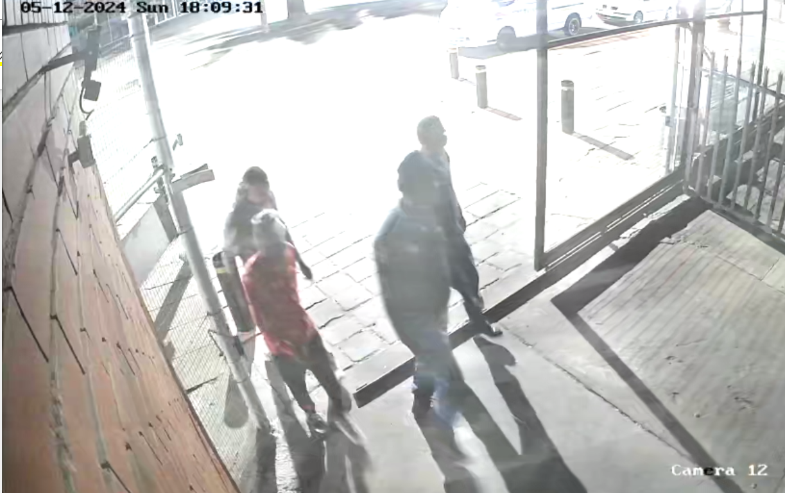

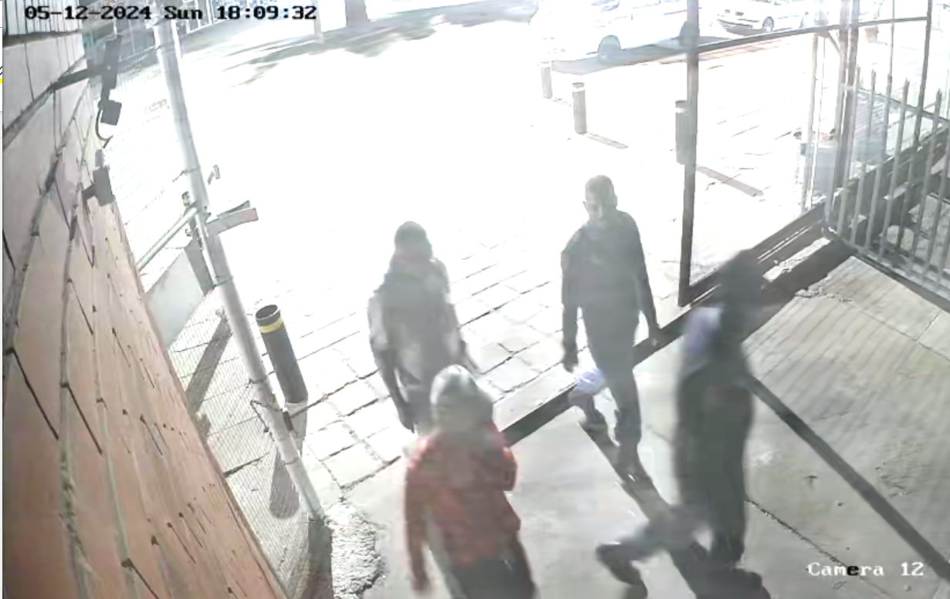

Camera 4 (Holding cells)
Whilst the video footage is not clear, it is not disputed that the accused entered, inter alia, holding cells 5 and 6 where Mr Rasmesi and Mr Mohlomi, both state witnesses, were detained. Between 18h10:57 to 18h11:34 the first holding cell is entered, seemingly cell 4. At 18h11:44, the accused can be seen having emerged from cell 4. At 18h13:01 the accused appears to be standing at the next holding cell with one of the police officers and is joined by the rest of the group shortly thereafter. At 18h13:34 to 37 they all enter the holding cell and emerge at 18h13:49 to 18h13:55, with the accused the last to exit. They all move to the next holding cell and from 18h14:13 to 18h14:17 enter the holding cell with one of the police officers. At 18h14:29, is seen on camera 12 exiting the gate at 18h15:28. At 18h14:49, the male with the blue top, fawn trousers and blue hat emerges from the holding cell, followed by the accused at 18:14:54 and Papie April at 18:14:59 who appears still to be talking to an awaiting rail detainees out of sight of the camera with the accused and blue top male watching on. By 18:15:36 the accused leaves with Papi April and the male with the blue top from the gate. The accused remains in the vicinity with the males seen in the video, at some stage appearing at on camera 12 when a male wearing a white shorts and black T-shirt arrives to light up a cigarette for the accused which seemingly share. The accused enters the frame again: and talks to him. He lights up a cigarette. By 18:16:35 the accused and the accused is not seen again.

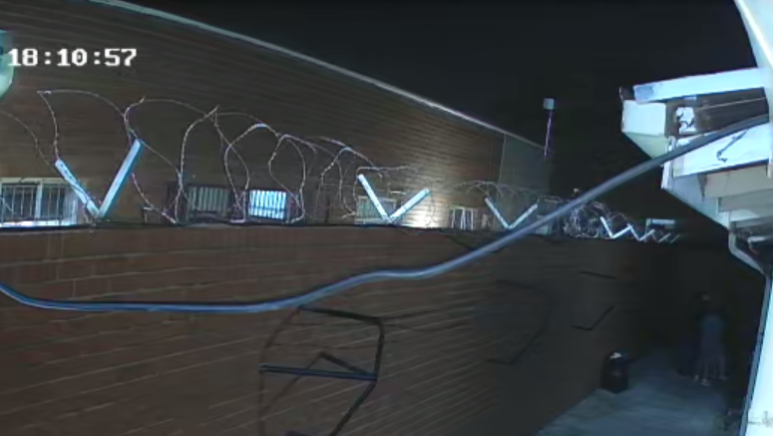

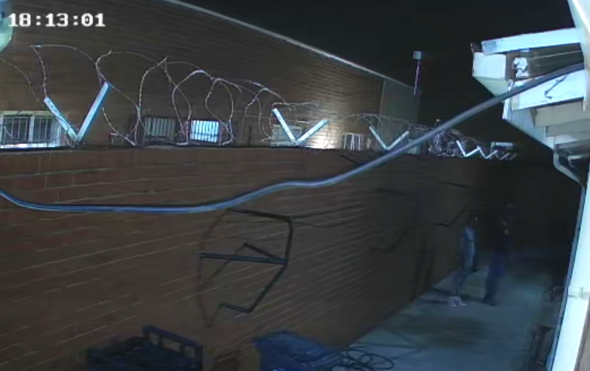

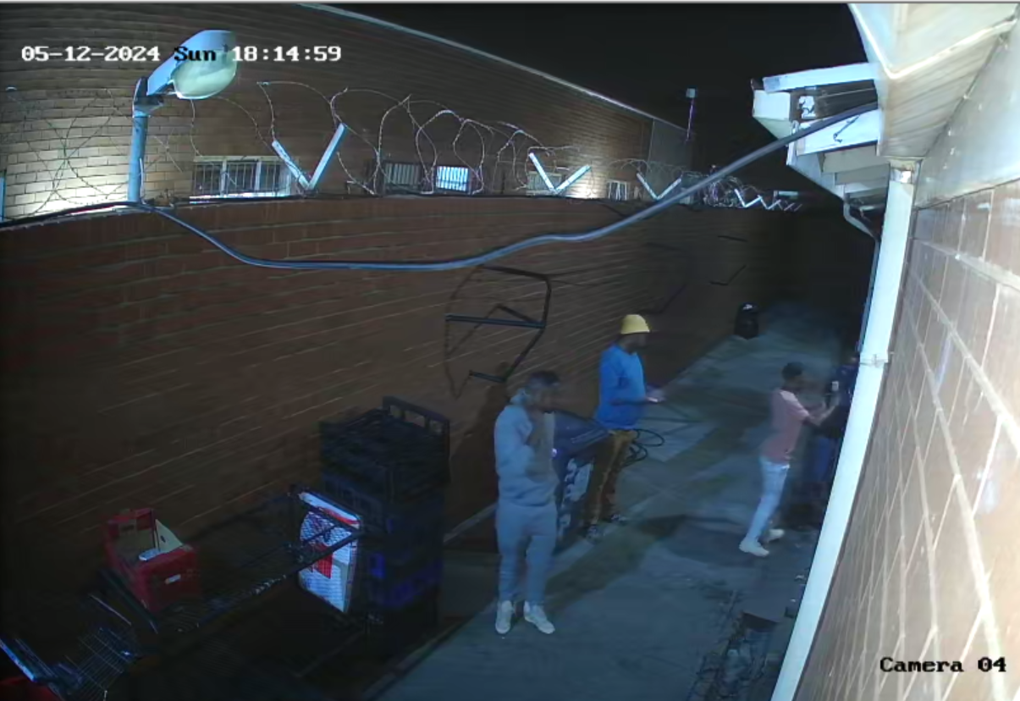

The alleged breach of condition 4 read with condition 5 – the reporting condition

[36] Sgt Mpudi testified specifically in relation to Exhibit D and D1. In particular, and in respect of 12 May 2024, he testified that the accused did not report that morning as per condition 4. What is glaringly apparent from Exhibit D is that there are several days which are unaccounted for, which according to the State totals 180 days. Exhibit D cross references the Occurrence Book (SAP 10) at Orkney Police Station. The extracts from the SAP 10 register were not presented as evidence by the State.

[37] It appears clear from Exhibit D that numerous police officers tasked with the duty to receive the accused when he was required to report, failed in their duty to complete the document properly and to make any cross reference in the Occurrence Book. It is further clear that Sgt Mpudi failed in ensuring proper compliance with his obligations in terms of condition 4 read with condition 5, when the accused left the Magisterial District of Orkney. Sgt Mpudi readily conceded his remissness in this regard. It is common cause that the accused did not report, as is evident on his own version for the period 1 to 4 December 2023. Further investigation on the veracity of the entries in Exhibit “D” when juxtaposed against the Occurrence Book is however merited.

Discussion

[38] In respect of the breach of condition 3 – communication with the minor children, the alleged breach only came to light when MM enquired from Sgt Mpudi whether it was true that the accused was not allowed contact with his children. Absent this question during a conversation with Sgt Mpudi, the alleged breach would not have been known. The criticism of Sgt Mpudi under cross examination on why he failed to take a statement from MM when this arose, did nothing to favour the enquiry for either the State or the accused. The best evidence on this issue was from MM.

[39] It is common cause that the accused at least from 01 to 04 December 2023 did not report at Orkney Police Station. According to MM the accused sojourned at her home with herself, her brother, and his minor children during this period. Further, that the accused attended an awards ceremony at the school of his daughter and spent time with the minor children at a Mall. The accused on the contrary maintains that whilst he attended the awards ceremony at his daughter’s school, he had no contact with her.

[40] The vehement opposition to the State calling MM to testify on instruction of the accused to Mr Dlanjwa and then in the event of such objection being dismissed not to cross examine MM was peculiar. In any event the accused subsequently instructed Mr Dlanjwa to cross examine MM. MM made a very favourable impression on this Court. She readily made concessions and did not demonstrate any bias. The attack on the evidence of MM through protracted cross examination directed at her credibility, did nothing to tilt the scales in favour of the accused on the probabilities. Regrettably, the tone of the cross examination on instruction of the accused, was directed at attacking MM based on her nationality as a Lesotho citizen. This was inherent in challenging her on the order of the Childrens’ Court, Orkney; the maintenance enquiry pending at Mogwase Magistrates’ Court and sadly a blight at her status in the country. Save for this attack on MM, her evidence on the true issue whether the accused breached condition 3 by communicating with his children, was a bare denial.

[41] The fact that there is no record of the accused being allowed to leave the Orkney Magisterial District in accordance with condition 4 read with 5, the common cause fact that he did not report from 1 to 4 December 2023 and his belated evidence of attending a funeral in Ledig, did not favour his version that he had no contact with his children and that he left the magisterial district of Orkney without the permission of Sgt Mpudi. The submission by Mr Dlanjwa that the accused initially did not want MM to be cross examined because she was a conduit to him receiving updates on his children, further strengthens the testimony of MM that the accused would day in and out call her to speak to the children.

[42] The probabilities in respect of a breach of condition 3 relevant to the children favoured the case for the State. I was accordingly satisfied that the breach of condition 3 by the accused relevant to the children constituted a gross or serious violation of condition 3 set by this Court. On this basis alone, the cancellation of bail and forfeiture of the bail money paid is merited in terms of section 66 of the CPA.

[43] In respect of the breach of condition 3 – communication with state witnesses, the alleged breach similarly only came to light when Mr Rasmesi whilst being transported from court to Orkney Police holding cells, told Sgt Mpudi about the visit from the accused, Papie April (a state witness) and two unknown men on Sunday 12 May 2024, literally on the eve of the trial that started on Monday, 13 May 2024. Absent this report, the visit to Mr Rasmesi, considering the lackadaisical attitude to the bail conditions set by this Court, would have in all probability, never come to light.

[44] In logical sequence, once Sgt Mpudi was informed by Mr Rasemesi of the meeting and the presence of video surveillance cameras at Orkney Police Station on or about 14 May 2024, he proceeded to the police station to view the footage the following day, 15 May 2024. The video footage serves to corroborate the evidence of Mr Rasmesi that the accused was present at the holding cells on Sunday 12 May 2024 when it was dark, and particularly his holding cell.

[45] The accused claimed not to know any of the men he is seen with on the video footage even though he was with them. The screenshots from the video footage above in my view demonstrates and proves not only on a balance of probabilities, but it may be said beyond a reasonable doubt, that the accused knew the men and that he was with them on Sunday 12 May 2024. From the first time they are seen at or near the gate leading to the Community Service Centre; to the male in the blue top, fawn trouser and yellow hat calling him and gesturing to him outside the Community Service Centre; and then shortly thereafter being seen walking together past the gate to the holding cells, and Sgt Serepedi confirming the congregation of the four men including the accused who enter the main gate to the holding cells; and entering the respective holding cells together, confirms the aforesaid.

[46] The accused confronted with the video footage does not and cannot dispute his presence at the holding cells where Messrs Rasmesi and Mohlomi were detained. The accused version is but a bare denial, claiming that he did not communicate with Mr Rasmesi or Mr Mohlomi in holding cell 5. This narrative based on a study of the video footage by the accused was sought to be edified with a submission that it is improbable that the accused in thirty (30) seconds could have requested Messrs Rasmesi and Mohlomi to change their versions of the involvement of the accused in the murder of his wife. A simple indication to Mr Dlanjwa during closing argument when the issue was raised, demonstrated that it is not only possible but probable, with time to spare, to give an instruction or request that versions or statements should be changed.

[47] Papie April, a state witness is said to be a gang leader in Kanana. The accused was in the company of the said Papie April as the video footage indicates. Papie April at least at cell 6 appears to be very vocal with someone in the holding cell, probably Mr Rasmesi who states on oath that not only the accused spoke to him but also Mr April. I find it improbable that the accused moving from holding cell to holding cell with Papie April and the three other men in his company was not privy to the conversation with Mr Rasmesi or Mr Mohlomi for that matter. I therefore find it highly improbable that the accused did not know Mr Papie April or that he was a state witness.

[48] All of the aforesaid considered, the surreptitious presence of the accused at the holding cells where state witnesses in his criminal trial are detained, in the face of condition 3 that he does not communicate with state witnesses, on the eve of his trial which was to proceed on Monday 13 May 2024, cannot be said to have been innocent. The version of the accused in so far as it differs from that of the State in this regard, must be rejected as false and the version of the State stands to be preferred.

[49] The breach of condition 3 prohibiting communication with state witnesses is equally a serious or gross breach and as with the breach of condition 3 otherwise, merits the cancellation of the bail and forfeiture of the sum of R50 000,00.

[50] In Packham supra the Court decided not to forfeit the bail paid on behalf of the accused since it was paid by a third party. I respectfully differ with that approach. The decision whether the bail amount should be forfeited is a judicial discretion which this Court must exercise judiciously. The discretion in my view cannot be exercised narrowly on the basis that the bail amount has been paid by a third party. In my view, the decision must account for the evidence and the seriousness of the breach inherent in that evidence. It matters not that a third party paid the bail amount. The forfeiture of the bail amount provided for in section 66 of the CPA is nothing more than a sanction which should be commensurate with the breach. The Legislature by way of analogy provides for similar sanctions related to bail in section 67 of the CPA as that provided for in section 66 of the CPA. The wording with the necessary changes is similar. In terms of section 67 of the CPA:

“67 Failure of accused on bail to appear
(1) If an accused who is released on bail —
(a) fails to appear at the place and on the date and at the time —
(i) appointed for his trial; or
(ii) to which the proceedings relating to the offence in respect of which the accused is released on bail are adjourned; or
(b) fails to remain in attendance at such trial or at such proceedings, the court before which the matter is pending shall declare the bail provisionally cancelled and the bail money provisionally forfeited to the State, and issue a warrant for the arrest of the accused.
(2)(a) If the accused appears before court within fourteen days of the issue under subsection (1) of the warrant of arrest, the court shall confirm the provisional cancellation of the bail and the provisional forfeiture of the bail money, unless the accused satisfies the court that his failure under subsection (1) to appear or to remain in attendance was not due to fault on his part.
(b) If the accused satisfies the court that his failure was not due to fault on his part, the provisional cancellation of the bail and the provisional forfeiture of the bail money shall lapse.
(c) If the accused does not appear before court within fourteen days of the issue under subsection (1) of the warrant of arrest or within such extended period as the court may on good cause determine, the provisional cancellation of the bail and the provisional forfeiture of the bail money shall become final.”
(emphasis added)

[51] Interference with state witnesses to perjure themselves, beside being serious, goes to the heart of interference with the integrity of the administration of the criminal justice system and the bail system. It shows utter disrespect and disdain for the Courts and society in circumstances where it is clear from the conduct of the accused that he regards himself, in the style of his signature “Government”, as being above the law. It is for these reasons, having regard to the serious and flagrant breach of condition 3 in its totality, that I exercised my judicial discretion in favour of forfeiture of the bail amount.

Order

[52] It is for the reasons as aforesaid that I handed down my order in an Executive Summary of the evidence, in terms of section 66(3) of the Criminal Procedure Act 51 of 1977 on 30 May 2024, in the following terms:
1. The bail of the accused is cancelled.
2. The bail amount of R50 000 (fifty thousand rand) paid is forfeited to the State.
3. The accused is remanded in custody to 3 June 2024 at the Circuit Court of the Division sitting at Klerksdorp for further trial before Acting Judge Reddy.
4. The accused is to be detained as an awaiting trial detainee at a detention facility other than Orkney Police Station.

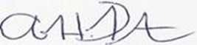
________________
AH PETERSEN
JUDGE OF THE HIGH COURT OF SOUTH AFRICA
NORTH WEST DIVISION, MAHIKENG

Appearances:

For the Applicant: Adv N Goloda with Adv B Chulu, Adv J Molefe and Adv F Tlatsana
Instructed by: Director of Public Prosecutions
Megacity Building East Gallery
3139 Sekame Street
MMABATHO

For the Respondent: Mr G S Dlanjwa

Instructed by: G S Dlanjwa Attorneys
4 Railway Avenue
Klerkindustria
Klerksdorp

