Reportable: NO
Circulate to Judges: NO
Circulate to Magistrates: NO
Circulate to Regional Magistrates: NO
IN THE HIGH COURT OF SOUTH AFRICA
NORTH WEST DIVISION – MAHIKENG
CASE NO: M461/21
In the matter between:-

AARON DWANYA SIBANDA FIRST APPLICANT
HARRY MASEGE SECOND APPLICANT
ZIPPORAH MODIBEDI THIRD APPLICANT
LUCAS LETSHOLO FOURTH APPLICANT
N.C SIBANDA FIFTH APPLICANT
PEARLY KGOSI SIXTH APPLICANT
REVEREND W.L MALEBYE SEVENTH APPLICANT
PROFESSOR C. LANDMAN EIGHTH APPLICANT
PEARL PITSE NINTH APPLICANT
KABELO MOGARI TENTH APPLICANT
TSHEPO MOLEFE ELEVENTH APPLICANT

ANY OTHER PERSON OR STRUCTURE WHO
BELIEVES ITSELF TO BE OR BEHAVES HIMSELF
OR HERSELF AS A MEMBER OF THE
UNITING REFORMED CHURCH IN
SOUTHERN AFRICA”
MOGWASE CONGREGATION” TWELFTH APPLICANT

ANY OTHER PERSON OR STRUCTURE
WHICH IDENTIFIES
ITSELF AS A MEMBER OF WHICH
PURPORT TO REPRESENT DEFUNCT
“SAULS PRESBYTERY “ THIRTEENTH APPLICANT

JOHNSON MAOKA FOURTEEN APPLICANT
SIMON NCUBE FIFTEENTH APPLICANT
LUCKY SEFORA SIXTEENTH APPLICANT
UNITING REFORMED CHURCH
IN SOUTHERN AFRICA: NORTHERN
REGIONAL SYNOD SEVENTEENTH APPLICANT

AND

THE UNITING REFORMED CHURCH
OF SOUTHERN AFRICA- MABODISA
CONGREGATION RESPONDENT

Judgment is handed down electronically by distribution to the parties’ legal representatives by e-mail. The date that the judgment is deemed to be handed down is 01 JULY 2024 at 16h00.

ORDER

The application for leave to appeal is dismissed with costs.

LEAVE TO APPEAL JUDGMENT

Reddy J

[1] This is an opposed application for leave to appeal to the Full Court of this Division against my entire judgment handed down on 14 February 2024. I shall, for pragmatism, throughout refer to the parties as cited in the application for leave to appeal. Counsel for both parties consented to the adjudication of this application on the papers.

[2] The applicants contend that this Court erred in or more of the following ways:

1.1 In finding that the Mabodisa Congregation had in fact authorised the deponent, Reverend Kwape to have instructed attorneys to institute the application on behalf of the Mabodisa Congregation.

1.2 In finding that notwithstanding that the events complained of had all occurred a considerable period before the interdictory relief was sought, and that interdicts are in respect of future unlawful conduct and not in and not in respect of alleged passed unlawful conduct, that the respondent was still entitled to have sought the relief it sought.

1.3 In not applying the legal prescripts as set out in Plascon Evans v Van Riebeeck Paints in that the version of the Applicants (Respondents a quo) was not accepted where there is a dispute of fact in preference to that of the respondent.

1.4. In finding that there was no genuine bona fide dispute of fact, which the Respondent was at all times aware of and which should have led to the above Honourable Court dismissing the application, alternatively referring the application to the hearing of oral evidence.

1.5. In dismissing the points in limine relating to the non-joinder in that the parties referred to as “any other person who identifies itself as member of and which purported to represent”, the Mogwase Congregation, whilst not being specifically joined was referred to as people affected and interested in the application.

1.6. In finding that Stipulation 45 of the Church Order has not been complied with.

1.7 In finding that the present Respondent had to prove on a balance of probabilities the rational factual connection between the actual threatened unlawful conduct and the persons against whom the interdict is sought;

1.8. In finding by implication without having dealt therewith that the Applicants had acted in a manner as set out in orders 1-6 of the Court Order without any analysis of the facts in this regard;

1.9. In finding that any of the Applicants had prevented the Respondent from utilising the premises at Erf Mogwase Unit 1;

1.10. In finding that any of the Applicants had committed any of the acts of violence or disruption to any of the activities of the Respondent;

1.11. In granting prayer 4, which is an order in favour Reverend Kwape who was not a party to the application, but merely a deponent on behalf of the present Respondent;

1.12. In ordering the present Applicants to pay the costs of the application, jointly and severally, the one paying the other to be absolved.

[3] The test to be applied in an application for leave to appeal is set out in section 17(1)(a) of the Superior Courts Act 10 of 2013, (“ the SCA”) which provides that:
(1) Leave to appeal may only be given where the judge or judges concerned are of the opinion that-
(a) (i) the appeal would have a reasonable prospect of success; or
(ii) there is some other compelling reason why the appeal should be heard, including conflicting judgments on the matter under consideration;”

[4] The case law has made it clear that this section has by using the word “only” indicated a more demanding test for leave to appeal to be granted. This is supported by the word “would” versus “could” in this section. In terms of section 17(1)(a)(i) of the SCA leave to appeal may now only be granted where a Court is of the view that the appeal would have a reasonable prospect of success. In The Mont Chevaux Trust v Tina Goosen and 18 Others 2014 JDR 2325(LCC) at paragraph 6 the following was stated in this regard:

“It is clear that the threshold for the granting leave to appeal against a judgment of a High Court has been raised in the new Act. The former test whether leave to appeal should be granted was a reasonable prospect that another court might come to a different conclusion, see Van Heerden V Cronwright & Others 1985(2) A 342 (T) at 343H. The use of the word “would” in the new statute indicates a measure of certainty that another court will differ from the court whose judgment is sought to be appealed against.”

[5] In S v Smith 2012 (1) SACR 597 (SCA), the concept of reasonable success was posited as follows:
“[7] What the test for reasonable prospects of success postulates is a dispassionate decision, based on facts and the law that a court of appeal could reasonably arrive at a conclusion different to that of the trial court. In order to succeed, therefore, the appellant must convince this court on proper grounds that he has prospects of success on appeal and that those prospects are not remote but have a realistic chance of succeeding. More is required to be established than that there is a mere possibility of success, that the case is arguable on appeal or that the case cannot be categorized as hopeless. There must, in other words, be a sound, rational basis for the conclusion that there are prospects of success on appeal.”

[6] In Ramakatsa and Others v African National Congress and Another (Case No. 724/2019) [2021] ZASCA 31 (31 March 2021), Dlodlo JA reiterated the methodology for finding the existence of a reasonable prospect of success when the following was enunciated:
“[10] Turning the focus to the relevant provisions of the Superior Courts Act (the SCA Act), leave to appeal may only be granted where the judges concerned are of the opinion that the appeal would have a reasonable prospect of success or there are compelling reasons which exist why the appeal should be heard such as the interests of justice. This Court in Caratco, concerning the provisions of s 17(1)(a)(ii) of the SC Act pointed out that if the court is unpersuaded that there are prospects of success, it must still enquire into whether there is a compelling reason to entertain the appeal. Compelling reason would of course include an important question of law or a discreet issue of public importance that will have an effect on future disputes. However, this Court correctly added that ‘but here too the merits remain vitally important and are often decisive’. I am mindful of the decisions at high court level debating whether the use of the word ‘would’ as opposed to ‘could’ possibly means that the threshold for granting the appeal has been raised. If a reasonable prospect of success is established, leave to appeal should be granted. Similarly, if there are some other compelling reasons why the appeal should be heard, leave to appeal should be granted. The test of reasonable prospects of success postulates a dispassionate decision based on the facts and the law that a court of appeal could reasonably arrive at a conclusion different to that of the trial court. In other words, the appellants in this matter need to convince this Court on proper grounds that they have prospects of success on appeal. Those prospects of success must not be remote, but there must exist a reasonable chance of succeeding. A sound rational basis for the conclusion that there are prospects of success must be shown to exist.” (footnotes omitted)

[7] Resultantly, I consider this application for leave to appeal on the basis that leave should be granted if a reasonable prospect of success is established, or if there are some other compelling reasons why the appeal should be heard.

[8] The application is founded on several grounds, most of the grounds in the Notice of appeal were dealt with in the main judgment and does not need to bear repetition. There is no underscoring that an applicant for leave to appeal must convince the court on proper grounds that there is a reasonable prospect or realistic chance of success on appeal. A mere possibility of success, an arguable case or one that is not hopeless, is not enough. There must be a sound, rational basis to conclude that there is a reasonable prospect of success on appeal.

[9] From my point of view, the applicants have not surpassed the statutory jurisdictional requirement as ensconced in section 17 (1)(a) of the SCA. The normal customary order in respects of costs should follow.

Order

[10] In the premises, I make the following order.
The application for leave to appeal is dismissed with costs.

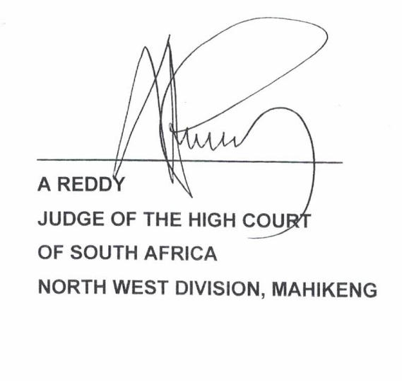

APPEARANCES

For the Appellants: Advocate RIP SC

Attorneys for Appellants GMI Attorneys
C/O VRTW INC
9 Proctor Avenue
Golfview
Mahikeng

For the Respondents: Advocate C A Kilowan

Mokoka & Partners Attorneys
3590 Wildevy Street
Danville Extension 34
Mahikeng

Date judgment reserved : 31 May 2024

Date judgment handed down: 01 July 2024

