

**REPUBLIC OF SOUTH AFRICA**



**THE HIGH COURT OF SOUTH AFRICA**

**GAUTENG DIVISION, PRETORIA**

|  |
| --- |
| **DELETE WHICHEVER IS NOT APPLICABLE:**  (1) REPORTABLE: YES/NO  (2) OF INTEREST TO OTHER JUDGES: YES/NO  (3) REVISED:  14 ……  DATE 9 APRIL 2024. SIGNATURE |

CASE NUMBER: 42362/2021

In the matter between:

ADÉ MEYER APPLICANT

and

HEINER MEYER FIRST RESPONDENT

HEINER MEYER N.O. SECOND RESPONDENT

(In his capacity as trustee of the

Akkedis Trust: IT8998/07)

ADÉ MEYER N.O. THIRD RESPONDENT

(In her capacity as trustee of the

Akkedis Trust: IT8998/07)

THE STANDARD BANK OF SOUTH

AFRICA FOURTH RESPONDENT

THE MASTER OF THE HIGH

COURT FIFTH RESPONDENT

______________________________________________________________________

**JUDGMENT FOR LEAVE TO APPEAL**

______________________________________________________________________

BOKAKO AJ

**Delivered:** This judgment was prepared and authored by the Judge whose name is reflected and is handed down electronically by circulation to Parties / their legal representatives by email and by uploading it to the electronic file of this matter on Case Lines. The date of the judgment is deemed to be 9 April 2024.

**INTRODUCTION**

1. This is an application for leave to appeal the judgment and order of this Court handed down on 31 August 2023. In that judgment, this court upheld the first to the sixth ground of exception. The applicant seeks to challenge that order before the SCA or, alternatively, a full bench. The respondents opposed the application.

2. It is a trite principle of our law that leave to appeal may only be given where the Judge or Judges concerned believe that the appeal would have a reasonable prospect of success or where there is some other compelling reason why the appeal should be heard, including conflicting judgments on the matter under consideration. *(See section 17 (1)(a)(i) and (ii) of the Superior Courts Act, 10 of 2013).*

3. The grounds for the leave to appeal are succinctly stated in the notice of application for leave to appeal, and I do not intend to restate them in this judgment. Furthermore, I would like to extend my gratitude and appreciation to both counsels for the submissions made in their heads of argument and at the hearing of this application.

4. I believe that I have considered all the issues raised in this application for leave to appeal in my judgment. I am therefore persuaded that another Court may come to a different conclusion in this case. Put in another way, I am of the considered view that there are reasonable prospects of success in this appeal. Therefore, the application for leave to appeal is granted.

5. In the circumstances, I make the following order:

1. The application for leave to appeal to the full bench of this Division against the judgment and order of 31 August 2023 is granted.

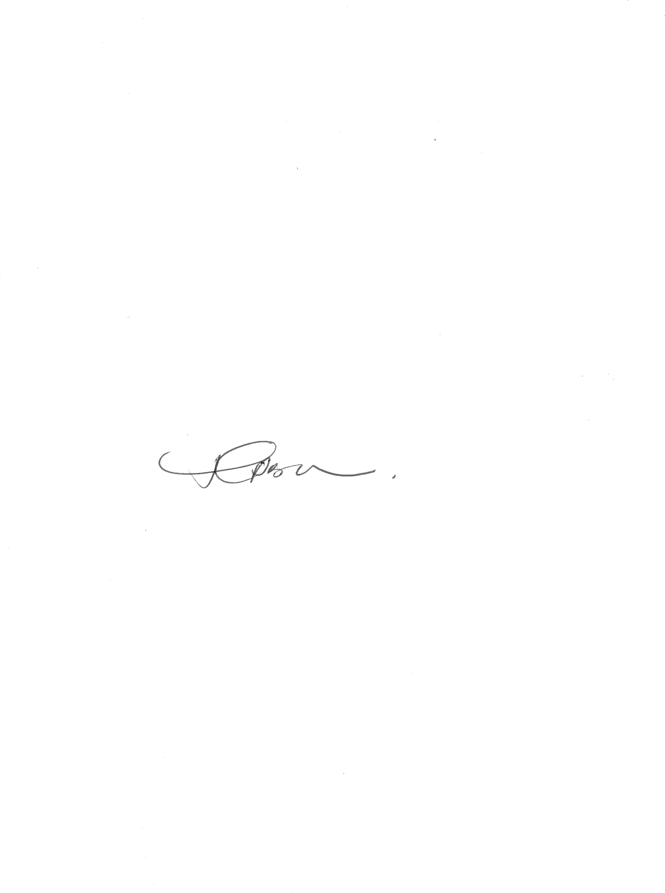

2. Costs of the application for leave to appeal are costs in the appeal.

**____________________**

**T BOKAKO**

***Acting Judge of the High Court***

***Gauteng Local Division, Pretoria***

APPEARANCES

Counsel for the Applicant Adv Nicole Hartman

Schoeman Attorneys 083 728 0444

Email: [schoemanattorneys@gmail.com](mailto:schoemanattorneys@gmail.com)

Ref: A Schoeman/A0465

Counsel for the 1st and 2nd Respondent Adv Collin Garvey

Attorneys for the First and Second Defendants:

Otto Krause Incorporated 011 675 2881

info@ottokrause.co.za Reference: Otto Krause/

ADS/MAT2969

Date of Hearing: 26 February 2024

Date of Judgment: 9 April 2024