

**IN THE HIGH COURT OF SOUTH AFRICA**

**KWAZULU-NATAL DIVISION, DURBAN**

**CASE NO: D8880/2021**

In the matter between:

**THE STANDARD BANK OF SOUTH AFRICA LIMITED**

**REGISTRATION NUMBER: 1962/000738/06 PLAINTIFF**

and

**GAVIN CHRISTOPHER YOUNG FIRST DEFENDANT**

**JOLENE CLAIRE YOUNG SECOND DEFENDANT**

**___________________________________________________________________**

**Amendment to the order**

**___________________________________________________________________**

**Henriques J**

1. It has come to my attention that there is an error in paragraph 1 of the orders in the preamble to the judgement.
2. Paragraph 1 of the order is amended to read “The application is dismissed.”

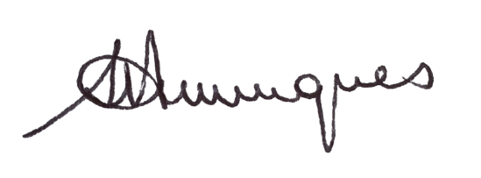

**J I Henriques, J**

**Judge of the High Court**

**Case Information**

NB. The amended order was handed down electronically by circulation to the parties’ representatives by email. The date and time for delivery is deemed to be 09h30 on 5 August 2022.

Counsel for the Applicant: Advocate SN Mfayela and B Jackson

Instructed by: Strauss Daly Inc

9th Floor Straus Daly Place

41 Richefond Circle

Ridgeside Office Park

Umhlanga

Durban

Tel: 031 570 5603

Reference: Mrs Chetty/S1272/8525/TMU

Email: [schetty@straussdaly.co.za](mailto:schetty@straussdaly.co.za);

[tmunsamy@straussdaly.co.za](mailto:tmunsamy@straussdaly.co.za), [TMthembu@straussdaly.co.za](mailto:TMthembu@straussdaly.co.za)

First and Second Defendants: No Appearance